Louise Giles - 1930-1976

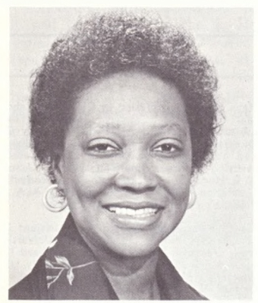

In 1975, Louise Giles became the first Black president of the Association of College and Research Libraries (ACRL). She was a graduate of Drexel University’s library school and Dean of the Learning Resources at Macomb County Community College (MI). Outstanding in the field of community college learning resource centers, a leader in the American Library Association, she died on December 31, 1976. Detroit firemen responding to a fire in her home discovered the bodies of Louise and her husband of 23 years at about 6:30 a.m.

Education

Louise Giles was born in Aragon, Georgia, on April 20, 1930.
She received her B.A. in foreign languages from the University of Akron in 1952 and her M.S.in library science from Drexel Institute of Technology in 1953 (Alice B. Kroeger Scholarship recipient).
In 1953 she received the Buenos Aires Convention Fellowship to spend one year as an exchange student in Tegucigalpa, Honduras.
She had completed course work for her doctorate from the Center for the Study of Higher Education at the University of Michigan and was a recipient of the John S. Brubacher Award from the Center for in 1975 for her outstanding graduate essay on the history and philosophy of higher education.

Career
Louise Giles was head of the foreign language collection and first assistant, young adult and adult librarian at Detroit Public Library from 1953-65.
She was associate dean of learning resources at Oakland Community College at the Highland Lakes Campus, Union Lake, Michigan and the Orchard Ridge Campus, Farmington, Michigan from 1965-70.
At the time of her death, Mrs. Giles was dean of learning resources at Macomb County Community College, Warren, Michigan, a position she had held since March 1970. Although her contributions were most instrumental in the growth and influence of learning resources, her influence and insight were missed throughout the college

Professional Associations

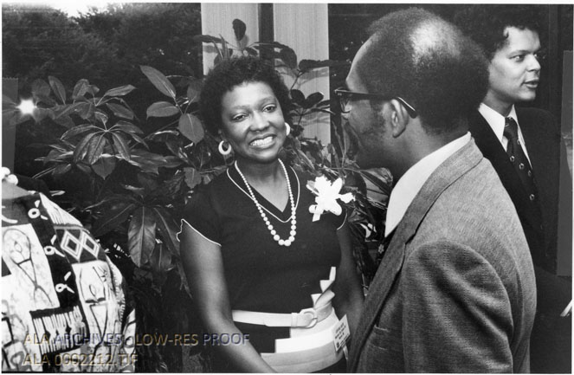
Louise Giles as President of the Association of College and Research Libraries

Louise Giles was active in many professional associations:
- President of the Association of College and Research Libraries.
- Chair of the Community and Junior College Libraries Section, member of many ALA committees),
- Michigan Library Association.
- Association for Educational Communications and Technology.
- Michigan Association of Administrators of Learning Resources.
- National Society for Programmed Instruction.
- Michigan Association of Community College Instructional Administrators.
- Michigan Academy of Science, Arts and Letters.

She had served accreditation teams for both the North Central Association and the Middle States Association Commission of Higher Education including an accreditation visit for the Middle States Association at the Caribbean Junior College, Puerto Rico.
Louise Giles was appointed a member of the Library Advisory Committee which was established by Dr. Daniel J. Boorstin, Librarian of Congress, to review the LC operation with an eye toward reorganization.

Louise Giles Scholarship- American Library Association

On February 1, 1977, the American Library Association Council approved a resolution unanimously endorsed by the ACRL Board of Directors and the ALA Awards Committee that honored Louise Giles and renamed the ALA Minority Scholarship as the Louise Giles Minority Scholarship.
In 1977, Clara Stanton Jones, the first Black President of the American Library Association awarded the first Louise Giles Minority Scholarship and scholarships were awarded annually thereafter.
At its 2002 Spring Meeting, the ALA Executive Board voted to permanently incorporate the Louise Giles Scholarship into the Spectrum Scholarship Family of funds and to retain its name as the Louise Giles Spectrum Scholarship and a scholarship has been named annually in her honor since 2003.

Selected Publications
Giles, Louise. “On the Cutting Edge of Change.” In New Dimensions in Academic Library Service, edited by E. J. Josey. Metuchen, NJ: Scarecrow Press, 1973.
Giles, Louise. “The Black Librarian as Change Agent.” In What Black Librarians Are Saying, edited by E. J. Josey, 256–267. Metuchen, NJ: Scarecrow Press, 1972.
Giles, Louise. “Focus on Community College Libraries.” Michigan Librarian, Summer 1971.
Giles, Louise. “Planning Community College Resource Centers.” American Libraries 2, no. 1 (January 1971): 51–54.
Giles, Louise, ed. Aspects of the Junior College Field: A Bibliography. Washington, DC: American Association of Junior Colleges, 1969.

Sources

American Library Association, 1977. “ACRL Board Pays Tribute to Louise Giles.” College & Research Libraries News 38 (3): 57. https://doi.org/10.5860/crln.38.3.57.
American Library Association.1977. “ALA Minority Scholarship Renamed for Louise Giles.” College & Research Libraries News 38 (3): 56.

Submitted by Kathleen de la Peña McCook

