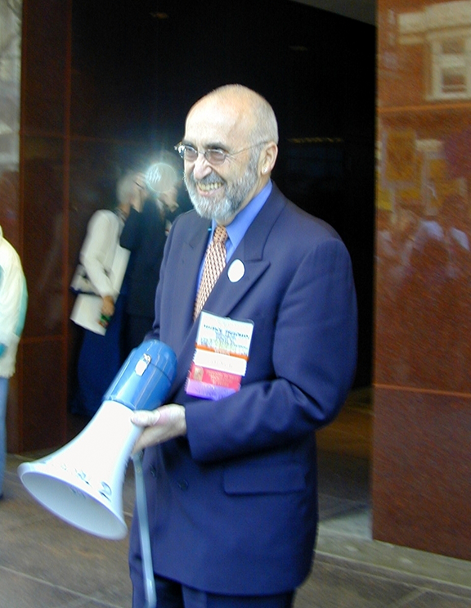
Maurice (“Mitch”) Freedman – 1939-2026

Maurice J. (Mitch) Freedman (November 14, 1939 – March 5, 2026) was an American librarian best known for his advocacy for librarians’ salaries and rights, socially responsible cataloging and library technologies, and championing the cause of intellectual freedom. He served as president of the American Library Association from 2002 to 2003.

Education
Mitch Freedman received his bachelor's degree from Rutgers University in 1961 and the Master of Library Science in 1965 from the University of California, Berkeley School of Librarianship. He was awarded the doctorate in Library and Information Studies from Rutgers University in 1983. His dissertation was: “The Functions of the Catalog and the Main Entry as Found in the Work of Panizzi, Jewett, Cutter, and Lubetzky.”

Career in Libraries and Education for Librarians
Mitch Freedman worked at the Library of Congress from 1965 to 1968 and at Information Dynamics Corp from 1968 to 1969.
From 1969 to 1974 he worked as director of the Technical Services Division at Hennepin County Library (MN). He instituted a policy of establishing non-pejorative cataloging and hired cataloger Sanford Berman to implement that policy. While at Hennepin County Library, Freedman also hired Michael McConnell after McConnell was fired from the University of Minnesota for being gay.
Freedman worked from 1974 to 1977 as coordinator of technical services for the branch libraries of the New York Public Library.
Mitch Freedman was an associate professor at Columbia University School of Library Service from 1977 to 1982 and a visiting professor at Pratt Institute; he also taught as an adjunct instructor at Rutgers University.
From 1982 to 2005, he served as the director of the Westchester Library System (NY). While there he oversaw the computerization of the catalog of library materials and fought legislation against Internet filters to limit individual access to websites. He raised the salaries of the children's and YA librarians at WLS so they would be on par with the higher paid staff roles that are more typically highly valued and paid.
After retirement from the Westchester Library System in 2005, he was interim director of several small libraries in New York, including the Nyack Library and the Pound Ridge Library. From 2013 to 2015 he served as the director for the New City Free Library.
After Marvin H. Scilken died in 1999, Mitch purchased The U*N*A*B*A*S*H*E*D Librarian from
Marvin's widow, Polly, beginning his editorship in 2000. The publication ceased in 2022.

Leadership in librarianship and Presidency of the American Library Association.

Mitch Freedman was one of the early activists in the American Library Association Social Responsibilities Round Table and a founding member of the Progressive Librarians Guild.
He was president of the American Library Association Information Science and Automation Division (later renamed the Library and Information Technology Association) from 1977 to 1978.

Before it ceased operations in 1999, Freedman was a speaker and consultant for the United States Information Agency, advising libraries around the world on collection development, resource sharing, cataloging, and other areas of library work.

He testified as a plaintiff in the 1997 lawsuit “American Libraries Association v. Pataki” challenging New York's Internet censorship law and was an outspoken critic of the 2000 Children's Internet Protection Act requiring the use of Internet filters.

In 2002-2003 Mitch Freedman ran as a petition candidate for the presidency of the American Library Association. He won that election. A political activist since his library school days at UC Berkeley during the Free Speech Movement of the early 1960s, as President Mitch hosted speakers including Barbara Ehrenreich, Amy Goodman, Naomi Klein, and Michael Moore.
During Freedman's presidency, he focused on improving library workers' salary and compensation, instituting the “Campaign for America's Librarians” and the “Task Force on Better Salaries for Library Workers” which created resources for helping library workers who wanted to address salary inequities.

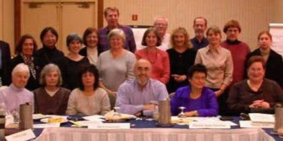
Mitch Freedman’s “Better Salaries for Library Workers Task Force “- 2002-American Library Association. Far Back Row from Screen Left: Norm Jacknis, Tom Wilding, Gene Kinnaly Center Row from Screen Left: Harriet Selverstone, Sha Fagan, Jenna Freedman, Rosemary Mesh, Joan Goddard, Donna Mandel, Carol Brey, Cathy Bremer, Yvonne Farley, Jill Uncyk Front Row from Screen Left: Mike Leber, Margaret Myers, Kathleen de la Peña McCook, 2002-2003 ALA President Maurice J. (Mitch) Freedman, Task Force Coordinator Patricia Glass Schuman, Patricia Smith

Based on the recommendations of that and other ALA committees a separate advocacy organization, the ALA/Allied Professional Association (ALA-APA), was founded in 2002.
In 1981 Mitch Freedman was honored with the Library and Information Technology Association Award for Achievement in Library and Information Technology.
He was honored with the American Library Association Joseph W. Lippincott Award in 2014.

“Mitch was an outspoken and visionary leader and a tireless advocate for better salaries and pay equity for all library workers, and for the humanistic application of technology in libraries. His contributions have had profound and lasting impact on who we are, what we do, our values, and what our work is worth. He literally changed the way librarians and library workers talk about their worth.”
– Patricia Glass Schuman

Selected Publications
Freedman, Maurice J. ( editor and publisher of The Unabashed Librarian from 2000-2022.)
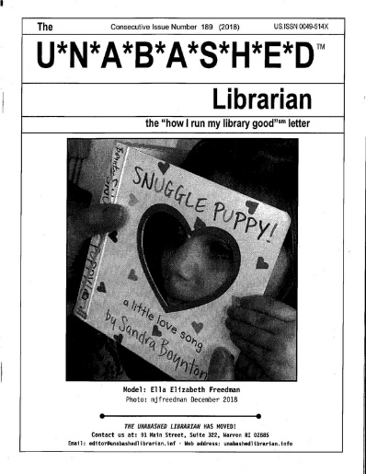

Freedman, Maurice J. 2003. “Continuity and Change for U.S. Libraries in the Digital Age: How U.S. Public and Academic Libraries Are Confronting the Challenge of the Digital Library.” Information Services and Use 23 (4): 211–26. https://doi.org/10.3233/ISU-2003-23402.
Freedman, Maurice J. 2003. “President’s Message: Mobilizing to Save America’s Libraries.” American Libraries 34 (1): 5.
Freedman, Maurice J. 2003. “President’s Message: Educating About Internet Filtering.” American Libraries 34 (3): 5.
Freedman, Maurice J. 2003. “President’s Message: Libraries, Priorities, and Telling Our Story.” American Libraries 34 (2): 5.
Freedman, Maurice J. 2003. “President’s Message: Let’s Support Equal Pay Day.” American Libraries 34 (4): 5.
Freedman, Maurice J., American Library Association Better Salaries and Pay Equity for Library Workers Task Force, Campaign for America’s Librarians, and Library Advocacy Now! Network (American Library Association). 2003. Advocating for Better Salaries and Pay Equity Toolkit. 2nd ed. Chicago, Ill.: American Library Association.
Freedman, Maurice J. 2002. “President’s Message: America’s Librarians Deserve Better Pay.” American Libraries 33 (8): 7.
Freedman, Maurice J. 2002. “President’s Message: Why Librarians?” American Libraries 33 (9): 7.
Freedman, Maurice J. 2002. “President’s Message: The Campaign for America’s Librarians.” American Libraries 33 (7): 7.
Freedman, Maurice J. 2002. “President’s Message: Now Is the Time for Better Salaries.” American Libraries 33 (11): 7.
Freedman, Maurice J. 1996. “Connection Development: Web Lessons from Westchester.” Library Journal 121 (16): 42–44.
Freedman, Maurice J., Maurice J. Freedman Associates, California Library Networking Task Force, and California State Library. 1994. A Survey of California Libraries, Archives, Museums & Historical Societies : Phase 1 Report on Bibliographic Resource Identification and Location to the California Library Networking Task Force, Network Planning Group, Bibliographic Resource Identification and Location Committee. Mount Kisco, NY: Maurice J. Freedman Associates.
Freedman, Maurice J. 1987. “Jazz Compact Discs for Your Library.” Library Journal 112 (19): 40–44.
Freedman, Maurice J. 1984. “Automation and the Future of Technical Services.” Library Journal 109 (11): 1197–1203.
Freedman, Maurice J. 1984. “Must We Limit the Catalog?” Library Journal 109 (3): 322–24.
Freedman, Maurice J. 1983. “The Functions of the Catalog and the Main Entry as Found in the Work of Panizzi, Jewett, Cutter, and Lubetzky.” Dissertation.
Freedman, Maurice J. 1982. Library Automation : Five Case Studies. New York, N.Y.: Library Journal.
Freedman, Maurice J. 1981. “Circulation Systems Past and Present.” Journal of Library Automation 14 (4): 278–85.
Freedman, Maurice J. 1979. “Opening a Library Catalog.” Library Journal 104 (19): 2277–80.
Freedman, Maurice J., S. Michael Malinconico, and American Library Association Information Science and Automation Division. 1979. The Nature and Future of the Catalog : Proceedings of the ALA’s Information Science and Automation Division’s 1975 and 1977 Institutes on the Catalog. Phoenix, AZ: Oryx Press.
Freedman, Maurice J., American Library Association’s Information Science and Automation Division, Catalog: Its nature and prospects, and Catalog in the age of technological change. 1979. The Nature and Future of the Catalog : Proceedings. London.
Freedman, Maurice J. 1977. “Public Libraries, the Library of Congress, and the National Bibliographic Network.” Library Journal 102 (19): 2211–15.
Freedman, Maurice J. 1976. “Automated Network Catalog Products and Services.” Journal of Library Automation 9 (2): 145–55.
Freedman, Maurice J. 1976. “Processing for the People.” Library Journal 101 (1): 189–97.
Freedman, Maurice J. 1976. “The Catalog: Its Nature and Prospects.” Library Journal 101 (4): 594–95.

Sources
Maurice J. (Mitch) Freedman Papers, 1996-2005 | The American Library Association Archives
Digital copies from the papers of Maurice J. (Mitch) Freedman, President (2002-03), includes articles, correspondence, interviews, photographs, reports, and speeches concerning administrative duties, affiliated professional organizations, conference logistics, election and inaugural activities, legislative advocacy and issues. Correspondents include Sanford Berman and Patricia Schroeder. Also included are materials for: ALA annual and midwinter conferences (2001-04), Better Salaries Task Force, Campaign for America's Librarians, Cuban libraries and librarians, IFLA conferences (2001-03), Iraqi libraries, media advocacy and training, Palestinian libraries, regional and state library association meetings, ALA policy on torture, and USA PATRIOT Act.
Carol Brey-Casiano. The Better Salaries Effort. Library Worklife February 2004.
Campaign for America’s Librarians Advocating for Better Salaries and Pay Equity Toolkit. January 2003.
Freedman, Maurice J. (Mitch), Ken Haycock, and William Sannwald. 2001. “Meet the Candidates for ALA President: Vote in the Election This Spring.” College & Research Libraries News 62 (3): 310–17. https://doi.org/10.5860/crln.62.3.310.
WorldCat

--Submitted by Patricia Glass Schuman

