Blane Dessy (1951-2026)

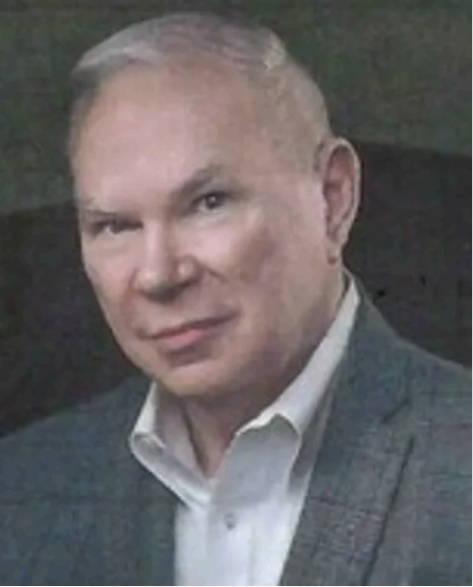
Blane Dessy, 74, well-read and well-loved, entered into the great archive of the universe on the morning of March 14, 2026. Genetically predisposed on his mother’s side to safeguard the English language, Blane lived the lifestyle of a librarian—organized, efficient, and unafraid of curating the voices and art surrounding him. He loved lists and stayed current on everything pop culture from Star Trek and Doctor Who to MTV. It was not uncommon to encounter neatly stacked papers arranged by topics in islands on his desk and dining room table.
He was born in Pittsburgh to Rita Keenan Dessy, whom he dearly loved, and, upon receiving a Bachelor’s in English from Indiana University of Pennsylvania and a Master’s in Library Science from the University of Pittsburgh, built libraries and the communities surrounding them at the local, state, and federal levels across Pennsylvania, Ohio, Oklahoma, Alabama, and Washington, D.C. He served as the Director of Federal Enterprises with the Library of Congress, the Director of Libraries for the Department of Justice, and the Founding Director of the National Library of Education before retiring to Erie in 2018 and serving as the Director of the Erie County Public Library. Here, in returning to PA, he felt his life had come full circle—he began his career in the Juniata County Library.
Blane often found ways to lift the voices of writers and artists through education and advocacy. During his attempt at retirement, in response to the warm embrace he felt from the Erie Community, he became an architect of the Arts in Erie, launching NWPA Poetry and working closely with the Rotary, Erie Arts and Culture, the Erie Community Foundation, and others. He commissioned an annual Anthology of Erie Poets and worked behind the scenes to elevate Erie-based art and literature. Holding education in high esteem in both his personal and professional life, he taught Library Science at the Catholic University of America in Washington, D.C., and later became the first employee and founding member of the Erie County Community College. He never forgot his alma mater, serving as a founder and advisor for the Dessy-Roffman Myth Collaborative at IUP. Director Sean McDaniel describes the Collaborative as “a living forum where scholars, artists, and students explore the enduring power of myth.”
Blane’s curatorial nature and love of art, music, dance, and literature led to the development of a Bibliography of Erie Literature and collections of books, chapbooks, and signed copies of work from around the world. His daughter, Adrienne Burke, says, as a child, he often gifted her signed copies of children’s books to read. Blane sometimes arrived to meetings of NWPA Poetry with chapbooks bound in nontraditional methods. There was a magical quality in his ability to procure and support lesser visible work by writers and artists, and his eclectic collections of music included Steely Dan (especially the side projects of Donald Fagan) and Shakira.
In addition to Adrienne, Blane leaves behind his husband Randal Eric Shannon, his brothers Tom and Kevin, and the arts and literary communities for whom he served as a heartbeat. His untiring selflessness was apparent in his care for his two cats, Tigger and Boo Boo Kitty, and in every conversation until his final breath. His kindness and untiring devotion to people and culture will serve as a foundation for Erie arts and literature moving forward. He asked that people remember him from their last interaction, from the last moment they witnessed the rhythmic benevolence and dry wit flowing from his lips.
There will be a celebration of life held for friends and family sometime in the coming weeks. In lieu of gifts, please donate to the Foundation for Indiana University of Pennsylvania, the Erie Community Foundation, and the Sarah A. Reed Children’s Center.
Arrangements are under the care of the Burton Quinn Scott Cremation and Funeral Services, Inc. 602 W. 10th Street, Erie, PA 16502.
Send condolences at www.BurtonQuinnScott.com

