Fr. Simeon Daly (1922-2012)

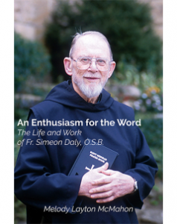

“ He was a seminal figure in the history of ecumenism in theological librarianship.”

Fr. Simeon Daly, OSB, monk and priest of Saint Meinrad Archabbey, St. Meinrad, IN, died on November 10, 2012, in the monastery infirmary. He was 90. He was a president of the American Theological Library Association 1979-1981.
Fr. Simeon was born in Detroit, MI, on May 9, 1922, to Philip and Marguerite (Ginzel) Daly, and received the name Philip John at his baptism.
After his elementary education, he enrolled in the minor seminary at Saint Meinrad. Invested as a novice in 1943, he professed his simple vows on August 10, 1944, and was ordained to the priesthood on May 18, 1948. The monks live by the wisdom and guidance of the Rule of St. Benedict, the sixth-century instructions for community living written by St. Benedict.
Fr. Simeon was appointed assistant librarian of the Archabbey Library in 1949, and that year received an STL degree from The Catholic University of America, Washington, D.C. Two years later, he received a Master of Science degree in library science.
On August 16, 1951, he was named head librarian, a position he held for 49 years. The abbey is named for the monk St. Meinrad of Einsiedeln, who died in 861. It is one of only two archabbeys in the United States and one of 11 in the world.

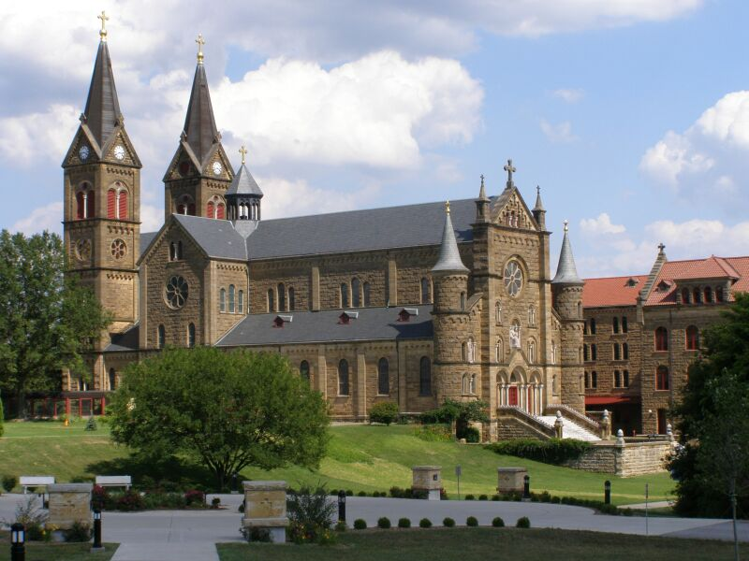

He was a member of various library associations, including the American Theological Library Association, serving as president from 1979 to 1981. He was the first Roman Catholic president of the American Theological Library Association (ATLA) and the first Executive Secretary of ATLA. He was a seminal figure in the history of ecumenism in theological librarianship.
Fr. Simeon was instrumental in the planning of Saint Meinrad’s new library, dedicated in 1982. He also served as the monastery’s master of liturgical ceremonies during the 10 years preceding, during and following the Second Vatican Council.
He was chair or a member of the monastery’s Liturgical Committee for many years, and he served as subprior (third in leadership) from 1975 to 1978.

Publication

Fr. Simeon was the author of Finding Grace in the Moment: Stories and Other Musings of an Aged Monk, published in 2005.
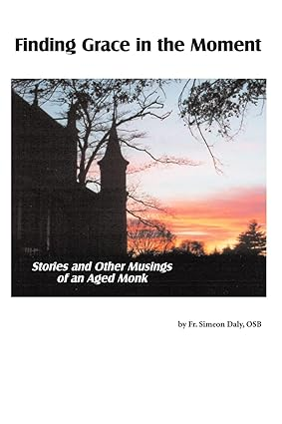

Finding Grace in the Moment is a collection of Fr. Simeon's writings all filled with the insight and wisdom learned from his lifetime journey as a monk and a lover of the written word. The collection includes personal stories, homilies, and reflections on life in the monastery. With joy, wonder and humor, this Benedictine monk and priest shares stories about his family and friends, his brother monks, and his musings on topics as varied as his door, church bells and chance meetings.

Sources
Melody Layton McMahon. An Enthusiasm For The Word: The Life And Work of Fr. Simeon Daly, O.S.B.
A Benedictine Monastery Saint Meinrad Archabbey
Saint Meinrad Archabbey (intro to the Abbey)
Fr. Simeon Daly, OSB - Saint Meinrad Alumni
Fr. Osb Obituary (2012) - St. Meinrad, KS - Courier Press
Fr. Simeon Daly, 90, St. Meinrad | Obituaries | duboiscountyherald.com

