Charles Brown (d.2020)

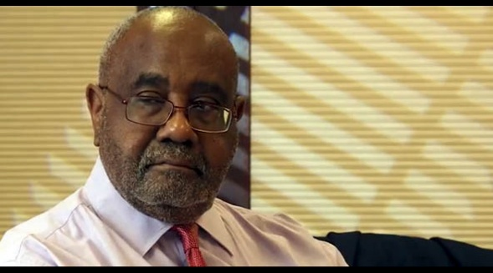

Charles Brown, who unselfishly dedicated many years of service to the American Library Association, the Public Library Association, and the library world at large, with great distinction and success passed on February 15, 2020.
Charles Brown enriched the public library community through his tireless service as a library director, bringing his outstanding leadership to the following communities, during his 50+ year career which encompassed the following communities:

• NEW ORLEANS PUBLIC LIBRARY – 2011-2019
• CHARLOTTE MECKLENBURG LIBRARY – 2004-2011
• HENNEPIN COUNTY LIBRARY – 1994-2004
• ARLINGTON COUNTY LIBRARY – 1986-1994
• SOLANO COUNTY LIBRARY – 1983-1986;

Charles Brown demonstrated the spirit of public service by serving as President of the Public Library Association (1990-1991); and by serving on the ALA Executive Board, ALA Council, and the Executive Board of the Black Caucus.

He worked energetically on many committees of the organizations including:
• PLA Founding Donors
• PLA Endowment Task Force
• PLA National Conference Committee
• ODLOS Minority Fellowship Advisory Committee
• ALA Board Finance and Audit Committee
• Nominating Committees

Charles Brown worked determinedly in the communities where he served and was a popular and noted speaker at library conferences in the U.S. and abroad
Friends and colleagues appreciated his leadership, friendship, ideas, and good humor during his life of outstanding service and extraordinary contributions to public librarianship and to the communities he served.

Sources
Berry, J. N., & Rawlinson, N. K. (1991). What makes PLA run? LJ interviews executive director Joey Rodger and president Charles Brown. Library Journal, 116(4), 43–45.
Brown, Charles | American Libraries Magazine
RESOLUTION HONORING THE MEMORY OF CHARLES BROWN American Library Association Council, June 27, 2020.

Submitted by Susan Hildreth

