Susan E. Brandehoff – 1946- 2025.

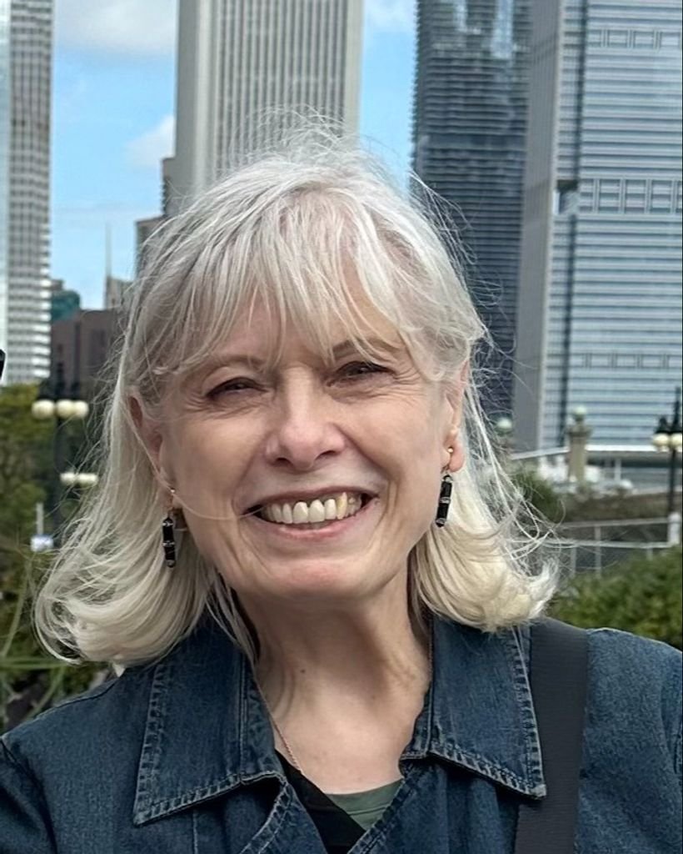

Susan E. Brandehoff of Chicago, passed away on May 4, 2025. She was born in Delphos, OH on Oct. 15, 1946, to Romus S. and Carolyn R. (Dukes) Brandehoff.

Susan was a 1964 graduate of Delphos St. John's and received her B.S. and M.S. degrees from the University of Illinois, Urbana-Champaign.

She spent most of her career with the American Library Association in Chicago, beginning as managing/executive editor of "American Libraries" magazine.
She later was director of Program Development and Partnerships for the Public Programs Office of ALA and was Project Director for many national projects including StoryLines America: A Radio/Library Partnership Exploring Our Regional Literature with a grant from the National endowment for the Humanities - 1998-2001. The project supported a series of reading and discussion programs about regionalism and American identity via talk show radio broadcasts and at libraries in California, Florida, Georgia, North and South Carolina, and Virginia.

Her career also included time in Hong Kong as managing editor of "Arts of Asia" magazine. Susan loved to travel and was a lifelong learner.
A donation to your local library is a wonderful way to remember Susan.

Selected Publications

Brandehoff, S. E. (2001). “Go figure!” exhibit brings kids and calculations together. American Libraries, 32(11), 60–61.
Brandehoff, S. E. (2000). Libraries team up with Bill Moyers to tackle tough end-of-life issues. American Libraries, 31(8), 96–97.
Lomax, G. L., & Brandehoff, S. E. (1998). StoryLines America joins libraries and public radio in smash kick-off. American Libraries, 29, 88–90.

Brandehoff, S. E. (1997). Turning libraries into cultural centers. American Libraries, 28, 41–43.
Brandehoff, S. E. (1987). Pupil success firmly linked to school library funding. American Libraries, 18, 632–633.
Brandehoff, S. E. (1987). A library Zoo story: rural library’s lending saga shows reach of ILL. American Libraries, 18, 108.
Brandehoff, S. E. (1986). Librarians get salary hikes after strike at Wayne State. American Libraries, 17, 744–745.
Brandehoff, S. E. (1985). Spotlight on women managers. American Libraries, 16, 20.
Brandehoff, S. E. (1985). Indianapolis PL finds gold beneath the grime of decades. American Libraries, 16, 480–481.
Brandehoff, Susan. “The Cutting Edge.” American Libraries 14, no. 10 (1983): 672–75.

Sources
StoryLines America: A Radio/Library Partnership Exploring Our Regional Literature (Part II: California and the SE), ALA (Chicago, IL 60611-2729). Susan E. Brandehoff (Project Director: January 1998 to October 2001)
To support a series of reading and discussion programs about regionalism and American identity via talk show radio broadcasts and at libraries in California, Florida, Georgia, North and South Carolina, and Virginia.

Susan Brandehoff Obituary (2025) - Delphos, OH - The Delphos Herald

Submitted by Deb Robertson

