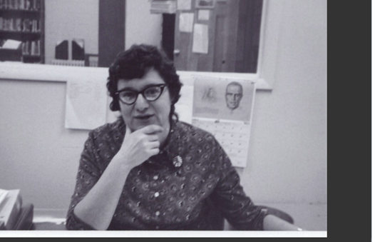
During my brief and only time away from public libraries, I had the great good fortune to work for Florence Beer as the night school librarian for the Syracuse Educational Opportunity Center (EOC).
Florence started her working life as a social worker in Pittsburgh and the influence of those experiences was embedded in her philosophy of library services. She received her MLS from the University of Pittsburgh and moved with her family to Syracuse, New York. Around 1970 she was hired to be the librarian for the EOC, she built the library from a few books in a cinderblock room to a real school library for an adult education program that could serve students and enhance classroom instruction. The core of the collection was books, but Florence recognized that students needed media and mixed media to supplement reading and get excited about course content. The students were in high school equivalency, English for speakers of other Languages, and college preparatory classes, coming for a second chance at education. With Florence’s support they often found comfort in the school library, Florence was a wonderful listener. She was also a great problem solver and met information needs to help with childcare, transportation, housing, and other stressful situations that stood in the way of learning.
Although I only worked with Florence for a short time in the 1980s, she and her husband Sylvan became lifelong friends and influencers. She was a remarkable woman who lived the values of equity, diversity, and inclusion. She was a champion of learning and her work proved that libraries do change lives.
Florence was an eclectic learner herself and accomplished sculptor. She loved the Yiddish language, the culture and religion of modern Judaism, cooking, gardening, and her husband and two children. Sculpture played an increasingly important part in her life, and she enjoyed her studio space where she could create art privately and then share completed pieces with others.
https://obits.syracuse.com/us/obituaries/syracuse/name/florence-beer-obituary?id=28202276

