Gordon Baker - 1954-2025



In 2019, Dr. Baker was recognized as the 2019 Georgia Public Library Champion of the Year by the Georgia Public Library Service. The award “is presented to an outstanding advocate who is not employed by a public library, but whose support significantly raised the profile of libraries and improved services.” Dr. Baker has been described as “Mr. Library for the State of Georgia. As a Trustee and board chair of the Henry County Public Library, he guided the board through tumultuous times with serious funding challenges.”
--- Julie White Walker, The State Librarian of Georgia

Dr. Baker’s profound influence and commitment to the library profession extended beyond formal titles, earning him the affectionate moniker “Mr. Library” in Georgia, and the admiration of colleagues and friends throughout Georgia, the Southeast, and the nation.
---American Library Association Memorial Resolution, June 30, 2025

Gordon Baker was known as a champion for libraries and for his unwavering love and dedication to his family and friends
Born on June 30, 1954, in Atlanta, Georgia, Gordon was a native of Henry County, attended Henry County public schools and graduated from Stockbridge High School in 1971. Gordon’s passion for education was set by his parents’ examples. His mother, Mary, was a classroom teacher for 30 years and his father, Howard, worked in education for over 34 years serving as a teacher, principal and superintendent.
Gordon graduated from Clayton Junior College (now Clayton State University) in 1973 with an Associate of Arts in Education. He completed his undergraduate studies at Valdosta State University with a Bachelor of Science in Elementary Education and a minor in Library Science in 1975. He received both a Master of Science in Library Service (1978) and Specialist of Library Service (1981) from Clark Atlanta University. He received his Doctor of Education in Educational Leadership from Nova Southeastern University in 1997.

Georgia School Library Career
He began his career in education in Spalding County as a teacher and assistant librarian at Beaverbrook Elementary School in Griffin. He served as an elementary teacher at Morrow Elementary School and then library media specialist at Kilpatrick Elementary School in Clayton County. In 1983, he was appointed as the media specialist for the newly established Edwin Kemp Elementary School in Clayton County. This was the first school in Clayton County to pilot an automated (computerized) circulation system.
In 1989, he became the library/media specialist at Henry County Junior High School in McDonough. In 1989, Gordon was appointed as the library/media specialist at Eagle’s Landing High School in McDonough, which was the first new high school established in Henry County in 25 years. He remained at ELHS for ten years, overseeing the school’s library/media program and implementing the new technologies in the building. In 2000, he was assigned the responsibility of inaugurating Union Grove High School. In 2001 he became the Coordinator of Instructional Technology & Media Services for the Henry County School System, a role he held for two years before moving to Luella High School in 2003. He retired from the Henry County School System on June 30, 2004.
During his tenure with the Henry County Schools, he coordinated the Henry County Spelling Bee for over 10 years as well as the Henry County Student Media Festival for seven years. In addition Gordon assisted with the Helen Ruffin Reading Bowl for many years and hosted it at Clayton State University during his tenure as Dean of the Library.

Clayton University Career
Starting in 1979, Gordon worked part-time as a reference librarian at Clayton State University. After retiring from Henry County in 2004, Baker assumed the role of Head of Public Services at the Clayton State Library. In June 2006, he became Director of Libraries at Clayton State University and was promoted to Dean in 2010. In May 2019, Gordon retired as Dean of Libraries at Clayton State University with 40 years of service to the University. He was the first person to have worked at Clayton State for 40 years. He has been given the title of Dean of Libraries, Emeritus.

Professional Service

Dr. Gordon Baker served as President of the American Library Association’s United for Libraries Board of Directors, and as Chair of that Committee he introduced and interviewed Connie Chung at the ALA National Convention in 2024. United for Libraries mourns the loss of Dr. Gordon Baker, who passed on June 7, 2025. Gordon was first appointed to the position of Trustee at Large in 2018 and elected to a three-year Trustee at Large position in 2019. In 2021, he was elected president-elect and served as United’s first two-year term President from 2022-2024. He continued to serve United for Libraries in 2024-2025 as Friend at Large and Immediate Past President.
President of the Southeastern Library Association
Gordon was a member of the Georgia Library Association since 1977 serving in many roles including President, advisor to the president and historian. He was honored by the Georgia Library Association with an honorary lifetime membership.
Beta Phi Mu, International Library and Information Studies Honor Society, Gordon serving as National Director and as a Scholarship Committee Member.
Dr. Baker served as state adviser of the Georgia Association of Media Assistants for approximately 25 years. This association is composed of school library, media, and technology students in grades 5-12.
He worked with the Georgia Student Media Festival since 1978. In addition to serving as a system festival chair, he also served as district and state festival chair serving as the state chair five times.
He served as a member of the Henry County Library System’s Board of Trustees serving as Board treasurer from 2000-2004 and chair of the Board of Trustees from 2005-2018.
Friends of Georgia Libraries.
Even in retirement to Savannah, Dr. Baker held up his hand to volunteer to become a trustee at Live Oak Public Libraries, which he held until his death.

Honors and Awards

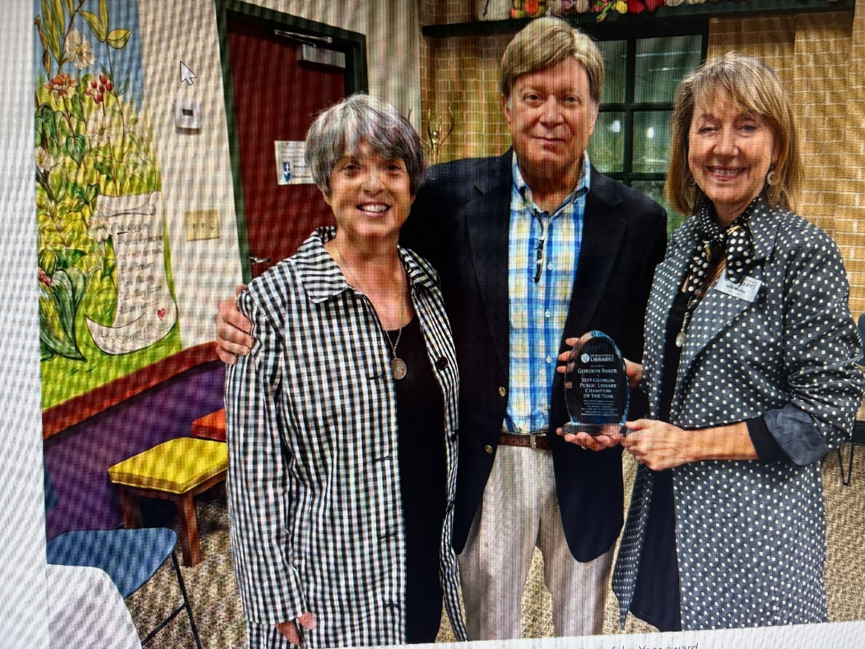
Dr. Baker receiving the 2019 Public Library Champion of the Year award. Pictured left to right: Director of PINES Elizabeth McKinney, Dr. Gordon Baker, and State Librarian Julie Walker.

Dr. Gordon Baker is the only person to have served as president of each of the three library/media/technology associations in Georgia. He has been recognized by each of these organizations with their highest awards
- President of the Georgia Library Media Association in 1982-83; William E. Patterson Award (GLMA)
- President of the Georgia Association for Instructional Technology in 1995; Walter S. Bell Distinguished Service Award (GAIT); Juanita Skelton Distinguished Service Award (GAIT)
- President of the Georgia Library Association during 2002-2003. the Nix-Jones Award (GLA), and the Bob Richardson Award (GLA); Georgia’s Elementary School Media Specialist of the Year by the Georgia Library Association in 1986.
Hal Mendelsohn Award- Southeastern Library Association

Sources

Gates, Crystal (2025) "In Memory of Dr. Gordon N. Baker: A Life of Service, Leadership, and Love for Libraries," The Southeastern Librarian: Vol. 73: Iss. 2, Article 5. DOI: https://doi.org/10.62915/0038-3686.2144 Available at: https://digitalcommons.kennesaw.edu/seln/vol73/iss2/5
Hoffman, Ashley T. Remembering Dr. Gordon Baker Ashley T. Hoffman. Georgia Library Quarterly 62 (4) 2025.
Sarah Trowbridge | Georgia Library Service |Jun 11, 2025 Honoring Gordon Newton Baker, 1954-2025 | GLS
Memorial Resolution Honoring Dr. Gordon Baker.pdf American Library Association Council. June 30, 2025
Dr. Gordon Baker–United for Libraries Profile
Georgia Public Library Service Facebook Tributes
Gordon Newton Baker Obituary. June 30, 1954 - June 08, 2025.

Submitted by Kathleen de la Peña McCook

