John Ellison -1941-2018

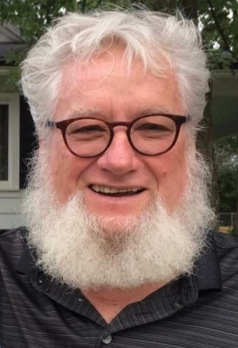

John William Ellison, associate professor emeritus of information and library studies and a pioneer in the field of distance learning, died September 11, 2018.

During a 38-year career at the University at Buffalo John Ellison taught in the master’s program in the Department of Information and Library Studies and was the first faculty member at UB to deliver long-distance education via the internet. Recognized for his research in intellectual freedom and media study, he produced more than 100 publications and media productions.

While serving as a Fulbright Fellow at the University of the West Indies in Kingston, Jamaica, in 2000, Ellison installed the region’s first distance-learning WebBoard online at the university, which placed UWI in a position to vastly increase the number and quality of its distance-learning programs.
He retired from UB in 2008.
A native of Darke County, Ohio, Ellison received a bachelor’s degree from Morehead State University, a master’s in education from Xavier University, an education specialist degree from Southern Illinois University and a PhD from The Ohio State University.
He worked as a librarian in public, school, medical and university settings, and taught in various academic departments at a number of universities in addition to UB, including Wright State University, Central Michigan University, University of Kentucky, Emory University, Sam Houston State University, University of Oklahoma, University of Illinois, University of the West Indies and Cape Coast University in Ghana, West Africa.
Colleagues note Ellison “loved the profession of library information science and media. He valued original thinking, bold action, confidence and truth. He will be greatly missed.”
Ellison was respected and loved by his students as well.
“He mentored me and many others as few others could have done. I never forgot the presence he was in my life … I would not have been able to achieve, thrive nor had the successes I did enjoy without his guidance and wisdom, which instilled in me the skills, abilities and confidence necessary to do so,” a former student recently wrote about Ellison.

Selected Publications

Ellison, J. W. (2000). Distance learning for today’s librarian. Library Review, 49(5), 240–242.
Ellison, John William, and Patricia Ann Coty. 1987. Nonbook Media : Collection Management and User Services. Chicago: American Library Association.
Ellison, John William, ed. 1985. Media Librarianship. New York: Neal-Schuman Publishers.
Ellison, J. W. (1982). Factors that determine effective library displays. Catholic Library World, 53, 374–376.
DiFelice, C., Ellison, J. W., & Ellison, J. W. (1983). Analysis of non-print media courses: a summary. Journal of Education for Librarianship, 23, 307–310.
Ellison, J. W., & Ellison, J. W. (1982). Non-book collections: storage and care practices. Catholic Library World, 54, 206–209.
Ellison, J. W. (1980). What are media librarians? Catholic Library World, 52, 233–234.
Sandner, Fred, John William Ellison, Gloria S. Gerber, and Susan E. Ledder. 1979. A Bibliography on the Storage and Care of Non-Book Materials in Libraries with Selected Annotations. Arlington, Va.: ERIC Document Reproduction Service.

Sources

"In Memory: John William Ellison," American Libraries 50, no. 1 (2019): 79.
John William Ellison. Graduate School of Education. University at Buffalo. The State University of New York. September 19, 2018

John William Ellison. Obituary.

