Terry Weech (1937-2025)

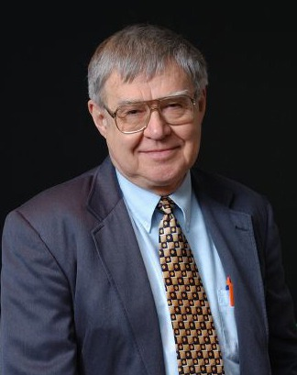

Dr. Terry Weech graduated from Knox College in Galesburg, where he majored in philosophy. He obtained the master’s degree in library science from the University of Illinois in 1965.
He was Documents Librarian, Illinois State Library, 1964-1967.
He received his PhD from the University of Illinois in 1972 and was also recognized as an HEA Fellow. His dissertation was: "State Governments and Publishers, an Analytic Study of State Publications."
Dr. Weech was head of the Library Science Department at the Mississippi University for Women in Columbus, Miss. 1973-1976. and an assistant professor in the School of Library Science at the University of Iowa in Iowa City 1976-1980.
In 1980 he became Associate Professor, Graduate School of Library and Information Science, University of Illinois, Urbana where he taught for over 40 years.
From 1998 -2010 he taught internationally:
- 1998. Financial Management of Libraries at the International Centre for Information Management Systems and Services at Copernicus University, Torun, Poland.
- 2009: Use and Users of Digital Libraries for DILL (Digital Library Learning – A European Union international Project) . The University of Parma, Parma, Italy.
- 2010: Digital Library Collection Development for DILL (Digital Library Learning – A European Union international Project) The University of Parma, Parma, Italy.

Dr. Weech's research focus was international librarianship, library and information science education, collection development, management and assessment of library services, government information resources, economics of information, intellectual freedom issues and public librarianship.
He traveled extensively, participating in American Library Association and International Federation of Library Associations and Institutions conferences, around the world, but primarily in Eastern Europe. He was Secretary of the International Federation of Library Associations (IFLA) Section on Education and Training and Chair of the IFLA Division on Research and Education, 2001-2003.
He received Fulbright Senior Specialist Award to lecture in Ljubljana, Slovenia, at University of Ljubljana and the National and University Library of Slovenia. March 15-29, 2002.
Dr. Weech was honored with a Scroll of Appreciation from the International Federation of Library Associations and Institutions (IFLA) for his distinguished contribution to the association and the library profession, especially in the internationalization of LIS education. As an active IFLA member, he wrote or co-wrote many research reports and gave lectures on librarianship and library science education in over thirty countries across Europe, Asia, Africa, North America, and South America. Weech received more than five Fulbright Senior Specialist and similar funded awards for international travel to share his expertise with students, faculty, and practicing librarians.

Terry and his wife, Eunice Weech, established an Intellectual Freedom Endowment Fund at the University of Illinois Foundation to advocate and educate for Intellectual Freedom.

Selected Publications

Weech, Terry (2016) IFLA Efforts to provide Standards for International Library and Information Studies Education: The Role of the IFLA Section of Education and Training – A Case Study. Paper presented at: IFLA WLIC 2016 – Columbus, OH – Connections. Collaboration. Community in Session 144 - Committee on Standards. http://library.ifla.org/id/eprint/1441

Weech, Terry and Chinyere Erondu (2011). “The iSchool Movement – What does it mean for the New Information Professional?” presented at Bobcatsss 2011, University of Western Hungary, Szombathely, Hungary, January 31-February 2, 2011. Published in Proceedings of Bobcatsss 2011.

"Information Ethics Education for Librarians in a Networked Society" with Angela Maycock. in Information, Innovation, Responsibility: The Information Professional in the Networked Society, Proceedings of the 14th Bobcatsss Symposium, Tallinn, Estonia, 30 January-1 February, 2006. pp. 178-187.
"Education for Digital Librarianship" in Information Resources and Library Services in the Electronic Environment: Proceedings of the Professional Conference of the 9 Union of Associations of Slovene Librarians. Ljubljana, Slovenia. October, 2005. p. 217-265.
"Globalization and Cooperation Concepts in Library & Information Science Curricula" in Libraries, Globalization and Cooperation, Papers from the International Conference held in Sofia, Bulgaria, November 3-5, 2004. University of Sofia, Sofia, Bulgaria, 2005. pp. 37-42.

"LIS Education and Multidisciplinarity — Enhancement or Disintegration: an Exploratory Study," with Marina Pluzhenskaia. Journal of Education for Library and Information Science 46, No. 2 (Spring, 2005) pp. 154-164.
"The Teaching of Economics of Information in Schools of Library and Information Science in the U.S." Published as a Contributed Paper in Proceedings of the 57th Annual Meeting of the American Society for Information Science, October 17-20, 1994, Alexandria, VA.

"Intellectual Property Rights from an International Perspective," (with Avishag Gordon, Haifa, Israel.) International Journal of Information and Library Research. 3 (No. 1, 1991): 57-65.

"The Use of Government Publications: A Twelve-Year Perspective," (with Beth Postema, Reference Librarian, Fargo (ND) Public Library) Government Publications Review 18 (May/June, 1991): 223-238.
"Per Capita Grants and Illinois Public Library Standards: An Analysis of Perceptions and Attitudes," Library and Information Science Research 10 (April-June 1988): 133-156.

"The Characteristics of State Government Publications, 1910-1969" In Government Publications: Key Papers, edited by Bernard Fry and Peter Hernon. New York: Pergamon Press, 1981, pp. 499-522. (Reprint of 1973 article selected for "Key Papers" series.)

Terry was an encouraging colleague always ready to discuss the future of library education when we taught together at the University of Illinois from 1980-1983. I last saw him with Katharine J. Phenix, an Illinois graduate, at the American Library Association Conference where he organized the University of Illinois Downs Intellectual Freedom Award Reception in Atlanta, 2017.
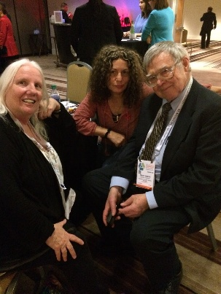

Sources

Weech passes away. University of Illinois. June 12, 2025.

Terry Weech Obituary (1937 - 2025) - Staunton, VA - The News-Gazette

Submitted by Kathleen de la Peña McCook

