Alphonse F. Trezza (1920–2009)

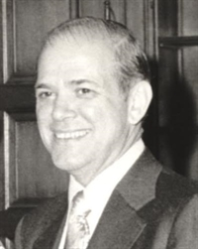

Alphonse F. Trezza (1920–2009) was a prominent American librarian, educator, and advocate for library systems and information science. He played a pivotal role in advancing library cooperation and resource sharing in the United States, particularly through his leadership in state and national library organizations.
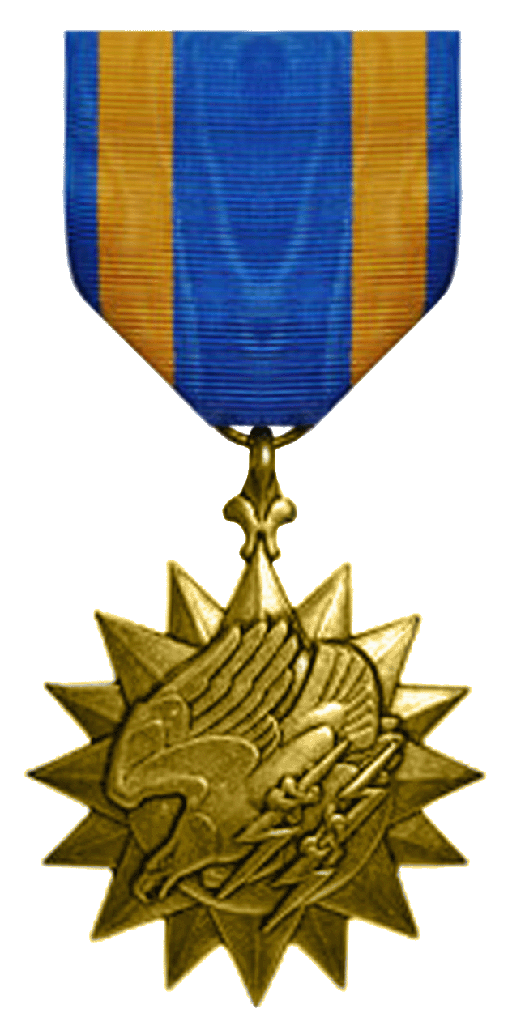
During World War II, Trezza served in the United States Army Air Forces (later the Army Air Corps) from 1942 to 1946, achieving the rank of First Lieutenant. He was assigned to the 70th Troop Carrier Squadron within the 433rd Troop Carrier Group, under the 5th Air Force. His service took him to the Pacific Theater, including the Philippines, where he participated in troop transport operations. For his valor, Trezza was awarded the Air Medal with clusters. His experiences during the war are documented in the Library of Congress's Veterans History Project.

Education and Career

After the War he earned an undergraduate degree at the University of Pennsylvania and the Drexel Graduate School of Library Science, where he was recognized as an Outstanding Alumnus in 1963.
During his studies he worked as a library assistant at the Free Library of Philadelphia, 1948-1949; as cataloger and assistant reference librarian at Villanova University, 1949-1950 as instructor, Villanova University, 1956-1960; as head of the circulation Department, University Pennsylvania Library, 1950-1956; and as lecturer, Drexel Institute School Library Science, 1951-1960.
He was Executive Director of the Catholic Library Association and editor of the journal, Catholic Library World, 1956-1960 where he focused on enhancing library services within religious and educational contexts.
He then moved to the American Library Association (ALA), first as executive secretary of its Library Administrative Division (now the Library Leadership and Management Association) and later as associate executive director.
From 1970 to 1975, Trezza was director of the Illinois State Library, a period marked by significant innovation.
He fostered resource sharing among libraries and oversaw the establishment of multi-type cooperative library systems, which integrated public, academic, school, and special libraries.
His work in Illinois emphasized interlibrary cooperation, funding strategies, and expanding access to information. He was Chairman Chief officers State Library Agencies (COSLA) in 1973-1974.
Trezza's national impact grew when he became executive director of the U. S. National Commission on Libraries and Information Science (NCLIS) in the mid-1970s.
He was instrumental in planning the first White House Conference on Library and Information Services in 1979, which shaped federal library policy and promoted a national information infrastructure.
His leadership at NCLIS addressed issues like library funding, automation, and information access for underserved populations.
He was director of the intergovernmental library, Cooperation Project Federal Library Committee/Library of Congress, Washington, 1980-1982.
In 1982, Trezza joined the faculty of Florida State University's School of Library and Information Studies as a professor, a position he held until his retirement in 1993, when he was granted Professor Emeritus status. He was Member planning and steering committee Florida Governor's Conference on Library and Information 1988-1991.

Professional Associations
- National chairman Catholic Book Week, 1954—1956.
- Illinois Library Association: chairman legislation-library development committee 1964-1969, member executive board.
- President, Chicago Library Club -1969.
- American Library Association Executive Board, 1974-1979; council 1973-1982, 88-92. chairman nominating committee 1988-1989, member legislation committee 1989-1991.
- Florida Library Association: Board of Directors 1987-1993, President 1991-1992, intellectual freedom committee, Florida Libraries publication, editor.
- Association Library and Information Science Education (government relation committee 1985-1987).
- International Federation Library Associations and Institutions (statistics standing committee 1976-1985, planning committee).

Awards and Honors
Trezza's contributions were widely recognized.
From the Illinois Library Association: Special Librarian’s Citation in 1965 and the Librarian’s Citation in 1974.

The American Library Association honored him with:
- Exceptional Achievement Award from the Association of Specialized and Cooperative Library Agencies in 1981.
- Joseph W. Lippincott Award in 1989.
- Honorary Membership in 2007

He received a Doctorate of Humane Letters (Honoris Causa) from Rosary College (now Dominican University) in River Forest, Illinois.
Posthumously, he was inducted into the Illinois Library Association's Illinois Library Luminary Honor Roll in 2011 for his pioneering work.

Publications

Trezza, A. F. (1972). Library buildings. ALA Editions.

- Trezza, A. F. (1974). Library General Information Survey (LIBGIS) state participation and development (Final report). U.S. Office of Education, Dept. of Health, Education, and Welfare.

- Trezza, A. F. (1974). Relationship and involvement of the state library agencies with the national program proposed by NCLIS (National Program for Libraries and Information Services, Related paper no. 1). National Commission on Libraries and Information Science.

- Trezza, A. F. (1979). Federal funding alternatives: A theme conference summary. National Commission on Libraries and Information Science.

- Trezza, A. F. (1982). Toward a federal library and information services network: A proposal (A report of the Intergovernmental Library Cooperation Project). Library of Congress.

- Trezza, A. F. (Ed.). (1985). Public libraries and the challenges of the next two decades. Libraries Unlimited.

- Trezza, A. F. (Ed.). (1987). Not alone--but together: A conference on multitype library cooperation. Florida State University.

- Trezza, A. F. (Ed.). (1989). Changing technology: Opportunity and challenge. G. K. Hall.

- Trezza, A. F. (Ed.). (1989). Effective access to information: Today's challenge, tomorrow's opportunity. G. K. Hall.

- Trezza, A. F. (Ed.). (1990). Commitment to service: The library's mission. G. K. Hall.

- Trezza, A. F. (Ed.). (1991). Issues for the new decade: Today's challenge, tomorrow's opportunity. G. K. Hall.

- Trezza, A. F. (Ed.). (1992). The funding of public and academic libraries: The critical issue for the '90s. G. K. Hall.

- Trezza, A. F. (Ed.). (1993). Lifelong learning: An imperative in today's society. G. K. Hall.

- Trezza, A. F. (Ed.). (1997). The library marketplace: A dialogue for librarians, publishers, and vendors. G. K. Hall.

Sources
Illinois- Library Luminary
Alphonse Trezza—State Agency Iron Duke.” American Libraries (Chicago, Ill.) 1973: 477–478.
Sullivan, P. (2009). A Tribute to Al Trezza. American Libraries, 40(3), 36–37.
Alfonse F. Trezza. Obituary.

Submitted by Kathleen de la Peña McCook

