Elizabeth W. Stone (1918 -2002)

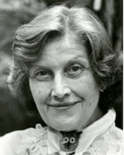

Elizabeth W. Stone (June 21, 1918 – March 6, 2002) was an American librarian and educator. She was often called “Betty Stone.” During her service as American Library Association President the National Library Symbol was adopted based on the recommendation of Dr. Stone’s ALA President's Task Force on a National Library Symbol.

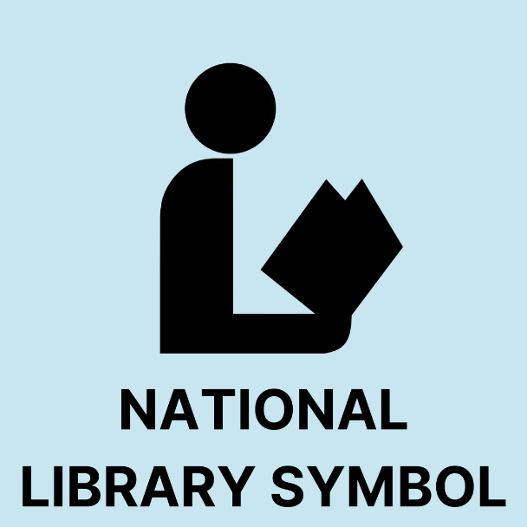

Dr. Stone received her A.B. and M.A. degrees and secondary teaching credentials from Stanford University; her M.S. in L.S. from the Catholic University of America and her Ph.D. from the American University.
She worked in public libraries in Pasadena, California, and New Haven, Connecticut.
Dr. Elizabeth W. Stone joined the faculty at Catholic University of America in 1961, was named chair of the Department of Library Science in 1972, and Dean in 1981. The University honors her memory with the Dr. Elizabeth W. Stone Lecture Series - Department of Library and Information Science - Catholic University of America, Washington, DC | CUA

Dr Elizabeth W. Stone was President of the American Library Association from 1981 to 1982.

Honors for Dr. Stone from the American Library Association included:
- Joseph W. Lippincott Award in 1986.
- American Library Association Honorary Membership in 1988.
- Beta Phi Mu Award for distinguished service to education for librarianship in 1998.

During her presidency, Dr. Stone prioritized public awareness of libraries as her central theme, aiming to highlight their vital role in society amid challenges like fluctuating federal funding for library programs.
Key initiatives under her leadership included:
- establishment of a presidential task force to develop a national library symbol, which ultimately adopted an open book design to promote universal recognition of libraries.
- She also chaired the National Library Week Committee, coordinating promotional efforts such as partnerships with corporations for voluntary library service campaigns.
- Issuance of the U.S. Postal Service's "America's Libraries" commemorative stamp in 1982, which Stone actively advocated for to symbolize libraries' cultural importance.
- Her Advocacy extended to policy matters, including ALA's endorsement of equal pay for comparable work, as highlighted in her communications during the term.

Below are two public awareness achievements: the National Library Symbol used as signage and the “America’s Libraries: Legacies to Mankind” Stamp.

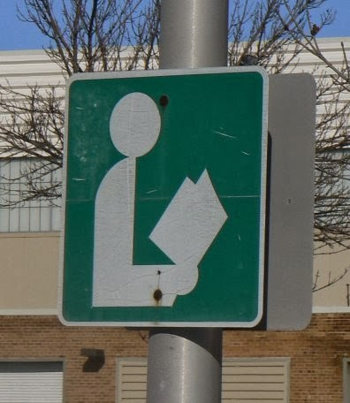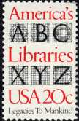

Continuing Library Education Network and Exchange (CLENE) (CLENE)
Dr. Stone chose continuing education for the topic of her doctoral dissertation. It was published in 1969 by Scarecrow Press under the title, Factors Related to the Professional Development of Librarians. Her study became a landmark that in turn motivated others to conduct further research and to work for improvement of the CE situation.
Her groundwork led to a contract from the National Commission on Libraries and Information Science for a study "to design a national conceptual blueprint for the provision of access to learning opportunities for all library and information science personnel.” The major outcome of this project was the recommendation that a new organization be created- the Continuing Library Education Network and Exchange (CLENE), intended to be the freestanding CE arm of the profession, involving associations, state library agencies, library schools, as well as employers and library/information personnel.
CLENE was launched in 1975. The following year, another federal grant supported the development of a model for a voluntary recognition system, and succeeding years saw the refinement of the system along with advocacy for its implementation. At the same time, criteria for quality and a provider approval system were developed. Once all the pieces were in place, however, funding to sustain CLENE as an independent organization ended, and this led to the decision to ask ALA to incorporate CLENE into its organizational structure.
In 1985, Stone, working with Brooke Sheldon and others, sponsored the first World Conference on Continuing Professional Education for the Library and Information Professions immediately before the Chicago Conference of the International Federation of Library Associations and Institutions (IFLA). As a result of this meeting, the Continuing Professional Education Round Table (CPERT) of IFLA was established. In the fall of 2002, the Round Table moved for status as a Section of IFLA, a legacy for library and information science professionals around the world. That Stone was able to generate funding for the creation of CLENE and CPERT is testimony to her dedicated and constant interest in CE and her willingness to give personal time and effort to the cause. She traveled to CE conferences around the world bringing ideas to and from them.

(Appreciation for information in this section to the scholarship in Varlejs, Jana, Blanche Woolls, and Brooke Sheldon. 2003. “In Appreciation of Betty Stone, Continuing Education Advocate.” Journal of Education for Library & Information Science 44 (1): 69–71.

Dr. Stone was also active in many other ways in library associations
- President of the District of Columbia Library Association,
- For the American Library Association in addition to her presidency. she was Chairperson of the Staff Development Committee of the Library Administration Division.
- For the American Association of Library Schools [now titled Association for Library and Information Science Education (ALISE)] she was chairperson of the Nominating Committee
and Chairperson of the Continuing Library Education and Chairperson of the Nominating Committee.

Selected Publications

Elizabeth W. Stone, "Some Historical Antecedents of Continuing Library Education," in Continuing Education for the Library Information Professions (Hamden, CT: Shoe String, 1985): 22-23.
Elizabeth W. Stone, "Continuing Professional Education," in ALA Yearbook 1985 (Chicago: American Library Association, 1985), 106.
Stone, Elizabeth W., Eileen Sheahan, and Katherine Jean Harig. 1979. Model Continuing Education Recognition System in Library and Information Science. New York: K.G. Saur.
Stone, Elizabeth W., and Mary Baxter. 1978. Bibliography on Nontraditional Learning : Developed for the 1978-1979 CLENE/USOE Institute : Statewide Systems of Continuing Education : New Directions. Washington, D.C.: CLENE.
Stone, Elizabeth W. 1977. American Library Development, 1600-1899. New York: H.W. Wilson Co.
Stone, Elizabeth, 1977. Development of a Continuing Education Recognition System in Library and Information Science Including Provision for Nontraditional Studies and Development of a Prototype Home Study Program. Final Report. Volume I of Two Volumes (1977)
The project described achieved two major objectives--the development of a model of a system for recognition of individual participation in professional continuing education by library/media/information personnel, and the development and demonstration of a prototype home study program to show that this learning mode can meet criteria for quality and that geographical location is no longer a barrier to learning. Opinions, comments, and suggestions on the issue of recognition were secured from more than 1,000 persons through interviews, group discussions, and correspondence. The model system suggested for consideration by the profession is based on this data and on information gathered from the literature and communication with leaders of recognition systems in other professions. Guidelines for the development of home study programs, formulated on the basis of a survey of the literature and interviews with home study professionals, were used in the development and pre-testing by 65 practitioners of a home study course entitled "Motivation: a Vital Force in the Organization." This report discusses procedures and methodology, a review of the literature, conclusions and recommendations, and the proposed model, together with suggestions for its implementation. Data collection instruments, documentation, and supplementary tables displaying field data and respondent characteristics are appended. 556 pages. OCLC Number / Unique Identifier:967289372.

Stone, Elizabeth W. and Continuing Library Education Network and Exchange. 1977. Continuing Education Resource Book. Washington, D.C.: CLENE.
Stone, Elizabeth W. 1974. Continuing Library Education as Viewed in Relation to Other Continuing Professional Education Movements. Washington: American Society for Information Science.
Stone, Elizabeth W., Ruth J Patrick, Barbara Conroy, and United States National Commission on Libraries and Information Science. 1974. Continuing Library and Information Science Education Project : Final Report to the National Commission on Libraries and Information Science. Washington: Graduate Dept. of Library Science Catholic University of America.
Stone, Elizabeth W., ed. Library Trends 20 (1) Summer 1971: Personnel Development and Continuing Education in Libraries.
Kortendick, James J., and Elizabeth W. Stone. 1971. Job Dimensions and Educational Needs in Librarianship. Chicago: American Library Association.
Elizabeth W. Stone, New Directions in Staff Development: Moving from Ideas to Action (Chicago: American Library Association, 1971); and Library Trends 20 (July 1971).
Stone, Elizabeth W. 1969. Factors Related to the Professional Development of Librarians, Metuchen, N.J.: Scarecrow Press.
Stone, Elizabeth W., and University of Illinois (Urbana, Ill). Graduate School of Library Science. 1967. Historical Approach to American Library Development : A Chronological Chart. Urbana Illinois: University of Illinois.

Sources
Elizabeth Stone Obituary (2002) - Washington, DC - The Washington Post
On Wednesday, March 6, 2002. Beloved wife of the late Rev. Dr. Thomas A. Stone; devoted mother of John Howard, Anne Elizabeth and James Alexander; loving grandmother of Zachary Thomas and Victoria Morrell; friend and mentor to many.
Amongst her many achievements: President of the American Library Association; Dean Emerita of the School of Library and Information Science, The Catholic University of America; Librarian and Archivist of the National Presbyterian Church;; Co-Founder and Executive Director of the Continuing Library Education Network Exchange; Author; and D.C. Mother of the Year.

The power of one: circumspice! The 2015 Elizabeth Stone Memorial Lecture and Keynote Address
U.S. Postal Service. While Elizabeth W. Stone was American Library Association President a stamp , “America’s Libraries” was issued. Here is a canceled first-day-of-issue postage stamp and envelope.
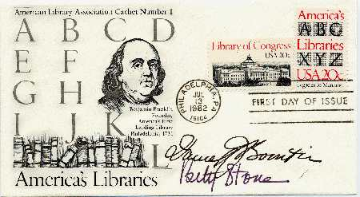

Envelope contains the phrase "American Library Association cachet number 1" at the upper left-hand corner, the letters A-L with images of Benjamin Franklin and book shelf in the center left and the phrase "America's Libraries" in the lower left. The 20 cent "America's Libraries" stamp is in the upper right-hand corner with a "First Day of Issue" cancellation stamp postmarked Philadelphia, PA July 13, 1982 below. The signatures of Betty Stone, then president of the American Library in the lower right. This First Day Cover for the America's Libraries postage stamp that was issued at the ALA Conference in Philadelphia and were available for sale for $3. The envelope contains a postcard detailing the history of the American Library Association and its past and present work.

Varlejs, Jana, Blanche Woolls, and Brooke Sheldon. 2003. “In Appreciation of Betty Stone, Continuing Education Advocate.” Journal of Education for Library & Information Science 44 (1): 69–71.

Elizabeth W. Stone Lecture Series
(Article and table submitted to Wikipedia on 2/15/2026 by K. McCook)
==
The Elizabeth W. Stone Lecture series at the Catholic University of America honors the contributions of the former dean of the School of Library and Information Science.^{[1]} Elizabeth W. Stone joined the faculty at Catholic University of America in 1961,was named chair of the Department of Library Science in 1972, and Dean in 1981.^{[2]}
The first lecturer in 1990 was Timothy S. Healy, S.J. who was former president of Georgetown University and president of the New York Public Library.^{[3]} Lecturers have included scholars, administrators from the Library of Congress, national library association officers, academic library officers, and alumni.
Year | Lecturer | Title
Richard Huffine | 2025 | "The Convergence of Data, Information and Knowledge in Practice Today”
Martin R. Kalfatovic | 2024 | "Finding the Nature of Illumination in Libraries and Museums: Cultural Heritage and the Technology of Culture"
Nicholas Alexander Brown | 2023 | “Community Engagement & Advocacy in Libraries: How to Thrive in Volatile Times”
Julius C. Jefferson Jr. | 2022 | “The First Amendment, Race and the Truth: Librarians and Social Justice”
Trevor Owens | 2021 | “Caring for Digital Collections in the Anthropocene”
No lecture | 2020
Kate Zwaard | 2019 | “Innovation and Digital Strategy at the Library of Congress”
Dave Shumaker | 2018 | How to Predict the Future"
Melanie Townsend Diggs | 2017 | “Being a ‘beacon of light’ in the face of adversity”
Don Collins | 2016 | "An Oceanographer's Voyage Into Librarianship"
Linda Ueki Absher | 2015
Barbara Stripling | 2014
Blane Dessy | 2013 | "The Federal Government's Information Sphere & The Myth of Federal Information Policy"
Deanna Marcum | 2012 | "Leadership for the Digital Age"
Elizabeth Aversa | 2011 | "A Passion for Libraries - or - Why We Do What We Do"
Clifford Lynch | 2010 | “Scholarship, Cultural Memory and Libraries in the 21st Century”
Camila Alire | 2009 | "Issues and Trends in American Libraries"
Andrew K. Pace | 2008 | "From SLIS to OCLC: An Alumnus Reflects on His Career and the Evolving Profession"
Deanna Marcum | 2007 | "Culture Shock: The Changing Nature of Library Science Education"
No lecture | 2006
Richard Baker | 2005 | "History on the Hill: From Gunpowder Paste to the Nuclear Option"
Siva Vaidhyanathan | 2004 | "The Anarchist in the Library"
Sanford Berman | 2003 | "Not in My Library: Issues of Workplace Speech and Governance"
Duane Webster | 2002 | "Reflections on the Future of Scholarly Communications"
Nancy Kranich | 2001 | "Why Do We Still Need Libraries?"
John Cole | 2000 | "Bicentennial of the Library of Congress"
Carla Hayden | 1999 | "Institutional Change in a Traditional Library"
Kurt Cylke | 1998 | "That All May Read" - National Library Service for the Blind and Physically Handicapped
Henriette Avram | 1997 | "On the Fourth Decade of the MARC Format"
Mathilde V. Rovelstad | 1996 | "Temples of Wisdom and Faith: The Picture World of Monastic Libraries of the Baroque Period"
Jeanne Hurley Simon | 1995 | "The Role of the National Commission on Libraries and Information Science in American Library Development"
Eileen D. Cook | 1994 | "Lobbying for Libraries: Thirty Years on Capitol Hill"
Hardy R. Franklin | 1993 | "Customer Service and the Library: The Crucial Link"
William J. Byron, S.J. | 1992 | "Library Support for Community Service"
Sheilah Kast | 1991 | "The Public's Right to Know in the Information Age"
Timothy S. Healy, S.J. | 1990 | "The Role of the Public Library in a Democratic Society"
References
- "Dr. Elizabeth W. Stone Lecture Series". Department of Information Sciences. The Catholic University of America. Retrieved February 15, 2026.
- Varlejs, Jana; Woolls, Blanche; Sheldon, Brooke (2003). "In Appreciation of Betty Stone, Continuing Education Advocate". Journal of Education for Library & Information Science. 44 (1): 69–71.
- "The Conscience of a Jesuit. Father Timothy Healy, New Head of the New York Public Library". U.S. News & World Report. 1989. p. 52.

Submitted by Kathleen de la Peña McCook

