Marilyn Walrath Goodrich Petersen (1935-2011)

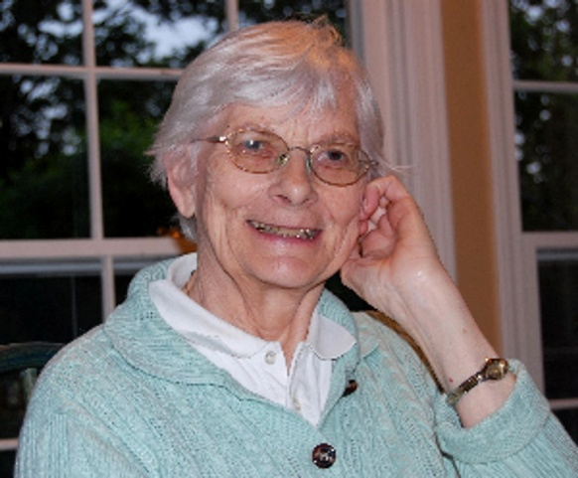

Marilyn Goodrich Petersen was on fire for spreading the NEED for librarians (spreading the skill of library science) in every public school. She began this quest in Ohio continuing with earning her Masters in Florida. As her family moved often, Marilyn became a shining star in Kansas. Her career was advocacy for librarian in every school and 'why' it promotes learning to a deeper level. President of the KASL in Kansas gave her a voice, to strengthen of what other states were recognizing “library media specialist teach students about THEIR future of importance of information gathering, reading, and technology.” Before retiring, she shared coordinator duties with Loretta Woods. Our primary schools were fully supported through her hard work. Today our specialists support the students and teachers of our outstanding Olathe Public School System by providing new strategies, changes in learning and teaching, and staying current on new information and finding fake facts. Thank you, Marilyn, for setting the bar of professionalism in many hearts of the career.

--Submitted by Sandra Ames

