Tze-Chung (Richard) Li (1927-2021)

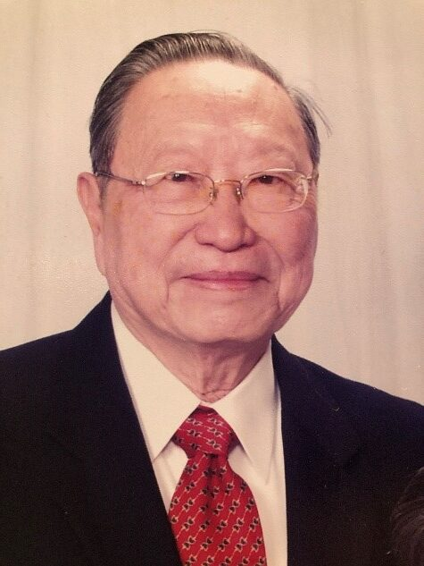

Dr. Li is one of the earliest Chinese American pioneers in library science education in the U.S. who played a truly outstanding leadership role as a scholar, teacher, lawyer, writer, former Dean of Graduate School of Library and Information Science at Dominican University in Illinois, and former Director of the National Central Library in Taiwan.

He was a founding member of the Chinese American Librarians Association.

Dr. Li’s broad and profound knowledge across many fields is shown in the number of academic degrees he had completed including a Ph.D. from the New School for Social Research in 1963; a M.L.S. Degree from Columbia University Graduate School of Library Service in 1963; a L.L.M. Degree from Harvard University Law School in 1958; a M.C.L. Degree from Southern Methodist University in 1957; and a L.L.B. Degree. cum laude, from Soochow University Comparative Law School of China in 1948.

In his early career in Taiwan, Dr. Li held many important government appointments including being a judge, an official in the Ministry of Justice and the Ministry of National Defense, the Examination Commissioner in the Examination Yuan, and the Director of the National Central Library.

Dr. Li was the first Chinese American scholar who became the Dean of a library school in this country. He is also a prolific writer who has edited and published more than 20 books and authored some 100 articles, translations, and book reviews in the fields of library and information science, law, land reform and political science.

Dr. Li was a very active member of numerous international and national associations such as the American Library Association, the Chinese American Educational Foundation from 1968-1970, the China Association Library and Information Science Education and the Library Association China in Taiwan and served as President of Phi Tau Phi from 1985-1987.
He was awarded the Chinese American Librarians Association CALA Outstanding Library Leadership Award. In 2013.
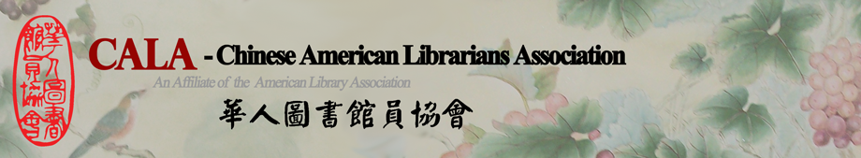

Selected Publications

- A Guide to Chinese Reference Sources (co-authored with his wife, In-Lan Wang, 1972)
- An Introduction to Online Searching (Greenwood Press, 1985)
- Social Science Reference Sources (Greenwood Press, 1980, 1990, and 2000).
- Li, Tze-chung, and International Conference on National Libraries--Towards the 21st Century Taipei, Taiwan) (1993 : 1993. National Information Research Network: The National Central Library Meeting the Challenge of the 21st Century. Taipei, Taiwan: National Central Library.
- Li, Tze-chung, and Rose Maria Li. 1986. Directory of Chinese American Librarians. 2nd ed. Oak Park, Ill.: Chinese Culture Service.
- Li, Tze-Chung. 1973. “Library Science Education in the Republic of China: An Appraisal.” Journal of Education for Librarianship 14 (1): 16–31.

Dr. Li was the founding editor of CALA’s Journal of Library and Information Science and a member of the advisory board for the Journal of Information, Communication and Library Science. Dr. Li also helped create several professional journals and series, including the International Journal of Reviews in library and Information Science (now World Libraries) and Guide to Asian Librarianship Series (Greenwood Press).

Sources
A Memorial Resolution Honoring Tze-chung Li American Library Association, June 27, 2020,
Tze-Chung (Richard) Li, Philanthropist, Pioneer in Library Education, and Mentor to Chinese-American Librarians, Dies at 93.

