Barbara A. Kuhn 1950-1997

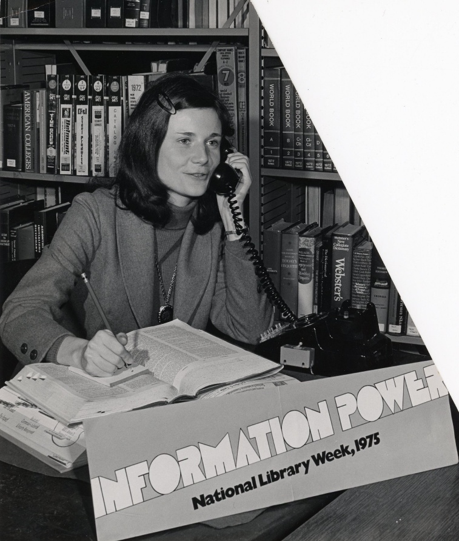

When I arrived at the Onondaga County Public Library Main Library (Syracuse, NY) in 1980, I had the great good fortune to provide reference and youth services in the Fiction and Humanities Department on the main floor of that grand old building. I shared office space and Barbara Kuhn was one of the reference librarians and part of the team.

Barbara was the “darling” of the library. Her lovely appearance and dress were a stark contrast to the drab Syracuse weather, and she had also married reference librarian John Kuhn only a few years before. Everyone was charmed by their romance and subsequent marriage.

On the surface Barbara was the model of decorum but those of us in the Fiction and Humanities Office knew that she would keep our confidence. We created some off-beat programs with non-traditional presenters. We believed that everyone was a programmer and readers advisor regardless of academic degree and encouraged all staff to help patrons. We also broke long-standing rules about eating in the library office and having visitors in the office during breaks and lunch.
After a move in 1988 to the new Central Library in the Galleries, Barbara became the head of telephone reference, and later the head of three different branches in the City of Syracuse. She was so congenial and competent that the library leadership moved her regularly to solve problems and trouble shoot.

After her death there was a tremendous outpouring of affection from staff and patrons. She made a difference in the lives she touched.

Submitted by Sari Feldman

Images provided by Dan Smith, librarian at the Local History & Genealogy Department, Onondaga County Public Libraries

