Lillian Gerhardt (dates unknown)

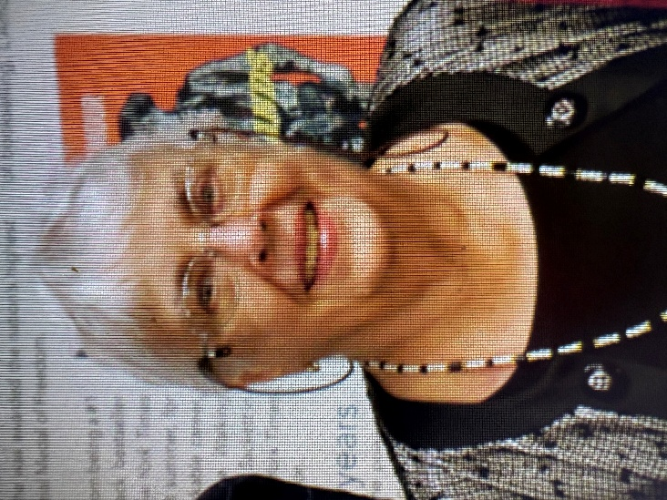

Lillian Gerhardt was passionate about libraries and the American Library Association’s role in supporting them. As editor of School Library Journal her editorials reflected that passion.
As a past president of the Association for Library Services to Children (ALSC , part of ALA) her interest in children, their library services and their books was obvious. Lil also cared about library services for everyone. If Council was meeting at ALA you could find her in the Press Section. Her knowledge of ALA’’s history was amazing. What did ALA do about a certain problem or service or project? The person to ask was Lillian Gerhardt.
Lillian N. Gerhardt (often called Lil) was a prominent American librarian, editor, and influential figure in children's and school librarianship. She served as Editor-in-Chief of School Library Journal (SLJ) for many years (active by the early 1970s through at least the mid-1990s, retiring around 1999). Under her leadership, SLJ grew from a supplement to Library Journal into a standalone, authoritative publication in the field.
Key details of her career and contributions:
- Education and early career — She was a graduate of the University of Chicago's Graduate Library School. She began her library journalism career at Kirkus Reviews (where she reportedly "caused trouble"), then moved to SLJ.
- Advocacy and influence — Gerhardt was known for her perceptive editorials, book reviews (including positive notice of S.E. Hinton's The Outsiders), and strong advocacy for high literary standards in children's books, intellectual freedom, and quality school library services. She was outspoken on issues like censorship and the evolution of children's literature.
- Personality and style — Described as having piercing blue eyes and a soft voice, she enjoyed ALA political drama, enforced rigorous journalism standards (deadlines, "newsiness"), and had a direct, sometimes fiery communication style (e.g., a notable heated 1974–1975 exchange of letters with Horn Book editor Ethel Heins over literary standards and the term "mainstream").
- Legacy and mentorship — She mentored successors and shaped professional discourse through editorials, presentations, and her authoritative voice in the field. She also contributed to or oversaw collections like School Library Journal's Best.

In 1998, she received the American Association of School Librarians (AASL, part of ALA) President's Crystal Apple Award for her significant impact on school libraries and students.
No widely published birth or death dates appear in major sources; she was professionally active from the 1960s/1970s into the late 1990s. Her work continues to be referenced in library science and children's literature discussions.

Sources
Roger Sutton, - The Horn Book | My editor Lillian. Mar 20, 2018.

Selected Publications

Gerhardt, Lillian N. 1999. “Tilling the Field of Children’s Literature.” School Library Journal 45 (7): 30–32.
Miller, Marilyn L., and Thomas W. Downen. 1997. School Library Journal’s Best : A Reader for Children’s, Young Adult & School Librarians. Edited by Lillian N. Gerhardt. New York: Neal-Schuman Publishers.
Gerhardt, Lillian N. 1981. “Children’s Access to Public Library Services: Prince George’s County Memorial Public Library, Maryland, 1980.” Library Quarterly 51 (1): 20–37.
Gerhardt, Lillian, N. 1973. Issues in Children’s Book Selection. New York: R.R. Bowker.

Submitted by AMY KELLMAN.
Amy Kellman and Lillian Gehhardt served on the ALSC Board at the same time. Amy also served on ALA Council.

