Arthur Curley (1938-1998)

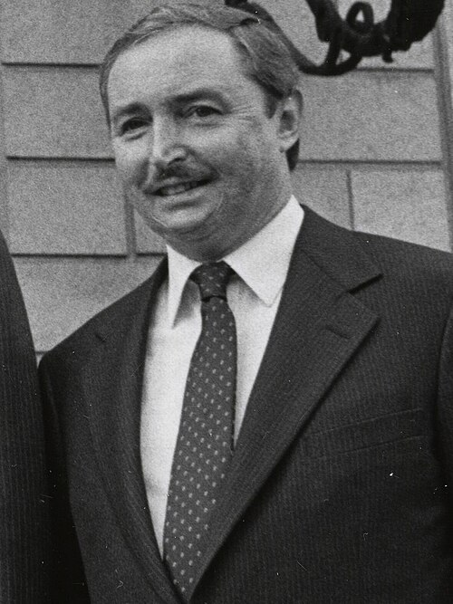

Arthur Curley, Director of the Boston Public Library (1985-1996) served as American Library Association President in 1994-1995—the beginning of the Internet. He was identified among “100 of the most important leaders we had in the 20th century."

Arthur Curley’s 1994 article, “Libraries: an American Value,” appeared in American Libraries in 1994.

“My goal as ALA president is to affirm libraries as a basic American value with even greater relevance and need for support in the Information Age.”

- That each of us has "inalienable rights," among which the right to be educated and informed is basic, and that government has a constitutional duty to ensure that citizens are sufficiently well informed to make wise decisions about the issues before their communities and their nation.
- That the ability of all people to obtain free and equal access to the widest possible range of information sources in all forms is essential to this objective.
- That libraries are fundamental to a civilized society and that library informational services are a public good.
- That in our democracy, because government is not only of and for the people, but by the people, it follows that government information belongs to the people and should not be sold for profit.
- That government can secure the people's right to information and knowledge most effectively by tax-supported libraries--public, school, academic, and those of government itself--federal and state.
- That the public library has proven its efficiency and effectiveness as a means of securing the people's right to know, since it is used by a majority of the people but has never received as much as two percent of the cost of government.
- That school library media centers support the curriculum and enrich the educational experience of children.
- That the academic library is the cornerstone of learning and provides the base of research for students and faculty.
- That the effectiveness of these libraries has been seriously endangered by decades of austerity, loss of tax support, and retrench merit at the hands of federal, state, and local governments.
- That the emergence of two classes of Americans, the information rich and the information poor, will be the inevitable result of declining political and monetary support.
- That adequate libraries and library services are vital to support education and research, and to broaden the horizons and opportunities for our youth, for minorities, for recent immigrants, and for the growing number of older and retired people.
- That greater support of libraries is mandatory if they are to develop fully the resources and services that reflect the very diverse needs of our multicultural society.
- That we must seize this moment of potential change in government thinking and carry forward the message that libraries are an important part of America's infrastructure that needs rebuilding.
- That to persuade communities and their political leadership to value and support libraries as they have done at other critical points in our history, the American Library Association must broaden coalition-building efforts and help mobilize pressure from citizens to reinstate and increase this support.
- That to secure the right to know for this generation and generations of Americans yet to come, the dangerous neglect of libraries must come to an end.
-- Curley, A. (1994). Libraries: an American value. American Libraries, 25, 691.

Career

The day after his 1959 commencement from Harvard, Arthur Curley began work in one of Boston Public Library's twenty-five branches. Following stints in Avon, Massachusetts, Detroit, and New York City, the forty-nine-year-old Curley came home to head Boston's historic landmark, and to lead it into a new era. (Chadbourne, R. D. (1987). Arthur Curley is where he wants to be. Wilson Library Bulletin, 62, 44–45. )

Arthur Curley earned a Bachelor of Arts degree in political science from Harvard University in 1959. He then pursued library science, obtaining a Master of Library Science from Simmons College in 1962.
Curley's entry into professional librarianship occurred through initial roles that emphasized community integration and resource expansion in smaller public libraries. He served as librarian at the Palatine Public Library in Illinois, where he advocated for joining the North Suburban Library System; a 1966 tax levy of 20 mills facilitated this affiliation, enabling the collection to double in size by 1968.
In 1968, Curley became director of the Montclair Public Library in New Jersey, focusing on outreach to the community's ethnic and cultural diversity. His initiatives included launching book wagon services in 1969, which contributed to a 40 percent rise in library usage over the subsequent two years. He continued in this capacity at least until 1973, during which time the library explored innovative services such as community information data banks.
He was deputy director of the Detroit Public Library from 1977-1980 where he focused on public services during a period of urban transition for the institution.
In 1980 to 1985, Curley was deputy director of the Research Libraries at the New York Public Library, contributing to administrative oversight of its extensive research collections and public access initiatives.
He was Director of the Boston Public Library from 1985-1996.
Arthur Curley, when director of the Boston Public Library, assumed the presidency of the Association of Research Libraries in 1994.

American Library Association

Curley was active in ALA for 30 years serving in various capacities including as a member of the ALA Council, the association's governing body, (1970-74, 1981-87) and Executive Board (1983-87). He was chair of the Intellectual Freedom Committee from 1991 to 1994
During his presidency (1994-1995) he founded “Library Advocacy Now” which facilitated important training for library advocates. Rather than merely promoting best practices "for Curley, LAN represented the first step of a grassroots effort of the ALA's 'awaking to activism'" The rhetorical force of his visions for the role libraries can have in society continues to be important for many librarians and library advocates.”
Curley also advanced ALA's Goal 2000 strategic plan, which sought to prepare libraries for the 21st century by prioritizing information literacy, technological integration, and equitable access to digital resources.
In speeches at ALA conferences, Arthur Curley highlighted the need for libraries to adapt to emerging technologies while maintaining their role as democratic institutions fostering informed citizenship. His leadership reinforced ALA's commitment to intellectual freedom, drawing on his prior experience in defending library collections against censorship attempts. Under Curley's presidency, ALA intensified partnerships with educational and cultural organizations to promote libraries as vital community hubs, including collaborations on literacy programs and arts initiatives.

Legacy

Arthur Curley, who began and ended his library career at the Boston Public Library (BPL), died on March 31 at his home in Swampscott, MA. He was 60. After graduating from Harvard in 1959, Curley joined BPL's Connolly branch in Jamaica Plain. He retired as director of BPL in 1996, after 11 years in that position. In between, he gained an MLS from Simmons College and served as deputy director of the Detroit Public Library and of the Research Libraries of New York Public Library, among other positions. He was American Library Association president from 1994 to 1995.
----(Arthur Curley, former BPL director/ALA president dies at 60. (1998, May 1). Library Journal, 123(8), 11.)

I had never met another librarian as proud of his or her calling as Curley. He shared and finally gave me that professional pride. One couldn't experience Arthur in discussion, or Arthur the man, without knowing you had been in the presence of a learned person. Watching him, I, too, began to challenge those who would ridicule or denigrate librarianship and librarians. Those were two of Arthur Curley's gifts to me and to the profession. From his career beginnings until its end, both at the Boston Public Library, Curley proudly professed the power of information, education, and the fundamental need of society for tax-supported, free public libraries to make that information and education accessible to all. Secondly, he proudly proclaimed his calling to and membership in the clan of librarians. It is a worthy pride we hide too often.—
---- (Berry, J. N. (1998). I’m proud to be a librarian. Library Journal, 123(8), 6.)

Posthumously, Arthur Curley was honored through the establishment of the Arthur Curley Memorial Lecture held at ALA Conferences. The lectures explored the intersection of libraries with intellectual, cultural, and political spheres. Curley was a champion of the arts and of the library’s role as a center that can transform the community.
The lecture series commemorated his lifelong dedication to the principles of intellectual freedom and free public access to information. Lecturers included Richard Rodriguez, Andrei Codrescu, Ishmael Beah, Richard Rhodes, Lizzie Velásquez, Ryan Gravel, Elizabeth Acevedo, Eric Klinenberg, Lewis H. Lapham and Jim Hightower.

Publications

Curley, A. (1995). ALA goal 2000: vision and reality. RQ, 34, 312.
Curley, A. (1995). Why Americans can’t wait. American Libraries, 26, 204.
Curley, A. (1995). Support ALA goal 2000. American Libraries, 26, 284.
Curley, A. (1995). Celebrating libraries. American Libraries, 26, 380.
Curley, A. (1995). ALA president’s message. American Libraries, 26, 510.
Curley, A. (1994). Libraries: an American value. American Libraries, 25, 691.
Curley, A. (1994). Anatomy of an advocate. American Libraries, 25, 962.
Curley, A. (1994). The awakening to activism. American Libraries, 25, 889.
Curley, A. (1994). Library advocacy now! American Libraries, 25, 784.
Curley, A. (1994). Libraries: an American value. American Libraries, 25, 691.
Schuman, P., & Curley, A. (1994). The bucks start here: ALA kicks off library funding campaign. Library Journal, 119(18), 38–40.
Statement by Arthur Curley, candidate for ALA president. (1993). American Libraries, 24(3), 278.
Curley, A. (1990). Funding for public libraries in the 1990s. Library Journal, 115(1), 65–67.
Curley, A. (1984). Fee vs free. Collection Building, 6, 2–3.

Sources

Kniffel, L., McCormick, E. & Sullivan, P. Dec. 1999. "100 of the most important leaders we had in the 20th century". American Libraries, 30, 11, pp. 38–48.
Ticket to Ride: Curley leads charge for library, school Internet access. (1995). Wilson Library Bulletin, 69(5), 13.
Arthur Curley has assumed the presidency of the Association of Research Libraries. (1992). Wilson Library Bulletin, 66, 21.
Nyren, K. (1985). Arthur Curley to head Boston Public Library. Library Journal, 110(7), 14.
Wikipedia- Arthur Curley

Submitted by Kathleen de la Peña McCook

