Steve Cisler (1942-2008)
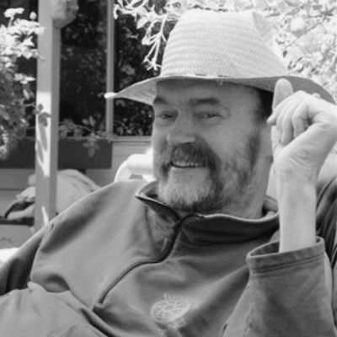

Steve Cisler (October 14, 1942 – May 15, 2008) was a librarian and visionary in the field of digital information access, often described as one of the first “digital librarians.” His work bridged traditional librarianship with emerging networked technologies, championing the connection of libraries to the Internet long before it was widely recognized as essential to public access and community development.
Cisler’s early career began with a Master of Library Science degree from the University of California, Berkeley, after which he worked as a public librarian in California for more than a decade. He first encountered networked computing in middle age, helping to found The WELL (Whole Earth ‘Lectronic Link) in 1985—one of the longest-running virtual communities.
In 1988, Cisler was recruited by Apple Computer, Inc. to serve as a Senior Scientist in the
Advanced Technology Group, where he established and directed the Apple Library of Tomorrow (ALOT) program. Through ALOT, he administered grants of funding, equipment, and software to libraries and community networking projects across North America, especially in under-resourced areas, enabling libraries to experiment with Internet connectivity and digital services.
Cisler’s influence extended into public policy and professional discourse, including organizing early conferences such as The Ties That Bind that brought together librarians, educators, activists, and technologists to discuss the social implications of networked information. He also authored reports and commentaries on topics such as digital privacy, community networking, and the impact of information technologies on library services. One documented conference report, Apple Library of Tomorrow: A Progress Report, captures the early evolution of these ideas in library contexts.
After leaving Apple in 1998, Cisler worked as an independent consultant supporting digital inclusion initiatives worldwide, including telecenters, school computing labs, and community networks in Latin America, Africa, the Middle East, and the Appalachian region of the U.S. In the final years of his life, he undertook a reflective project exploring life “o line” among people without Internet access, traveling through the U.S. and Mexico to better understand how communities communicated and shared information without digital connectivity.
Cisler was inducted posthumously into the Internet Hall of Fame in 2023 for his work on digital information access and connecting libraries and underserved communities to global networks.

Selected Publications
Breeden, L., Cisler, S., Guilfoy, V., Roberts, M., & Stone, A. (1998). Computer and communications use in low-income communities: Models for the neighborhood transformation and family development initiative. Baltimore, MD: Annie E. Casey Foundation.
Cisler, S. (1995). Can we keep community networks running? Computer-mediated communication magazine, 2(1), 6.
Cisler, S. (1994). Community computer networks: Building electronic greenbelts. Emerging communities: integrating networked information into library services [papers presented the 1993 Clinic on Library Applications of Data Processing, April 4-6, 1993].
Armour Polly, J., & Cisler, S. (1994). Usenet for librarians. Library journal (1976), 119(15), 3132.
Cisler, S. (1990). Apple library of tomorrow: a progress report. Database, 13(2), 94-97.

Sources https://www.wired.com/2008/05/steve-cisler-ri/ https://www.internethallo ame.org/inductee/steve-cisler/ https://www.nettime.org/Lists-Archives/nettime-l-0805/msg00033.html

Submitted by Stephen T. Bajjaly

