Miriam Braverman - 1920-2002

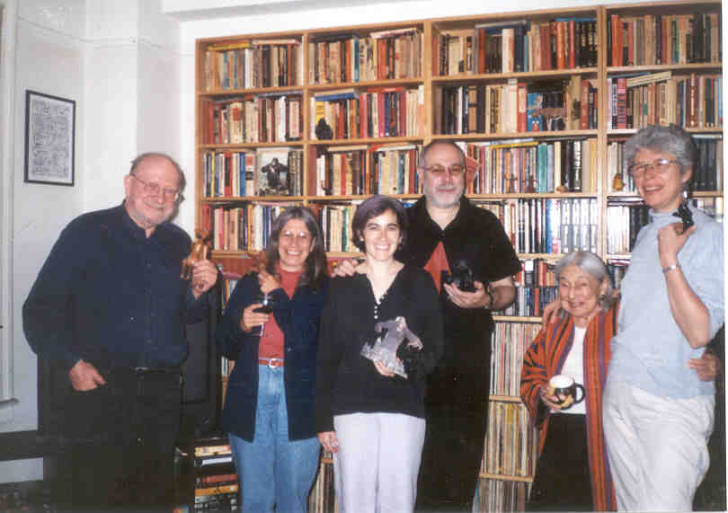
(L-R) John N. Berry III, Ann Sparanese, Jenna Freedman, Mark Rosenzweig, MIRIAM BRAVERMAN, Elaine Harger

Tabling at a Socialist Scholars Conference in the early-1990s with copies of Progressive Librarian
to offer attendees, I met Miriam Braverman. A petite, spry women in her mid-70s, she was quite
surprised to discover the existence of a new group of leftist librarians. Here, at the Borough of
Manhattan Community College is where our friendship began. A friendship that lasted to the day
she died in a hospital bed at Mount Sinai Morningside in New York City. A friendship remembered
daily at the desk I inherited from her.

Miriam was an inspiration to at least two generations of librarians. She was a founding member of
the New York City chapter of the Social Responsibilities Round Table of ALA. In the 1960s she
worked for the Brooklyn Public Library as community coordinator, and in the ‘70s joined the faculty
of the School of Library Service at Columbia University. Pat Schuman wrote of Miriam, “She was
like a mother to us. I was in my early 20s, Miriam must’ve been about 40 but she seemed much
older. She was always incredibly supportive, very political. Miriam came to our meetings and gave
us much sound advice.”

That was my experience of Miriam twenty years later in the ‘90s. She was retired by then, but
what stories she could tell: organizing with the Socialist Workers Party in the 1940s in
Youngstown, Ohio, where her husband Harry Braverman worked in a steel mill; visiting libraries in
Mississippi in 1965 as a member of the Friends of Freedom Libraries; working as a community
outreach librarian for Brooklyn Public Library; teaching at Columbia University’s School of Library
Service. Oh, the people she knew, the places she went!

When the Progressive Librarians Guild decided to establish a coordinating committee, Miriam
stepped up to represent retirees. But, really, she never “retired.” She even enjoyed a romance late
in her life with a “fellow traveler.”

The idea of human life free from the exploitation, racism, misogyny, and violence of capitalism was
a guiding star for Miriam, and she knew that libraries could serve to liberate people from the chains
of oppression, ignorance, and subservience to a globally cruel economic system.
Miriam loved life, she loved people and libraries and books, and she was much loved.

The Progressive Librarians Guild established The Miriam Braverman Memorial Award in 2003, which encourages student papers concerned with an aspect of the social responsibilities of librarians, libraries, or librarianship.

For further reading see:

Berry III, John N, 2010. On the Picket Line with Miriam. Library Journal, May 21.
Braverman, Miriam, 1965. “Mississippi Summer”. School Library Journal, November 1965.
- “Mississippi Summer” was reprinted in Progressive Librarian, #44, Spring 2016.
- Braverman Awards (2003-2023). Progressive Librarians Guild.
Jackson, Andrew P. (Sekou Molefi Baako). 2016. Memories of Miriam R. G. Braverman,
1920-2002. Progressive Librarian, #44, Spring 2016

On Miriam Braverman: some pieces for a biography (2017). Progressive Librarians Guild.
Rosenzweig, Mark, 2002. In Memoriam: Miriam Braverman. SRRT Newsletter, #141, December
2002.

Submitted by Elaine Harger

