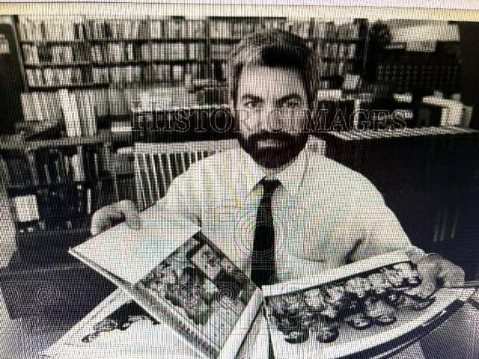

Gary O. Rolstad (1948-2005)

Gary Rolstad, Associate State Librarian for Louisiana at the State Library of Louisiana, was a prolific writer and advocate for adult services in public libraries. In 2001 he was honored with the Anthony Benoit Career Award by the Louisiana Library Association.

Gary was born in Sisseton South Dakota and grew up in the Bloomington MN area.
He graduated from the University of Minnesota. He earned the Master’s Degree at Louisiana State University, School of Library & Information Science.
He was Associate Editor of RQ , the journal of the American Library Association, Reference and Adult Services Division [now RUSA] and a frequent book reviewer of books on adult services.

Prior to his appointment at the State Library of Louisiana Gary held these positions:
- director of the St. Bernard Parish Library in Louisiana;
- consultant for adult services at Queens Borough Library in NY;
- media librarian in Hennepin Co MN

Gary joined his father Orvin and mother-in-law Rita on April 6, 2005 after a valiant fight with cancer and its complications. Survived by beloved wife Gwen, stepsons Chad and Jace Burton, father-inlaw Cyril Doyle, sisters and brothers-in-law Pam and Dennis Bernius, and Karen and Steve Kohls, and their families; also by mother Bernice, brothers Jack (Pam), Randy (Gayle), and sister Sandy (and friend Luther Thompson), all of Minnesota.

Publications
Rolstad, Gary O. 2000. “The Future.” Louisiana Libraries 62 (3): 3–4.
Rolstad, Gary O. “Online and Rural.” American libraries (Chicago, Ill.) 2000: 35

Rolstad, Gary O. 1993. “Collection Knowledge Skills: Training Support Staff for Readers’ Advisory.” Collection Building 12 (3–4): 31–35.

Rolstad, Gary O. 1993. “Literacy and Adult Education: Extending the Right to Know.”
Your Right to Know: Librarians Make It Happen, January 1, 30–4. American Library Association.
(1992 Your Right to Know : Librarians Make It Happen : Conference within a Conference Background Papers. [Chicago]: American Library Association.

Gary O. Rolstad. 1993. “Developing Readers’ Advisory Services: Concepts and Commitments.” Collection Building 12 (3–4): 5–117.

Rolstad, Gary O. “Our Kind of Service, Readers’ Advisory Is.” Collection building 12.3/4 (1993): 5–6.

Spanhoff, Elisabeth de Rijk, and Gary O. Rolstad. 1993. “Literacy and Public Libraries in Louisiana: A Recent History and Survey.” Mississippi Libraries 57 (April): 13–16.

Rolstad, G. O. (1991). Adult services. Libraries & Information Services Today, 65–70.

Rolstad, Gary O. 1991. “Interpersonal Networking: An Oral Tradition Survives.” LLA Bulletin 53 (January): 145–47.

Rolstad, Gary O. 1989. “Special Populations and a Strategy to Eliminate Barriers.” Bookmark (Albany, N.Y.) 47 (January): 118–21.

Rolstad, Gary O. 1989. “Adults, Library Services To.”
ALA Yearbook of Library & Information Services, V14, 1989, January 1, 19–21.

Rolstad, G. O. (1988). Training adult services librarians. RQ, 27, 474–477.

Rolstad, Gary O, and Janice M. Simpson. “Adult Services.” Ed. by Gary O Rolstad. RQ 27.4 (1988): 474–478.

Rolstad, Gary O. 1988. “Adults, Library Services To.”
ALA Yearbook of Library & Information Services, V13, 1988, January 1, 21–3.

Rolstad, Gary O., and Douglas J. Orlyk. 1988. “A Myriad of Messages and Media Opportunities.” RQ 27 (April): 317–20.

Rolstad, Gary O. 1987. “Adult Education Programs for Minorities.” RQ 27 (September): 179–82.

Rolstad, G. O. (1986). “Adults, Library service to.” ALA Yearbook of Library & Information Services, V11, 1986, 40–3.

Rolstad, Gary O. “ASE Update.” RQ 26.1 (1986): 18.

Sources:

Gary Rolstad Obituary

Kim, Ann. 2005. "Obituary: Gary O. Rolstad," Library Journal 130 (10): 32.

Louisiana Library Association

RUSA-Our History. Hansen, Andrew M. 1995. “RASD: Serving Those Who Serve the Public.” RQ 34 (March): 314–38.

