Dr. William "Bill" Armstrong Katz (1924 –2004)

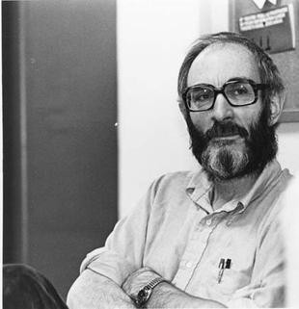

Dr. William "Bill" Armstrong (July 6, 1924- September 12, 20040 was born in Seattle, Washington.
He received his B.A. in Journalism from the University of Washington in 1947. He received his M.A.
in Library Science from the same school in 1956.
Katz served in the U.S. Army from 1942-1945 during World War II and received the Bronze Star.
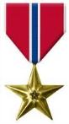

Katz's library career began at the Kings County Library in Washington where he worked as a reference librarian from 1975 to 1960.
He then worked for the American Library Association Editorial Department in Chicago until 1964.
He received the PhD from the Graduate Library School, University of Chicago in 1965.
He was associate professor of library science at the University of Kentucky until 1966.

Katz was editor of the journal Reference Quarterly ( RQ) for 10 years, during which time he oversaw its transition from a short newsletter to a leading scholarly journal.
He served as the editor for the Journal of Education for Librarianship (journal of the Association for Library and Information Science Education) from 1964 to 1972.

In 1966 he was appointed professor at the School of Information Science and Policy (SISP) at the State University of New York at Albany where he would remain for the rest of his academic career.
He was editor of The Reference Librarian and The Acquisitions Librarian.
In 1969, Katz published his two-volume Introduction to Reference Work which quickly became a standard textbook in reference education. The 8th edition was published in 2002. He also created and edited the reference text Magazines for Libraries, first published in 1969, which is in its 29th print edition as of 2021.
He was honored with the Isadore Gilbert Mudge Citation for Reference Librarianship by the American Library Association in 1973.
Katz also served as editor and compiler of over 40 works on various topics in library science, poetry, and the history of books. In 1991, he and his wife, Linda Sternberg Katz, published The Columbia Granger's Guide to Poetry Anthologies.

Katz also published on bibliographic history, including Cuneiform to Computer: A History of Reference Sources (1998) and A History of Book Illustrations: 29 Points of View (1994). Katz wrote more than 50 books and articles during his career.

Selected Publications Katz, William A.
Introduction to Reference Work. 2 vols. 1st-8th edition. New York: McGraw-Hill, 1969-2002.

Magazines for Libraries: For the General Reader and School, Junior College, College,
University and Public Libraries. 1st-14th edition. New Providence: Bowker, 1971-2005.

Readers, Reading and Librarians. Binghamton: The Haworth Information Press, 2001.

Cuneiform to Computer: A History of Reference Sources. Metuchen: Scare crow Press, 1998.

See also Maatta, Stephanie (2007-07-12). "William A. Katz: A Lifetime of Scholarship". The Reference Librarian. 47 (1): 9–15.

Sources
For more see:
Berry, John (November 15, 2004). "Reference Expert Bill Katz Dies". Library Journal. 129 (19): 17–18.
Maatta, Stephanie (2007-07-12). "William A. Katz: A Lifetime of Scholarship". The Reference Librarian. 47 (1): 9–15.
Wallace, Danny P.; Van Fleet, Connie (Winter 2004). "Remembering Bill Katz". Reference & User Services Quarterly. 44 (2). American Library Association: 109–110.

------------------------------
Kathleen de la Peña McCook
Distinguished University Professor
School of Information
University of South Florida
------------------------------

