Sister Mary Field, O.P. (1918-1986)

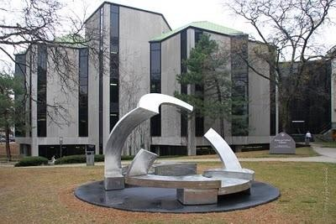

Sister Mary Field, O.P. was Chief Librarian at Rosary College (now Dominican University) from 1964- 1980. She was instrumental in the move of the college library from Power Hall to the new Rebecca Crown Library (1972-photo above). The library’s exterior shape is a St. Andrew’s Cross.
Sister Mary Field earned the BA from Rosary College in Social Sciences in 1939; and an M.A. in History from the University of Wisconsin-Madison in 1940. She then taught history and managed libraries at Medford High School and Reedsburg High School in Wisconsin.
She entered the Dominican Order of Sinsinawa from St. Cecilia Parish in Wisconsin Dells in 1946 as Sister Marie Jean.
She was librarian in many Catholic High schools: Trinity High School in River Forest, Illinois; Visitation High school in Chicago; Sacred Heart High School in Washington, D.C.; St. Catherine’s in Anaconda; and Bishop McGuinness High School in Oklahoma City.
In 1960 she earned the M.A. in Library Science at Rosary College.
From 1960-1964 she was reference librarian at Rosary College and Chief Librarian from 1964-1980.
After leaving Rosary she was Oral Historian for the Dominican Order of Sinsinawa.

Source
Cassie Vazquez, Archivist
Dominican Order of Sinsinawa

Submitted by Kathleen de la Peña McCook

