Librarians We Have Lost (1976-2026), Lynn Carol Tvrdik (Hattendorf) Westney

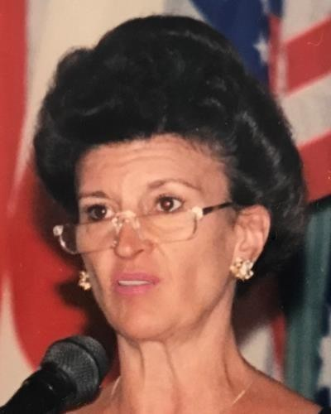

Lynn Carol Tvrdik (Hattendorf) Westney (1947- 2021). Born December 24, 1947, in Chicago, IL to Joseph and Alma (Stankovitch) Tvrdik. Until 1980 her name was Lynn Carol Tvrdik.
I met Lynn in 1972 at the University of Chicago, Graduate Library School. We were friends for the rest of her life.
In June 1980, Lynn married William Homer Hattendorf, II, who preceded her in death in 1995. In August 1997, she married Robert J. Westney, who preceded her in death in 2014. The true breadth of Lynn’s scholarship has been obscured by her frequent surname changes—a problem faced by many female academics. Over her lifetime, she published under at least four different surnames: Tvrdik, Hattendorf, and Westney, both singularly and in combination (e.g., Lynn C. Hattendorf, Lynn C. Westney, Lynn C. H. Westney, Lynn Hattendorf Westney).

Lynn earned a BA in Sociology from Loyola University in Chicago and an MS in Library and Information Science from the University of Illinois at Champaign. Lynn enjoyed a 25-year career at the University of Illinois at Chicago where she was a reference librarian and Associate Professor and Coordinator of Reference Collection Development.
She was a member of the American Library Association, active in the Business Reference and Services Section (BRASS); the Illinois Library Association, the American Names Society and the Canadian Society for the Study of Names.
She received the Reference Services Press Award from the American Library Association, Reference and User Services Association (RUSA) in 1989 for the outstanding article published in RUSQ (previously RQ).

Lynn was Editor of the Educational Rankings Annual from 1991-2006.

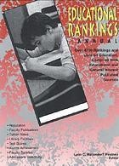
Educational Rankings Annual (cover) by Lynn Hattendorf Westney

She also wrote five annual assessments of ranking methodologies for RQ.
Lynn wrote numerous scholarly papers, many of which she presented as a guest speaker in a variety of international locations, including Australia, Canada, Costa Rica, Switzerland, Thailand, and the United States. Throughout most of her career, Lynn devoted much of her scholarship to celebrating the rewards of digitization without losing sight of the librarian’s academic responsibilities regarding this (then) new information technology.
Lynn also served as the editor of a regular column on e-journals, “E-Journals-Inside and Out,” for JAHC: Journal of the Association for History and Computing. The column focused on freely accessible e-journals, enewsletters, and other electronic publications relevant to history, computing, and interdisciplinary research. The column began in April 1999 as a collaborative effort with Ryan Johnson and continued under Westney’s sole editorship from May 2002 until August 2008.
In addition to her scholarship in librarianship Lynn was also an avid reader of onomastic sciences. She was a long-time member of both the Canadian Society for the Study of Names and the American Name Society. In 2007, she published an article for NAMES: A Journal of Onomastics that provided an in-depth history of culinary names inspired by famous women: “From Courtesans to Queens: Recipes Named for Women.” The article was featured in a 2007 special issue of NAMES devoted entirely to women’s names and naming practices.
Her 2008 article, "Dew Drop Inn and Lettuce Entertain You: Onomastic Sobriquets in the Food and Beverage Industry" was published and commented upon internationally and was recently referenced in 2025 on Hub Pages.

Selected Publications:
Westney, Lynn C. Hattendorf. 2015. “Mutually Exclusive?” In Digital Scholarship in the Tenure, Promotion, and Review Process, 30–41.

Journal of History and Computing, Columnist- "E-Journals Inside and Out." 1999-2008.
Westney, Lynn C. “Intrinsic Value and the Permanent Record: The Preservation Conundrum.” OCLC systems & services 23.1 (2007): 5–12.
Westney, Lynn C. “Conspicuous by Their Absence: Academic Librarians in the Engaged University.” Reference and User Services Quarterly 45.3 (2006): 200–203.
Westney, Lynn. “From Courtesans to Queens: Recipes Named for Women.” Names: A Journal of Onomastics.
55.3 (2007): 277–285.
Hattendorf Westney, L.C. (2000), "A Trivial Pursuit? Information technology and the tenure track", CampusWide Information Systems. 17 No. 4, pp. 113-119.
Westney, Lynn C. Hattendorf. “‘Proceedings of the XIXth International Congress of Onomastic Sciences’. Ed. W.F.H. Nicolaisen .” Names: A Journal of Onomastics. 1998: 307.
Hattendorf, Lynn C. Educational Rankings of Higher Education: Fact or Fiction? Paper presented at the International Conference on Assessing Quality in Higher Education (8th, Queensland, Australia, July 15, 1996). ERIC-ED 401 785.
Hattendorf, Lynn C. 1991. Educational Rankings Annual 1991 - 2006, (annual) - 1500 Rankings and Lists on Education, Compiled from Educational and General Interest Published Sources. Detroit: Gale Research.
Hattendorf, Lynn C. “College and University Rankings: An Annotated Bibliography of Analysis, Criticism, and Evaluation.” RQ 25.3 (1986): 332–347.
Hattendorf, Lynn C. “College and University Rankings: Part 2—An Annotated Bibliography of Analysis, Criticism, and Evaluation.” RQ 26.3 (1987): 315–322.
Hattendorf, Lynn C. “College and University Rankings: Part 3—An Annotated Bibliography of Analysis, Criticism, and Evaluation.” RQ 27.3 (1988): 337–357.
Hattendorf, Lynn C. “College and University Rankings: Part 4—An Annotated Bibliography of Analysis, Criticism, and Evaluation.” RQ 28.3 (1989): 340–367.
Hattendorf, Lynn C. “College and University Rankings: Part 5—An Annotated Bibliography of Analysis, Criticism, and Evaluation.” RQ 29.3 (1990): 402–420.
Hattendorf, Lynn C. The Art of Reference Collection Development. RQ, v29 n2 p219-29 Win 1989.

Sources:
In Memoriam: Lynn C. Westney. by I. M. Nick (Germanic Society for Forensic Linguistics) Names: A Journal of Onomastics 69 (Spring 2021).

Obituary: Lynn C. Westney Chicago Tribune, Jan. 16, 2021.

------------------------------
Kathleen de la Peña McCook
Distinguished University Professor
School of Information
University of South Florida
------------------------------

