Librarians We Have Lost, Sesquicentennial Memories -1976-2026: Lucia M. Tryon
Lucia M. Tryon became Pensacola's first female city department head when she was appointed chief librarian of the Pensacola Public Library in 1938, which she helped establish and was dedicated to until the end of her life. During her time at the helm of the Pensacola system, the library grew twenty times its original size. Lucia created a library for the Black community during times of racial segregation as well as their first bookmobile program. When she was forced to retire on her 65th birthday, she described it as, "the saddest day of my life." She volunteered with the Friends of the Library for as long as her health allowed. Lucia Tryon passed away on November 30, 2000 at the age of 97.

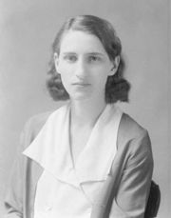

--Submitted by Tori Ladd

