Librarians We Have Lost, Sesquicentennial Memories -1976-2026: Nettie B. Taylor (1914–2016)

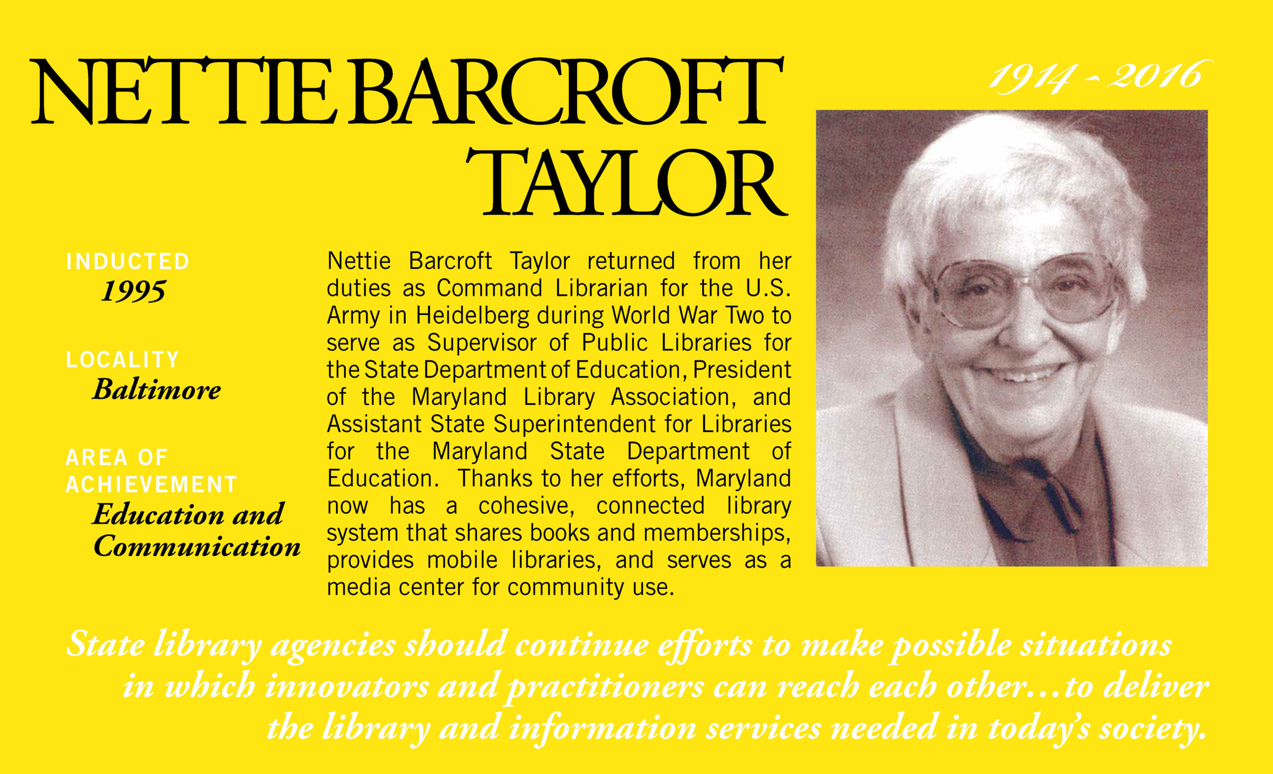

In 1942 Nettie B. Taylor earned a master's degree in library science from the University of North Carolina, and she joined the Women's Army Corps, becoming the Command Librarian for the U.S. Army in Heidelberg, Germany.
Nettie Taylor served as the Assistant State Superintendent for Libraries and Chief of Library Development and Services for the Maryland State Department of Education. She developed a structured and cooperative network of libraries in Maryland.
She lobbied, on behalf of ALA, for passage of the first Library Services Act in 1956. She also lobbied for increases in the per capita grant aid to public libraries in Maryland. She was an advocate of Bookmobiles for library service in rural areas and recognized the value of technology for libraries.
She was a founding member of the Chief Officers of State Library Agencies (COSLA) and was founder and President of ALA's Continuing Library Education Network and Exchange Round Table (CLENERT).
She also was a President of the Association for Specialized and Cooperative Library Agencies (ASCLA) and served for a time as an ALA Councilor. She received the Joseph W. Lippincott Award for Distinguished Service from ALA in 1984 and the Maryland Library Association Distinguished Service Award in 1979. She was named to the Maryland Women's Hall of Fame in 1995.
In 2005 she was awarded Honorary Membership from the American Library Association. Upon her death in 2016 a Memorial Tribute was made by the American Library Association.
Nettie was a mentor and advocate to me as a young librarian in Maryland, opening opportunities to serve on committees in Maryland and recommending me when I applied to be a library director out of state.

--Submitted by Carolyn Anthony
Sources:
Kelly, Jacques (October 27, 2016). "Nettie Barcroft Taylor, retired Maryland State Librarian, dies". Baltimore Sun.
"Nettie Barcroft Taylor". Maryland Women's Hall of Fame. Maryland State Archives. 2001.
"Memorial Resolution Honoring Nettie B. Taylor". American Library Association. December 21, 2017.

