Brett Sutton, A Legacy of Kind Knowledge and Human-Centered Information Science (ALA Sesquicentennial Memories 1976–2026)
Dear Colleagues,
It's Election Day and we've a lot on our minds. So I took time to remember Brett Sutton, A Legacy of Kind Knowledge and Human-Centered Information Science (ALA Sesquicentennial Memories 1976–2026). Enjoy.
Professor Brett Sutton (March 13, 1948 – August 4, 2018) taught my first doctoral seminar at the University of Illinois at Urbana-Champaign, setting a high standard for scholarship and kindness that is unforgettable and continues to guide me today. A dedicated field anthropologist, folklorist, and librarian, Brett's work spanned from his pioneering research on African American spiritual folk singing in North Carolina to his visionary contributions to library and information science. His archival efforts reflected a deep commitment to preserving and promoting cultural heritage, while his academic endeavors expanded the methodologies of anthropology within information science. The finding aid for the Brett Sutton Collection at the University of North Carolina at Chapel Hill provides details of his full education (Ph.D. in Anthropology, Masters in Library Science), and early accomplishments as a folklorist and librarian, the more unusual of which I share first:
"Along with Sutton's numerous articles, books, and papers on religious folksongs (1986-1988), he participated in radio and film documentaries. As an audio engineer for WUNC public radio, he worked on a five-part series on North Carolina folklife that includes The Golden Echoes of Creedmore, N.C. and Being A Joines: Brushy Mountain Tale Teller. Sutton, along with Joan Fenton, initiated Back Porch Music,
WUNC's popular weekend music program, and in 1986, he contributed sound recordings for A Singing
Stream, a film by Tom Davenport." (Source: Finding Aids, UNC.)
Brett's gentle and caring nature drew students to him instantly. He was an accomplished musician who played many instruments. He and his wife, Ellen-a fellow librarian and educator-created a warm, familial environment, generously opening their home to us. Their hospitality made us feel valued and supported, transforming gatherings into enriching experiences as meaningful as any formal class.
One of Brett's many gifts to me was a Christmas music CD, which I still play each year, pausing to remember his humor and kindness. I can vividly picture him accompanying me on the many flights of stairs in McKinley Hall, where the GSLIS classrooms and offices were located. At the top, he would joke about being too old for such a climb! He exemplified quiet yet profound empathy, often stepping in to alleviate minor challenges while consistently treating students with respect and care, a rarity in academia.
Though I only took one class with him, his guidance in my doctoral research was invaluable, leading me to publish my first peer-reviewed articles and solidifying my path as a mixed-methods researcher. He encouraged me to consult literature from various disciplines-especially anthropology, which he taught me to appreciate. The influence of his mentorship continues to resonate in my work today.
Brett's scholarly legacy includes his seminal works: The Rationale for Qualitative Research: A Review of Principles and Theoretical Foundations, published in 1993 in The Library Quarterly, and his editorial contributions to Networks, Open Access, and Virtual Libraries: Implications for the Research Library (1992). The latter, which I cited in my doctoral dissertation, was prescient in its insights into virtual access, open resources, and "documents that come with their own processing tools," laying the groundwork that continues to shape libraries. As noted by Karen Drabenstott in her report, Analytical Review of the Library of the Future, Brett's work has had a lasting impact on the profession.
After graduation, life took us in different directions, and we corresponded only briefly. Brett became the Dean of Information Services at Aurora University (Ill). I had always intended to reconnect and thank him properly, but hearing of his passing last year brought a wave of reflection. Brett's impact lives on, not only in the students and colleagues he mentored but also in our professions, perhaps even more profoundly than he realized. Librarians are the unsung architects of society, wielding the power of knowledge to transform lives; Brett Sutton's enduring influence is a testament to the profound impact that dedicated educators have in a world that often overlooks their contributions.
For those interested in exploring Brett's body of work related to his folklore research and musical contributions, more information is available through the Brett Sutton Collection (see References below).
My heartfelt condolences go to Brett's family and all who knew him. May you find comfort in knowing that his legacy endures through the many lives he touched and the indelible mark he left on our profession.
If you knew Brett or his wife Ellen, a lifelong librarian, I hope you will share your memories. These were two awesome people who made our world a better place. I look forward to hearing from you. Thanks. Warm Regards,
Anita
Anita S. Coleman, PhD|Infophilia | Antiracism Digital Library & Thesaurus | iSchool@UIUC
References:
Brett and Ellen's family-maintained forever memorial site: https://www.forevermissed.com/brettsutton/ and https://www.forevermissed.com/ellen-dawson-sutton/
Brett Sutton Collection, 1974 - 1975. https://finding-aids.lib.unc.edu/20041/#d1e111
Sutton: https://www.journals.uchicago.edu/doi/abs/10.1086/602619 and https://catalog.hathitrust.org/Record/004930799
Drabenstott:
https://deepblue.lib.umich.edu/bitstream/handle/2027.42/58006/Analytical_review_of_the_library_of
_the_future.pdf?sequence=1
Coleman: https://dl.acm.org/doi/pdf/10.1145/226188.226203
Source: ALA Connect Posted Nov 05, 2024 03:43 PM
RE: Brett Sutton, A Legacy of Kind Knowledge and Human-Centered Information Science (ALA Sesquicentennial Memories 1976–2026)
A clarification first and then a correction.
Dr. Brett Sutton (1948 - 2018) is one of the Librarians We Have Lost (ALA Sesquicentennial Memories, 1976 - 2026).
Correction: GSLIS UIUC at the time I mention, early 1990s, was in David Kinley Hall, not McKinley as I originally wrote. Thanks, Linda Smith.
Best,
Anita
Anita S. Coleman, PhD | Infophilia | Antiracism Digital Library & Thesaurus | iSchool@UIUC
Source: ALA Connect Posted Nov 07, 2024 02:22 PM

Bright Day Star: Music for the Yuletide Season - Old Carols and Dance Tunes from the British Isles, Germany & Appalachia, by The Baltimore Consort (1994) is the Christmas music CD that Brett gifted me almost two decades ago (see CD front cover below). I'm listening to it now, in the first week of Advent, in honor of Brett, Ellen, and their lovely family. Their kindness still moves me.
I also wanted to share that my memorial of Brett, written Nov. 2024, was found by son Ethan Sutton earlier this year, March 2025. He promptly wrote me a heartfelt note of appreciation. He was googling "Back Porch music" when he stumbled upon my essay posted in LHRT.news.
Brett Sutton, along with Joan Fenton, initiated Back Porch Music, WUNC-FM's long running music program.
Anita

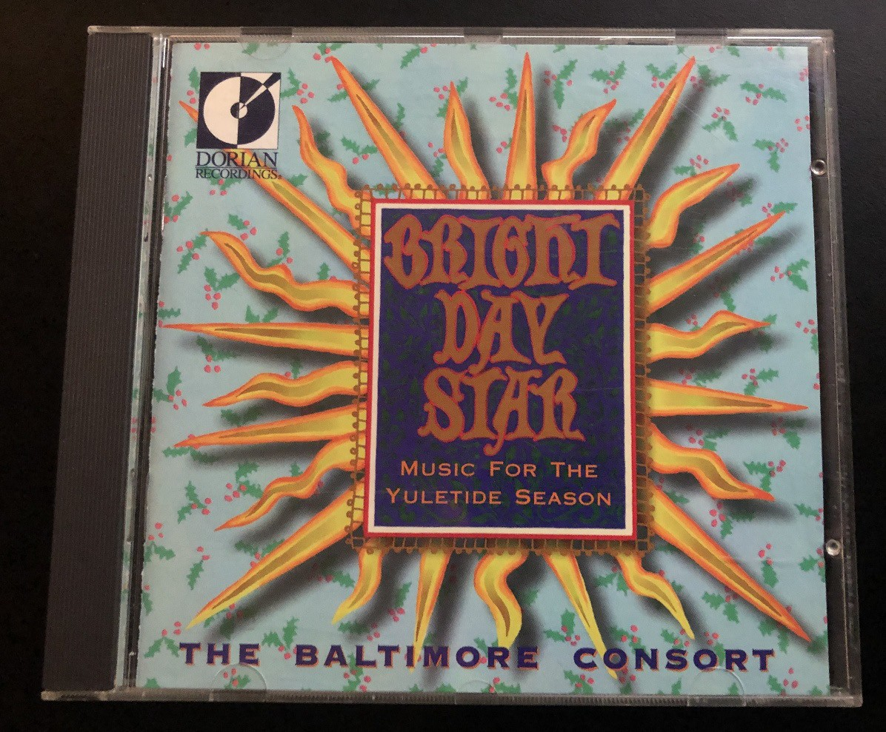

------------------------------
Anita Sundaram Coleman, PhD | Infophilia, A Positive Psychology of Information ------------------------------
Source: ALA Connect Posted Dec. 5, 2025

