Librarians We Have Lost, Sesquicentennial Memories -1976-2026: John Spears

Reprint of news release: Message to the Community about the Passing of Buffalo & Erie County Public Library Director John Spears
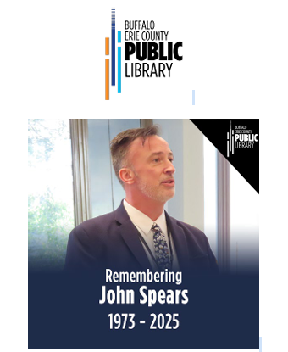

Buffalo, N.Y., July 21, 2025 - It is with great sadness that the Buffalo & Erie County Public Library System announces the passing of Library Director John Spears following a courageous battle with cancer. John died on Sunday, July 20, 2025 at the age of 51.
John Spears was appointed Library Director in Buffalo in April 2022 following a national search. He brought with him more than 25 years of library management experience having worked in libraries in Colorado, Missouri, Illinois, and Utah.
John Spears will best be remembered for his leadership in advocating to protect intellectual freedoms. He was known for taking a prominent stance in encouraging funding for libraries to continue to provide free, equal, and equitable access to information for everyone.
For the Buffalo & Erie County Public Libraries, John is also credited with taking immediate actions in early 2023 to ensure public safety at the downtown Central Library when the difficult decision was made to close temporarily in the wake of safety concerns caused by an influx of teenagers each afternoon.
In 2024, Director Spears was honored by the New York Library Association (NYLA) for innovative leadership in fostering relationships with all sectors of the community and libraries. He was also an active member, advocating for library funding and resources, through speaking engagements and published articles for the Western New York Library Resources Council (WNYLRC), New York Library Association (NYLA), American Library Association (ALA), Library Leadership and Management Association, the International Federation of Library Associations, and Public Libraries Magazine.
John leaves behind his partner, Brian Dimit, his father, brother, and sister, and many friends in the library, Elmwood neighborhood and the Buffalo Quaker communities.
A public Celebration of Life featuring music, slides, speakers and a video, was held on August 20, 2022 at the downtown Buffalo Central Library. More than 250 attended onsite and over 100 from all over the world watched via Zoom. Tributes came from all over including from the international library community who expressed how John Spears had touched many lives.
Donations in honor of John Spears can be made to the Library System’s Freedom to Read campaign at: https://bl.buffalolib.org/SpearsMemorial

Contact: Joy Testa Cinquino Assistant Deputy Director, Development & Communications Buffalo & Erie County Public Library Central Library 1 Lafayette Square Buffalo, New York 14203 716-858-7182 testaj@buffalolib.org
Photo 1: Members of the Spears family who came to Buffalo for the Celebration of Life on August 20, 2025. They are standing in front of an outdoor library wall tribute to John Spears. (photo credit Joy Testa Cinquino)
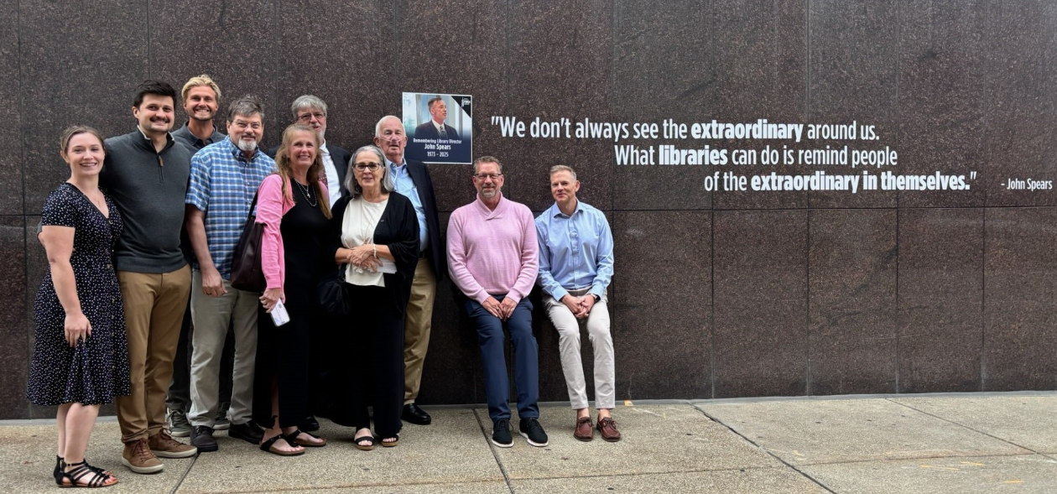
Photo 2: Buffalo Library Director John Spears with library partners from Project Flight of Western New York (photo courtesy of Buffalo & Erie County Public Library)


Photo 3: Buffalo Library Director John Spear announcing the Freedom to Read campaign featuring new library cards (2023) (photo courtesy of Buffalo & Erie County Public Library)
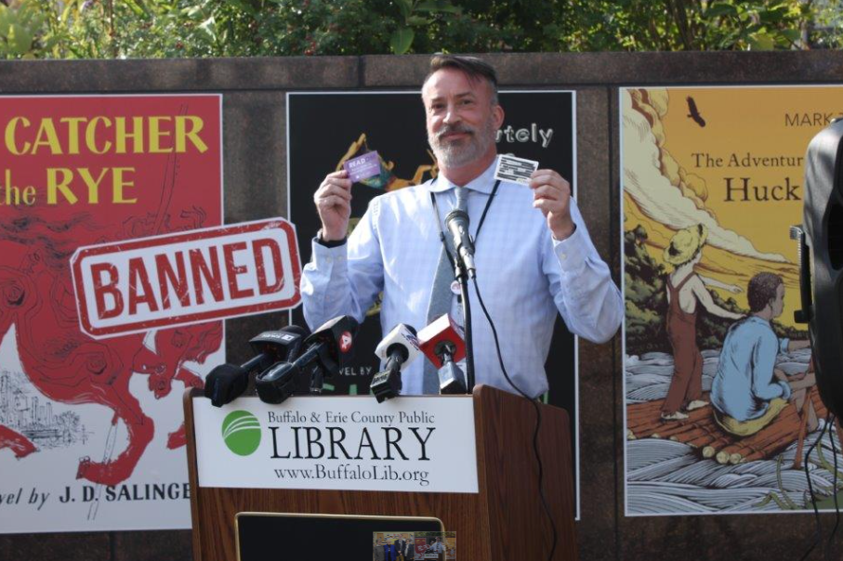
Photo 4: Library Director John Spear at the reopening of the Isaías González-Soto Branch Library in Buffalo (March 2025) (Photo courtesy of Buffalo & Erie County Public Library)

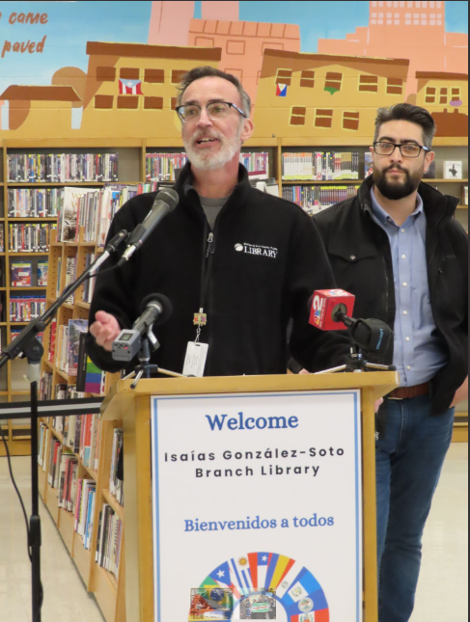

Photo 5: Library Director John Spears (far right) is joined by the Erie County Executive and Library Trustees to announce Fine Free Buffalo & Erie County Public Libraries. (April 2022) (Photo courtesy of Buffalo & Erie County Public Library)

Celebration of Life Program
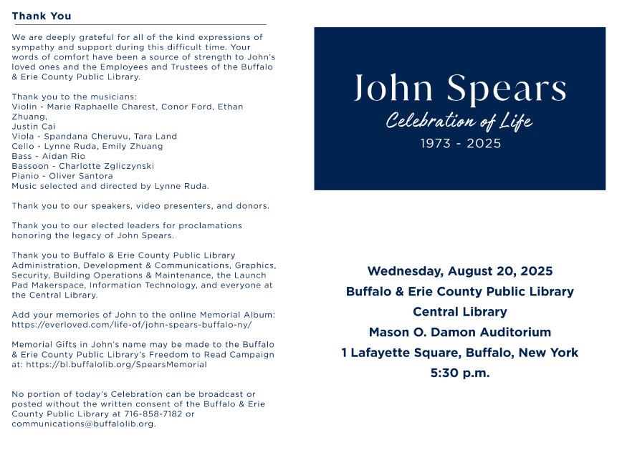

A memorial for John Spears is also available at https://everloved.com/life-of/john-spears-buffalo-ny/

Tribute submitted by Joy Testa Cinquino

Additional tribute added by Rachel Fleming (December 8, 2025):
Core Board of Directors Meeting SEPTEMBER 2025 DOC #26.02 1 page DRAFT Memorial Resolution Honoring John Spears (1974-2025)
Whereas John Spears was a dedicated and energetic leader, an inspiring mentor, and exemplary of professional service to members of LLAMA and its predecessor, the Core Division of the American Library Association, during more than twenty-five years of membership;
Whereas John Spears spent much of his career leading public libraries across the country, Joliet PL (IL), Naperville Public Library (IL); Salt Lake City Public Library (UT); Pikes Peak Library District (CO) and Buffalo & Erie County Library (NY), where he championed serving diverse populations; Whereas John Spears actively participated in the Library Leaders and Management Association, serving as its president (2016/2017), chair of the LLAMA Reorganization Task Force (2015-2017), Public Libraries Advisory Committee (2013-2017), American Library Association Professional Ethics Committee, and many other committees;
Whereas John Spears made exceptional contributions to other professional organizations, including the American Library Association, the Library Administration and Management Association, the Freedom to Read Foundation, the Intellectual Freedom Round Table, the Public Libraries Association, and actively participated in state library associations, where he served, and most recently, the New York Library Association;
Whereas John Spears was recognized with a prestigious award: the Mary Bobinski Innovative Public Library Director Award (2024/NYLA);
Whereas John Spear’s generosity, kindness, dedication, and passion will be missed by all who knew him; now, therefore, be it Resolved, that the American Library Association (ALA), on behalf of its members:
1. Honors the life and leadership of our friend and colleague, John Spears, and thank him for his dedication and excellent service; and
2. Extends its deepest sympathy to his partner, Brian Dimit, and his family.

