Spencer Gilbert Shaw
August 15, 1916 - June 16 2010

Spencer Gilbert Shaw’s librarian career spanned over the course of 45 years, working mainly in
Hartford, Connecticut, New York, New York, and Seattle, Washington. He was the first
African-American librarian hired at the Hartford Public Library, eventually becoming branch manager, and made a point to break barriers regarding his race throughout his career.

Growing up in Hartford, CT, his parents and family heavily encouraged literacy, a college education, and pursuing a fruitful and purposeful career. Because literacy and education were emphasized throughout his life, a career in librarianship were obvious choices to him.

Dr. Shaw received his B.S. from Hampton University in 1940, his Bachelor of Library Science from University of Wisconsin–Madison in 1941, and advanced graduate studies from the
University of Chicago Graduate Library School in 1949. Shaw’s focuses as a librarian were community engagement, increasing child literacy rates, and overal patronage at the library.

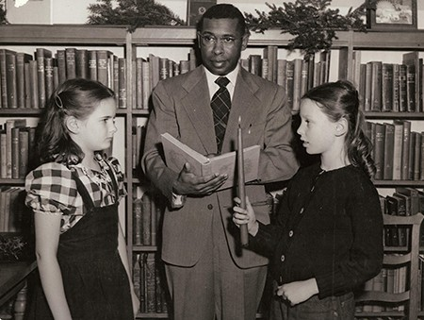
Shaw leading children’s storytime, 1950

Shaw was incredibly active throughout the country, often visiting different colleges and university libraries, lead storytimes at different schools, engaged with teachers and educators to
better their own classroom engagement, and frequently appeared on radio and television shows. Additionally, he worked with people learning English, visited hospitals and frequently initiated outreach to get more and more people into the library.
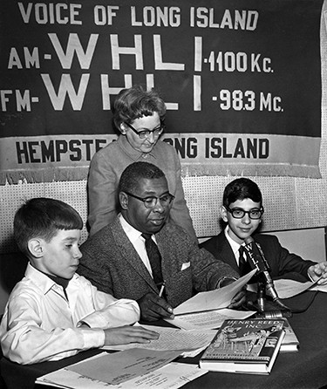
Shaw and children on the radio, Long Island, NY

Shaw then became a professor at the University of Washington in Seattle, WA. In regards to his cross-country move from New York to Washington State, on the phone with his mother “In a
family conference, my mother asked, ‘Seattle?’ ‘Yes, Mother,’ I replied. ‘But what if you got sick?’ ‘They have hospitals in Seattle, Mother!’” (UW iSchool, 2011).

Throughout his tenure at UW, Shaw was able to engage with more countries and expand multiculturalism into children’s literacy and library programming. Upon retirement in 1986,
Shaw moved back to the East Coast and continued to volunteer as a storyteller with the Hartford Public Libraries, where his career first blossomed.

Shaw passed away June 16th, 2010 at the age of 93, but his legacy and impact is certainly to be remembered and celebrated for generations to come.

References

iSchool, U. of W. (2011, January 27). Spencer G. Shaw, 1916-2010. Spencer G. Shaw, 1916-2010 | Information School | University of Washington. https://ischool.uw.edu/news/2020/07/spencer-g-shaw-1916-2010
School, U. of W. I. (2010, June 16). UW iSchool mourns loss of Spencer G. Shaw. UW iSchool mourns loss of Spencer G. Shaw | Information School | University of Washington. https://ischool.uw.edu/news/2017/01/uw-ischool-mourns-loss-spencer-g-shaw
Hamilton, A. (2010, July 18). A Pied Piper of Children’s Stories. A Pied Piper of Children’s stories - hartfordinfo.org.
http://www.hartfordinfo.org/issues/documents/history/htfd_courant_071810.asp

