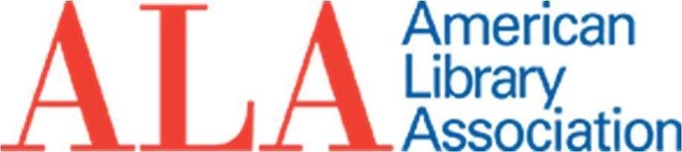

MEMORIAL RESOLUTION HONORING JENNIFER FORD PAUSTENBAUGH

Whereas Jennifer Ford Paustenbaugh, a renowned library leader and, since 2013,
University Librarian at Brigham Young University, died November 23, 2019;
Whereas Jennifer Paustenbaugh’s career included service at Oklahoma State University as Associate Dean of Libraries for Planning and Assessment and in prior positions as Head of the Patent and Trademark Library, Director of Library Development, Puterbaugh Foundation Professor of Library Service and Head of Special Collections and University Archives, and as the Executive Director of the Women's Archives;
Whereas, Jennifer Paustenbaugh represented the BYU library in national associations such as the Association of Research Libraries (ARL), The Greater Wester Library Alliance
(GWLA), the Utah Academic Library Consortium (UALC), The Consortium of Church Archives and Libraries (CCLA), and many other organizations;
Whereas, Jennifer Paustenbaugh transformed library services, programs, and structures to make them more student focused and developed new ways for students to access scholarly resources, ensuring that students will benefit from her influence for years to come;
Whereas, Jennifer Paustenbaugh served the American Library Association (ALA) and its various divisions continuously for twenty nine years, from 1990 through 2019;
Whereas, Jennifer Paustenbaugh served the Library Leadership and Management
Association (LLAMA) through a variety of appointments, most recently as Chair of the LLAMA President’s Planning Committee;
Whereas, Jennifer Paustenbaugh served the Association for Library Collections and Technical Services (ALCTS) as the chair of ALCTS’ first Fundraising Committee, through which she shared considerable expertise not widely held at that time among the membership and brought cohesion and consolidation to a previously piecemeal fundraising program, resulting in greater dollars being raised and directed to ALCTS key priorities; and
Whereas, Jennifer Paustenbaugh served the Association for College and Research
Libraries (ACRL) as a longtime member and through service on the ACRL/RBMS Conference Planning Committee; now therefore, be it

Resolved, that the American Library Association (ALA), on behalf of its members:
- honors the life, leadership, and service of our colleague, Jennifer Ford
Paustenbaugh, with thanks for her outstanding contributions to librarianship; and
- extends its deepest sympathy to Jennifer’s husband, Richard Paustenbaugh, her children, Erik and Kristen, and other family and many friends.

Adopted by the Council of the American Library Association
Tuesday, January 28, 2020, in Philadelphia, PA
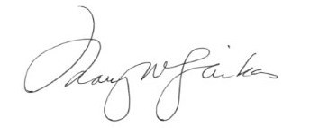
Mary W. Ghikas, Executive Director and Secretary of the ALA Council

