Marcus Allen McCorison--Librarians We Have Lost, Sesquicentennial Memories -1976-2026
Original Message:
Sent: 7/14/2025 11:10:00 PM
From: Brett Spencer
Subject: Marcus Allen McCorison--Librarians We Have Lost, Sesquicentennial Memories -1976-2026 Marcus Allen McCorison https://www.americanantiquarian.org/marcus-mccorison
McCorison was known as the "Tiger of Rare Book Librarians" and the "Grand Acquisitor."
This obituary was created by the American Antiquarian Society. Thanks to Dr. Anita Coleman for sending the link.
--------------------------------------------------------------------------------------------------------------------
In honor of the Sesquicentennial next year (150th Anniversary of ALA) in 2026, the Library History Round Table is hosting Librarians We Have Lost, Sesquicentennial Memories -1976-2026. This collage of tributes seeks to honor librarians who died between 1976-2026. The tributes are published to ALA Connect and a digital memorial on LHRT News & Notes.
We invite tributes from anyone about any library worker who passed away between 1976-2026. To submit a tribute, please use the form at https://lhrt.news/librarians-we-have-lost-sesquicentennialmemories-1976-2026-2/
For questions or comments, please reach out to Dr. McCook (kmccook@usf.edu) or Brett Spencer (dbs21@psu.edu).

------------------------------
Brett Spencer
Reference Librarian
Thun Library, Penn State Berks
He/Him/His ------------------------------ Posted Jul 16, 2025 01:09 PM
Thanks, Brett!
I wish I had been able to write a tribute myself to share some of the delightful insights I've uncovered during my research. One intriguing coincidence: next year marks the 100th anniversary of Marcus Allen McCorison (d. 2013), antiquarian, librarian, and bibliographer extraordinaire was born on July 17, 1926. Coincidentally, our sesquicentennial will celebrate the founding of the ALA on April 6, 1876.
His 1991 Jayne Lecture, "Humanists and Byte-Sized Bibliography: Or, How to Digest Expanding Sources of Information," published in the Proceedings of the American Philosophical Society, Vol. 135, No. 1 (Mar. 1991), pp. 61-72, is a fabulous read that explores how library research has changed over the past 25 years.
In the past, researchers would travel to various cities, stay in budget accommodations, and manually search through library card catalogs to gather information for their work. They took handwritten notes and returned home to write their findings. However, this romanticized approach has shifted dramatically. Today, researchers often rely on grants and funding, using technology like computers instead of traditional card catalogs. This transformation has altered the nature of scholarship, making it more dependent on financial support and technological tools. His opening para is authentically written with humor! His focus is on humanities research (development and digitization of the ESTC). But his insights will resonate with anyone who began their library careers in the 1970s, 1980s, and even early 1990s.
Another more recent McCorison's paper also deserves mention, particularly in light of the ongoing challenges to intellectual freedom and the evolving definitions of "obscenity" today. Titled "Printers and the Law: The Trials of Publishing Obscene Libel in Early America," it was published in The Papers of the Bibliographical Society of America, Vol. 104, No. 2 (June 2010), pp. 181-217. It provides valuable historical context that can inform our understanding of contemporary issues surrounding censorship and the rights of publishers.
Anita
Anita Sundaram Coleman, PhD | infophilia, a positive psychology of information | iSchool@Illinois Posted Aug 24, 2025 01:49 PM

Librarians We Have Lost, Sesquicentennial Memories -1976-2026: Marcus A. McCorison
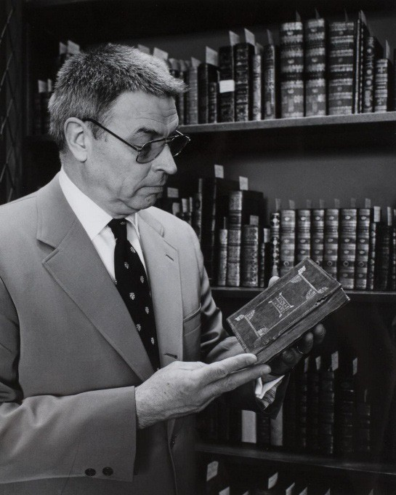
Marcus A. McCorison (1926 –2013) was a bibliographer, librarian and historian of American printing and book history. He was President of the American Antiquarian Society (AAS). He was also president of the Bibliographical Society of America.
McCorison served with the United States Naval Reserve during World War II. He graduated from Ripon
College in 1950 and earned master's degrees from the University of Vermont (1951) and Columbia University, School of Library Service (1954). His graduate study was interrupted by U.S. Army service as a first lieutenant in Korea in 1951–52.
His first professional position was at the Kellogg Hubbard Library in Montpelier, Vermont. In 1955 he became the chief of rare books at Dartmouth College.
McCorison was appointed librarian at the American Antiquarian Society in 1960. He was sometimes referred to as the "Grand Acquisitor," as he expanded the Society's holdings by 115,000 items and provided access to the Society's collection with a machine-readable catalogue system. He established a fellowship program for visiting scholars. He grew the AAS endowment. The Wall Street
Journal characterized him as tracking down rare books like a hungry wolf. He retired from the AAS in 1992.

Selected Publications
- McCorison, Marcus A. (2010). "Printers and the Law: The Trials of Publishing Obscene Libel in Early America." The Papers of the Bibliographical Society of America 104: 181– 217.
- McCorison, Marcus A. (2007). "Bibliography and the Book Trades: Studies in the Print Culture of Early New England." The Papers of the Bibliographical Society of America 101
(2): 221–25.
- McCorison, Marcus A. (1991). "The Annals of American Bibliography, or Book History, Plain and Fancy." Libraries & Culture 26.1: 14–23.
- McCorison, Marcus A. (1984). "Bibliography and Libraries at the Brink: A Jeremiad." The Papers of the Bibliographical Society of America 78.2.: 127–136.
- McCorison, Marcus A. (1981). Isaiah Thomas, the American Antiquarian Society and the Future. Worcester, Mass.: Reprinted from American Antiquarian Society. Proceedings of the American Antiquarian Society 91.
- McCorison, Marcus Allen.(1961). "A Bibliography of Vermont Bibliography and
Printing." The Papers of the Bibliographical Society of America 55.1 (1961): 17–33.

Sources
Winship, Michael. "Marcus Allen McCorison: 17 July 1926–3 February 2013." The Papers of the Bibliographical Society of America 107.2 (2013): 146–150.
Marcus Allen McCorison.1926-2013 American Antiquarian Society.
William M. Bulkeley. A rare-book hunter tracks down quarry like a hungry wolf --- antiquarian society's director finds supplies dwindling, adding to the challenge. Wall Street Journal. May 06 1986.
------------------------------
Kathleen de la Peña McCook
Distinguished University Professor
School of Information
University of South Florida ------------------------------ Source: American Antiquarian Society website: https://www.americanantiquarian.org/marcus-mccorison

Marcus Allen McCorison
1926-2013
Marcus A. McCorison, 86, described by the Wall Street Journal in 1986 as the tiger of rare book librarians, died, surrounded by his family, on February 3, 2013, in Worcester, Massachusetts.
McCorison’s skills as a noted librarian, bibliographer, and scholar of early American printing were informed by his intense personal interest in American cultural history. He was named president emeritus of the American Antiquarian Society at his retirement in 1992, following thirty-two years of distinguished service as the Society’s librarian, director and then president. McCorison, sometimes referred to as the “Grand Acquisitor,” expanded the Society’s holdings by some 115,000 items and greatly enhanced access to the Society’s collection by creating a machine-readable catalogue system and encouraged the production of bibliographies that would include AAS holdings. He laid the foundations for a scholarly community through the establishment of the fellowship program to draw visiting scholars from around the world to Worcester. McCorison also enlarged the institution’s endowment with vigorous and successful fundraising campaigns and personal appeals to potential donors.
After serving with the United States Naval Reserve during World War II, McCorison graduated from
Ripon College in 1950 and earned masters degrees from the University of Vermont (1951) and Columbia University (1954). His academic study was interrupted by U.S. Army service as a first lieutenant in Korea in 1951-52. His first professional position was of the Kellogg Hubbard Library in Montpelier, Vermont. In 1955 he became the chief of rare books at Dartmouth College. McCorison served as of Special
Collections at State University of Iowa in 1959. After accepting the position of librarian at the Society in 1960, McCorison moved to Worcester and gradually became involved with most of the historical associations in the region. He was a trustee of The Fruitlands Museum in Harvard, Massachusetts until 1989 and was a trustee of both Old Sturbridge Village and Historic Deerfield. He was a member of the
Club of Odd Volumes, the Society of Printers, the Colonial Society of Massachusetts, the Massachusetts
Historical Society, Worcester Club, Worcester Fire Society, St. Wulstan Society, and United
Congregational Church. McCorison was also an honorary member of the New-York Historical Society, Ephemera Society of America, Zamorano Club of Los Angeles, the Century Association, and the Roxburghe Club of San Francisco.
His professional contributions include service as president of the Bibliographical Society of America, on the Board of Governors of the Research Libraries Group, as a founder of the Independent Research Libraries Association, trustee of the Vermont Historical Society, and councilor of The Grolier Club.
McCorison’s consultancies included the National Endowment for the Humanities, Folger Shakespeare Library, Independent Research Libraries Association, Library of Congress, and the Newberry Library. He was awarded Distinguished Alumnus Awards from Ripon College and Columbia University’s School of Library Service. Honorary degrees were bestowed on McCorison from Assumption College, Clark University, College of the Holy Cross, and the University of Vermont.
McCorison authored numerous books, pamphlets, and scholarly articles. In 1963, after thirteen years of research, he published his Vermont Imprints, 1778-1820, which lists every known item printed in Vermont before 1821. His essay entitled "The Annals of American Bibliography, or Book History Plain and Fancy" was published by the University of Texas in 1991, the same year his "Humanists and Bytesize Bibliography, or How to Digest Expanding Sources of Information" appeared in the Proceedings of the American Philosophical Society. McCorison produced dozens of catalogues and articles on the history of American printing and printers, including "Isaiah Thomas, The American Antiquarian Society and the Future" (1981), and "Early American Bookbindings from the Collection of Michael Papantonio"
(1983). Recently, McCorison completed the essay, “Percy Grassby 1882-1972, An Outsider Inside Boston’s World of Print” (2012), designed by his great friend and collaborator, Roderick Stinehour for the Society of Printers and “Benjamin Tighe, Book Scout, 1895-1975” for the Baxter Society (2012).
Marcus McCorison was born on July 17, 1926, in Lancaster, Wisconsin, son of Rev. Dr. Joseph Lyle McCorison, Jr., and Ruth Mink McCorison, formerly of East Corinth, Vermont. Marcus was married for forty-eight years to Janet Buckbee Knop, who died in 1998. He was predeceased by a daughter, Mary (Mrs. Joshua L. Rosenbloom).
He is survived by his dear friend, Carolyn Knight Dik; a sister, Virginia Simmons; four sons, Marcus II and wife Helen, Andrew and wife Stacey, James and companion Karen, Peter and wife Catherine; a daughter, Judith and husband Jeffrey Gove, and eleven grandchildren: Emily, Justin and Molly Gove; Sarah and
Matthew McCorison; Samuel and Melanie McCorison, Jacob McCorison; Benjamin, Nathan and Timothy Rosenbloom. Marcus’ accomplishments were many, none more so than the respect and abiding love of his family and friends.
Worcester, MA United States

Elected to AAS
April 1960

