Father James J. Kortendick, PhD (1907-1986)

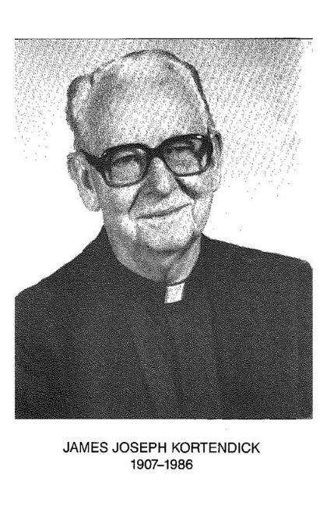

Father James J. Kortendick, PhD ([ 1907-1986) was director the Department of Library and Information Science at the Catholic University of America from 1941-1972.
In 1963 he earned the PhD from The Catholic University in education. His doctoral thesis was a study of Catholic theological seminary libraries in the United States

He was President of the Association for Library and Information Science Education (ALISE) in 1969/70; and President of the District of Columbia Library Association from 1952 to 1954.
He was honored with the American Library Association Beta Phi Mu Award for distinguished service to library education in 1966.
*****

Born on March 19, 1907, Father Kortendick was one of five children born to Lawrence V. and Margaret (nee Dooley) Kortendick in Pecatonica, IL. After the family moved to Milwaukee, WI, he received his secondary education at Marquette University High School.
In 1926, James entered St. Charles College, Catonsville, MD, to begin studies for the priesthood, completed his preparation at St. Mary’s Seminary, Baltimore, and was ordained for the Archdiocese of Milwaukee and for service with the Society of St. Sulpice on May 26, 1934.
Father Kortendick’s first assignment after ordination was as a teacher of English and religion at the seminary of St. Edward’s in Seattle, where he also began graduate studies in English literature and education at the University of Washington to comply with State accreditation norms.
Returning to Baltimore in 1936 for the Sulpician year of formation, Father Kortendick also taught English at St. Charles College, was admitted to the Society in 1937, and at the same time received an appointment to St. Mary’s Seminary to teach English and speech and also to serve as the librarian and treasurer.
The primary direction of Father Kortendick’s Sulpician ministry, however, had been found in his appointment as seminary librarian, for which he had no formal training, although he had served two years as a librarian assistant while a seminarian.
In 1939, he began that training as a full-time student at The Catholic University of America in Washington, D.C. Receiving his L.S.B. degree, he continued at the University with graduate studies in education and philosophy, when, in early 1941 serious illness of the University librarian led to a request that Father Kortendick become full-time reference librarian, which, in effect, made him acting librarian of the University and head of the department of library science.
In 1942, he was also appointed to the faculty of Theological College as a spiritual director of seminarians, a post he would hold until 1969.
In 1946, following the appointment of a new University librarian, Father Kortendick was appointed an assistant professor and chairman of the Department of Library Science, the department he had been directing for five years.
He successfully managed the accreditation process, and the department was accredited by the American Library Association as a graduate library school in 1946/47.

During the succeeding years he became increasingly involved with professional activities in the library field.
For the American Library Association these included:
- President of the library education division 1960-1961.
- Chairman of the library administration development committee, 1964-1965.
- From 1967 to 1969, he was a member of the committee on liaison with accrediting agencies of the Association of College and Research Libraries.
- Beta Phi Mu American Library Association distinguished service to library education in 1966.
For the Association for Library and Information Science Education (ALISE)
- President, 1967-1970
For the Catholic Library Association these included
- Executive Council from 1943 to 1952
- Chairman of the committee on the Catholic Periodical Index from 1950 to 1958

In 1974, Father Kortendick was awarded the Benemerenti Medal from Pope Paul VI for distinguished services on the faculty of The Catholic University, and, in the same year, he was presented the distinguished service award of The Catholic University in recognition of devoted and outstanding leadership in the field of higher education.
In 1972, Father Kortendick retired as chairman of the department of library science but taught there for one more year and then took one year of sabbatical leave.
In 1972 in Milwaukee, he served as interim director of the Marquette University libraries until the following September when a new librarian had been found. The position also included overseeing the University archives.
During the next two years, Father Kortendick retired at Theological College in Washington, while also chairing The Catholic University’s Friends of the Library and serving on the Sulpicians' provincial finance committee.
He received a new invitation to use his professional skills, this time from St. Patrick’s Seminary in Menlo Park, which needed an interim librarian. He eagerly accepted the position and began his new work in California in September 1976 adding to his schedule a one-semester course that he taught at San Jose State University.
in the fall of 1978, he moved back to Baltimore and took up residence in St. Charles Villa. Even then he undertook to chair the Sulpician archives committee for a year.

Selected Publications

Kortendick, James J., and Elizabeth W. Stone. 1971. Job Dimensions and Educational Needs in Librarianship. Chicago: American Library Association.
Kortendick, James J., Elizabeth W. Stone, and Catholic University of America Department of Library Science. 1970. Post-Master’s Education for Middle and Upper-Level Personnel in Libraries and Information Centers. [Washington]: U.S. Office of Education, Bureau of Research.
Kortendick, James J. “Continuing Education and Library Administration.” ALA Bulletin 61, no. 3 (1967): 268–72.
Kortendick, James J. 1966. (preface) An Index to G.K. Chesterton. Edited by Joseph W. Sprug. Washington, D. C.: Catholic University of America Press.
Kortendick, James J. 1963. The Library in the Catholic Theological Seminary in the United States.
Washington, D.C.: The Catholic University of America Press. (review: Heckman, Marlin L. 1966. “The Library in the Catholic Theological Seminary in the United States . James J. Kortendick.” The Library Quarterly 36 (2): 170–71.)

Catholic University of America, and Eugene Paul Willging. 1958. “A Survey of Catholic Americana and Catholic Book Publishing in the United States, 1831-1900 : [A Series of Eleven Masters Dissertations in Library Science Prepared by Graduate Students under the Direction of Eugene P. Willging as Major Professor and James J. Kortendick as Reader].” Dissertation.
Kortendick, James J. “THE AALS THE USBE.” Newsletter (Association of American Library Schools) 8, no. 2 (1956): 12–14. http://www.jstor.org/stable/43945322.

Workshop on the Production and Use of Technical Reports Catholic University of America) (1953 :, and Bernard M. Fry. 1955. The Production and Use of Technical Reports; the Proceedings of the Workshop on the Production and Use of Technical Reports Conducted at the Catholic University of America from April 13 to April 18, 1953. Edited by James J. Kortendick. Washington: Catholic University of America Press.
Kortendick, James J. 1942. “The History of St. Mary’s College, Baltimore, 1799-1852.” Dissertation. Catholic University of American
Kortendick, James J., and Elizabeth W. Stone. 1970. “Education Needs of Federal Librarians.” Drexel Library Quarterly 6 (3/4): 264–78.

Sources
• Kortendick, Father James Joseph. Sulpician Necrology. Society of St. Sulpice. August 20, 1986.

