Mrs. Irene O. Hendrick (approximately 1890-1992), Asheville, Buncombe, North Carolina.
Irene O. Hendrick, born Irene Stewart, was born appx. 1890 in Florida, who moved to
Asheville, Buncombe County, North Carolina in 1926 to accept the role of Head Librarian at the Asheville Colored Library (1927-1966) —now known as the Pack Memorial Library. Sponsored by the Young Men’s Institute (YMI), it officially became the first Negro library in Buncombe County. Its opening started a revolution where black leaders of Asheville discovered that lobbying and negotiation could help improve the neighborhood.
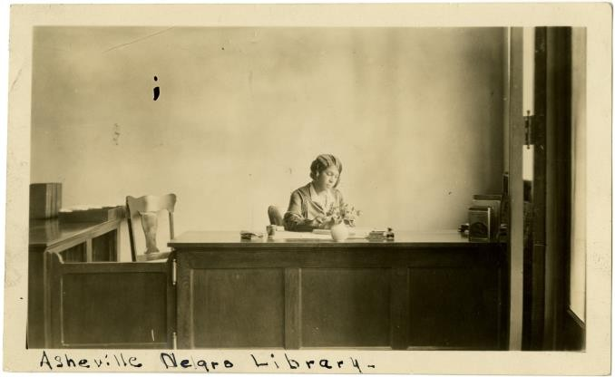
Librarian Irene Hendrick. State Archives of North Carolina.
She was a wife, mother, and beloved librarian. Hendrick married Robert McKinney
Kendrick, Sr., and would later welcome her son, Robert Kendrick Jr., in 1917. As the first African American librarian and manager of Asheville's first black library, Mrs. Irene Hendrick continued to be a community advocate. As part of her profession, she taught community people how to read and gave job training to local women. She campaigned for the inclusion of books about African Americans in the collection, beginning with works by historians such as Roland Hayes. She also contributed to the collection by subscribing to newspapers and other sources. She kept adding books about or authored by well-known African Americans because she wanted people in her neighborhood to recognize themselves in the literature they read. She encouraged young people to realize that they too could be leaders.
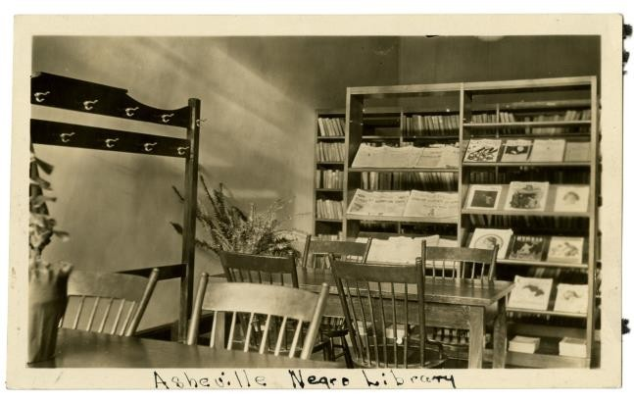
Asheville Negro Library, interior view. State Archives of North Carolina.

Up to her retirement in 1966, Mrs. Irene Hendrick remained as the Colored Library's head librarian. In 1962, the library discreetly merged with Asheville's library system, but it was still in operation. The library was renamed the Market Street Branch and moved to a new location shortly after retirement, effectively ending segregation. Despite her retirement, Kendrick joined Friends of the Library and continued to support libraries. She would pass away on March 26th, 1992.

Matthieu Castillo
University of South Florida

Sources:
Parker, P.S. (2016). Appalachian Activists: The Civil Rights Movement in Asheville, NC. [Master’s Thesis, Appalachian State University.] Department of History. https://libres.uncg.edu/ir/asu/f/Parker,%20Patrick_2016_Thesis.pdf
Calder, T. (2018). Asheville Archives: Irene Hendrick and the Colored Library, 1927-1966. Mountain Xpress. https://mountainx.com/news/asheville-archives-irene-hendrick-andthe-colored-library-1927-1966/
North Carolina Digital Collections. (n.d.) Asheville Negro Library, interior view. [Photograph]. State Archives of North Carolina. https://digital.ncdcr.gov/Documents/Detail/ashevillenegro-library-interior-view/48296

North Carolina Digital Collections. (n.d.) Asheville Negro Library. Librarian seated at public desk.
[Photograph]. State Archives of North Carolina. https://digital.ncdcr.gov/Documents/Detail/asheville-negro-library.-librarian-seated-atpublic-desk/48298

