Cynthia Graham Hurd: "Libraries are always inclusive" (Librarians we have lost,
ALA Sesquicentennial Memories, 1976 - 2026)
Posted Nov 14, 2024 10:05 PM
Dear Colleagues,
Today, in a small gesture of tribute, I shared Cynthia Graham Hurd's story and impact on me at our panel session Charting Turbulent Skies: Can Libraries Sustain Anti-Racist Efforts in Our Politicized Climate? at the Charleston Conference 2024. I will never forget Cynthia's life and values-a reminder of what librarians can stand for: resilience, justice, and above all, inclusion. May all librarians and information professionals strive to honor her vision by championing libraries as places of peace and inclusion, even amid turbulent times.
Cynthia Graham Hurd (1960–2015) was a beloved librarian and community leader in Charleston who served her community for over 31 years. Guided by her conviction that "Libraries are always inclusive, never exclusive," she devoted her life to fostering compassion, inclusion, and public service. Her life was tragically cut short in the 2015 shooting at Mother Emanuel AME Church. Yet her legacy lives on through the Cynthia Graham Hurd Foundation, literacy programs, scholarships in her name, and the renaming of the St. Andrews Library branch, where she once managed. The City of Charleston has also honored her by designating the area around the AME Church as the Mother Emanuel Way Memorial District.
Two memorials to Cynthia have a special meaning for me. Though I never met Cynthia or the other members of the Mother Emanuel Nine, their story had a profound impact on my life. Inspired by them, I returned to library work, creating the Anti-Racism Digital Library (ADL) as a clearinghouse for antiracism, dedicated to the nine victims of the Emanuel AME Charleston 2015 shooting. Discovering that the term "anti-racism," while an official Library of Congress subject heading, was underutilized in favor of materials focused on "racism," I asked: How can we practice anti-racism if our vocabulary primarily reflects racism? In 2020, the Library of Congress added the ADL to its permanent web archive. Today, it is being reimagined by another young librarian and scholar as the Global Library for Anti-Racism and Digital Citizenship, extending Cynthia's vision of libraries as inclusive spaces that foster understanding and embrace all.
The second tribute is a living memorial of ten cherry and five elm trees planted in front of the Gaillard
Center in Charleston. The tree honoring Cynthia bears a simple but moving plaque: Mrs. Cynthia Graham Hurd, God-fearing. Compassionate. There is a lovely fountain, roses, and benches in this living memorial garden. The Gaillard Center, one of three venues hosting the 2024 Charleston Conference, lies across from the historic AME Church, where another plaque reads, Love is stronger than hate. These trees embody the spirit of compassion of the Mother Emanuel Nine, and the surviving congregation, and I've had the privilege of walking past them each day this week. The words inside the church resonate as the trees flourish nearby-a testament to the healing power of forgiveness. Over 2,200 librarians, vendors, and publishers have walked through this living memorial garden this week, several times, en route to difficult conversations, learning, and networking.
If you would like to see pictures of the living memorial garden, please let me know. Cynthia's accomplishments and service are also documented on the Cynthia Graham Hurd Wikipedia page. Thank you.
Warm regards,
Anita
Anita S. Coleman, PhD | Infophilia | Antiracism Digital Library & Thesaurus | iSchool@UIUC | BlueSky
Source: ALA Connect
Photos added 12/06/25
- Living Memorial Tribute to Emanuel AME – Mrs. Cynthia Graham Hurd
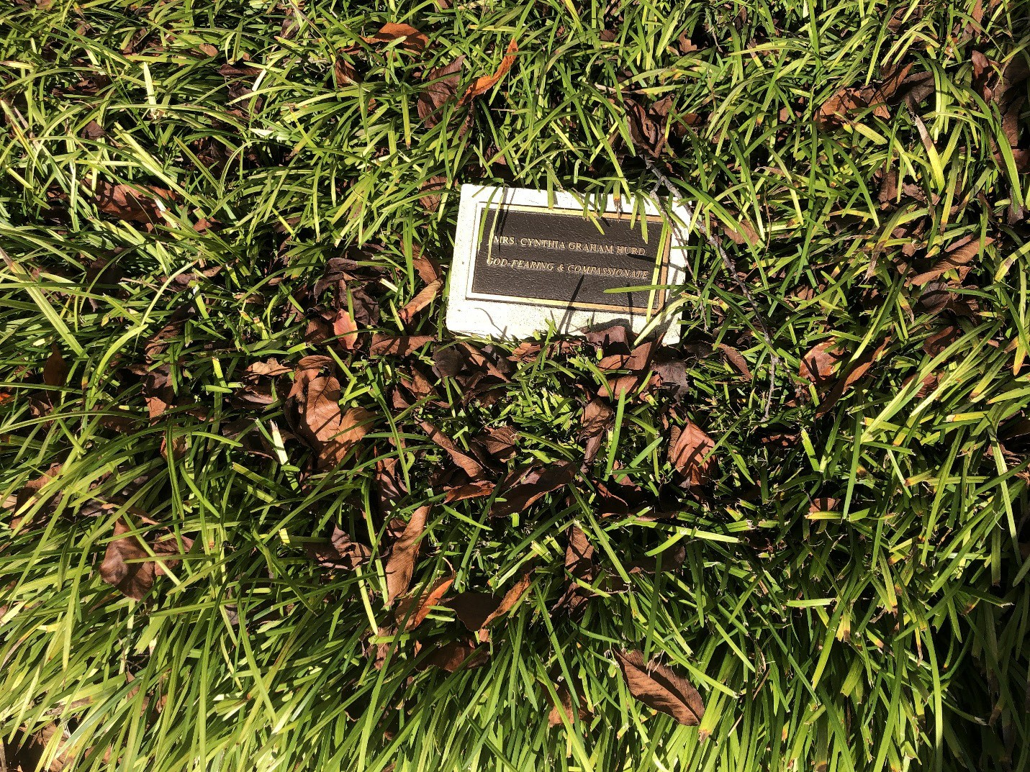

- Tribute plaque in the memorial garden in front of Gaillard Center, Charleston, SC
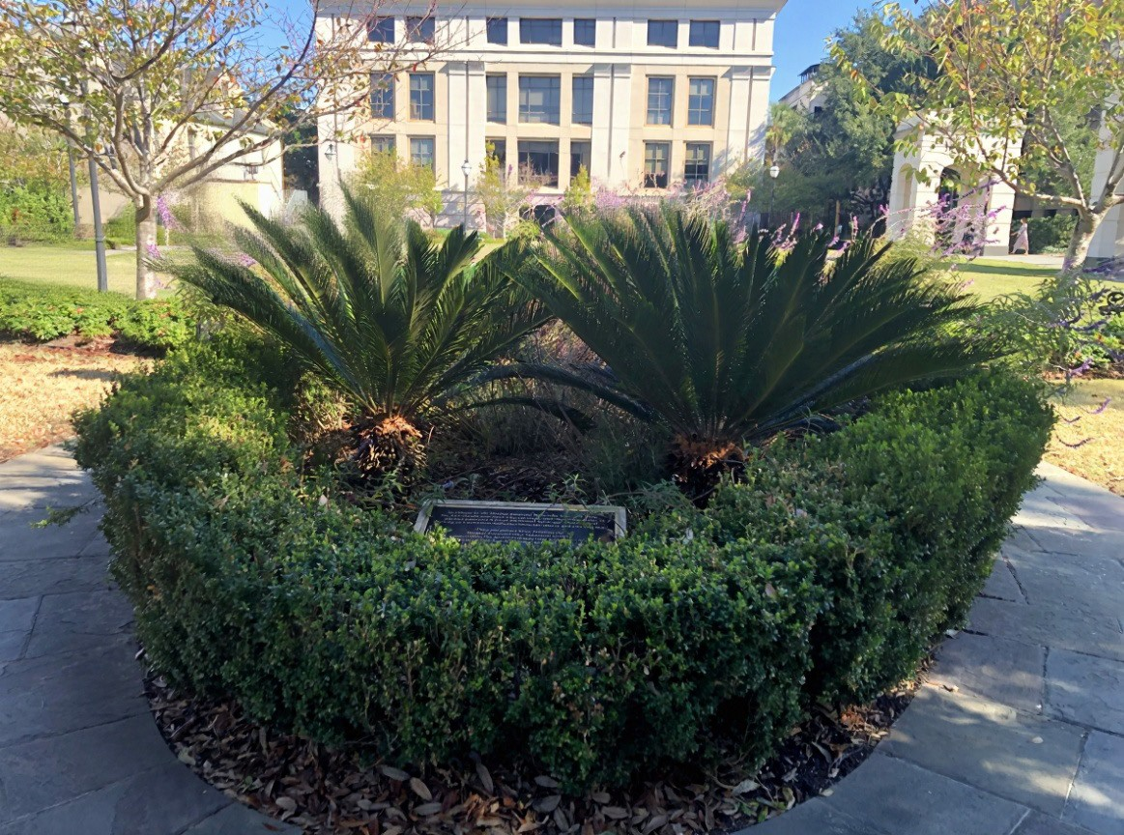
- Living Memorial Tribute to Mother Emmanuel Nine who lost their lives from City of Charleston
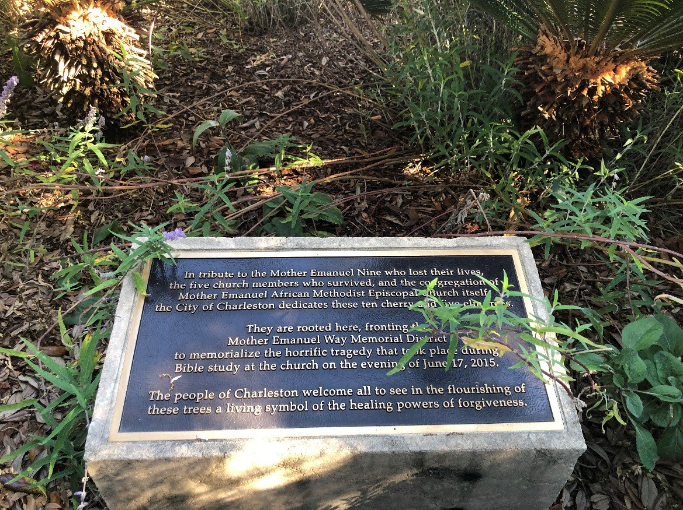
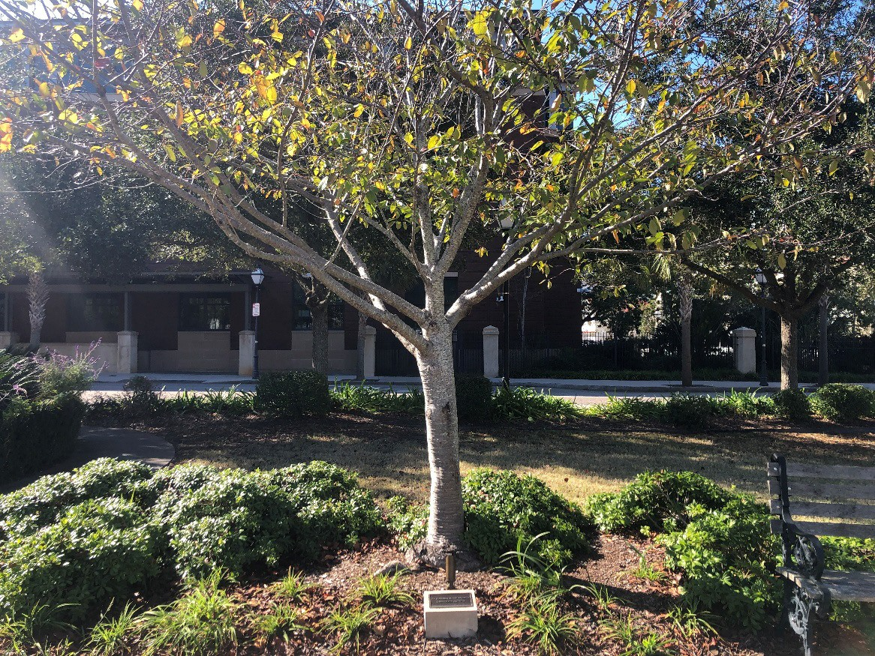
- Above: One of the living memorial trees in front of Gaillard Center
- Mother Emmanuel Church and sign showing the Memorial Emmanuel Way Historic District
