Dr. Herbert Goldhor (February 8, 1917-March 29, 2011)
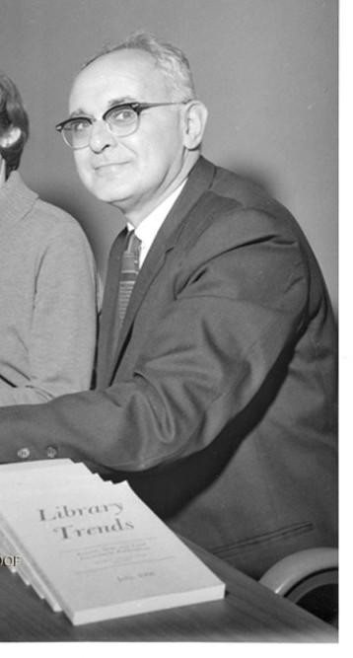

Dr. Herbert Goldhor's career as a librarian began in 1943 when he received a Ph.D. from the
University of Chicago's Graduate Library School where he completed a thesis on “The
Selection of Employees in Large Civil Service and Non-Civil Service Public Libraries.”

He served in the U.S. Army in World War II, primarily in the European Theater from 1944 to 1946, where he rose to the rank of Second Lieutenant. His military role involved libraryrelated activities, including the training of soldier-librarians to support educational and recreational services for troops following the D-Day invasion in June 1944. In a 1947 article Goldhor detailed this experience describing how he helped establish and lead training programs for enlisted personnel to manage army libraries in liberated areas like Paris by late August 1944.

After serving in the Army, he joined the Library School faculty of the University of Illinois
Urbana-Champaign where he remained for six years (1946-1951). In 1952, he moved to Indiana to become the chief librarian of the Evansville and Vanderburgh County Public Library.
Dr. Goldhor then returned to Illinois to direct the Graduate School of Library Science from 1962-1978, during which time he also taught graduate courses and published numerous articles and two books. In 1975 he became director of the school's Library Research Center, a position he held until his retirement in 1987.
Throughout his career, Dr. Golhor believed strongly that public libraries, access to information and ideas, and continued learning were essential to a democratic society.

Awards and Honors:
Krikelas, James; Bunge, Charles A. (Fall 1989). "Herbert Goldhor: A Tribute and Bibliography". Library Trends. 38 (2): 295–312.
1988. Melvil Dewey Medal from the American Library Association for “his contribution to library education, his gathering and analysis of statistics, and his leadership in library administration and professional associations.”
1987. Librarian of the Year from the Illinois Library Association.

Selected publications:
Goldhor, Herbert. An Introduction to Scientific Research in Librarianship. Urbana, IL: University of Illinois, Graduate School of Library Science, 1972.
Wheeler, Joseph L., and Goldhor, Herbert. Practical Administration of Public Libraries. New York: Harper & Row, 1962.
Goldhor, Herbert (July 1947). "The Training of Soldier Librarians in the European Theater". Library Quarterly. 17 (3): 171–184.

Sources

Herbert Goldhor papers, 1939-1981. University of Illinois Archives.
Powell, Ronald R. “Problem Solving in Libraries: A Festschrift in Honor of Herbert Goldhor.” Library Trends 38(2): 150-325, Fall 1989.
"Herbert Goldhor". Obituary. The News-Gazette. 2011-04-10. Retrieved 2025-11-01.

Linda C. Smith, Professor Emerita, School of Information Sciences, University of Illinois
Urbana-Champaign

