

A Memorial Resolution Honoring William A. (Bill) Garrison, Jr.
Whereas the American Library Association (ALA) and the academic library community lost a valued member and colleague on April 28, 2020, with the death of William A. (Bill) Garrison, Jr.;
Whereas following increasingly responsible positions at Northwestern University;
Stanford University; the University of Colorado, Boulder; and Syracuse University, Bill served as Dean of Libraries at the University of South Florida, Tampa, from 2008 to 2015;
Whereas Bill was active in the Association for Library Collections and Technical
Services (ALCTS) as Vice-Chair/Chair/Past Chair of the Cataloging and
Classification Section (CCS, now called the Cataloging and Metadata
Management Section) from 1999-2002, as member or chair of many CCS and ALCTS committees over the years, as well as in the broader ALA context as a member of the Association of College and Research Libraries, the Library Administration and Management Association and the Library and Information Technology Association;
Whereas he was nominated by ALA to be a representative to the International Federation of Library Associations and Institutions (IFLA) Cataloguing Section from 2003-2011 and, during that time, served as editor of the section’s newsletter, and was active in the work of the section’s International Standard Bibliographic Description (ISBD) Review Group;
Whereas Bill was a strong supporter of the Program for Cooperative Cataloging
(PCC) from the Program’s beginning in 1995 and served as a member of the Standing Committees on Standards and Training and the PCC Policy Committee while also serving as BIBCO, NACO and SACO trainer for newly-added PCC participants;
Whereas he was active throughout his career in the development of cataloging and classification standards, not only in the traditional context of library catalogs, but in the emerging world of metadata for digital objects, helping to develop standards for the Colorado Digitization Project, which influenced other projects across the U.S.;

Whereas Bill shared his knowledge and experience widely through publications, presentations, preparation and presentation of training workshops, consulting and mentoring;
Whereas he utilized his broad experience to develop student-driven programming and services during his tenure as Dean of Libraries at USF;
Whereas Bill was active in the Association of Research Libraries (ARL) during his service at ARL member institutions and was chosen as an ARL Leadership Fellow for 2005-2006; and
Whereas his breadth and depth of knowledge, his wry sense of humor, and his quick wit will be greatly missed by all who knew him; now, therefore, be it Resolved, that the American Library Association (ALA), on behalf of its members:
- recognizes the significant contributions of William A. Garrison, Jr., to librarianship around the world over the course of his career and mourns his death; and
- extends its sincerest condolences to his family, friends and colleagues.

Adopted by the Council of the American Library Association Saturday, June 27, 2020, ALA Virtual Council Meeting
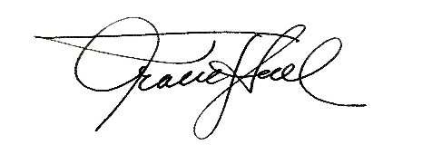
Tracie D. Hall, Executive Director and Secretary of the ALA Council

