Librarians We Have Lost, 1976-2026: Dr. Charles D. Churchwell

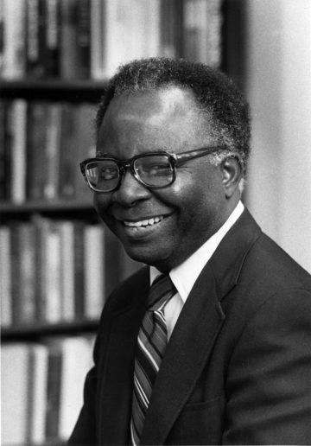

Dr. Charles D. Churchwell (1926-2018) wrote The Shaping of American Library
Education. ( ALA, 1975). He was a university administrator and library science professor
After graduating from high school, Dr. Churchwell joined the United States Army, serving for two years in the U.S. and Philippine Islands. He obtained the rank of Sergeant 4th Grade. After returning from the armed forces in 1948, Churchwell attended Morehouse College and four years later, he received his B.S. degree in mathematics. In 1953, Dr. Churchwell graduated from Atlanta University with his M.L.S. degree.
Dr. Churchwell became an instructor with Prairie View A&M College in 1954 where he met and married Yvonne Ransom. Two years later, he and Yvonne moved to New York City, New York so he could work as a reference librarian for the New York Public Library. He left New York for Illinois to earn the Ph.D. degree in library science at the University of Illinois at Urbana-Champaign.

After completing his thesis, "Education for Librarianship in the United States: Some Factors which Influenced its Development between 1919 and 1939," Churchwell received his Ph.D. in 1966, the first African American man to earn a Ph.D. degree from the university. Oral interviews with Dr. Churchwell are in the university archives.
In 1967 Dr.Churchwell became the associate director of the libraries at the University of Houston, the first African American to work for the university during a time of intense segregation. He became heavily involved with the Black Student Union during this time, working as a liaison during a controversial campus visit by Black Panther Bobby Seale.
In 1970, Dr. Churchwell became a professor of library science and director of libraries for Miami University in Ohio, where he redesigned and renovated the library.
Dr. Churchwell was the first African American director of an ARL library at Brown University in 1974.
In 1978, Dr. Churchwell was appointed Dean of library services at Washington University in St. Louis and established a unique endowment to fund the library's technical services.
After nearly a decade in St. Louis, Dr. Churchwell was appointed tenured professor with Wayne State University in Detroit.
He spent the 1990s as Dean of the School of Library and Information Studies for Clark Atlanta University, before retiring in 1999.
Dean Churchwell passed away on September 19, 2018.

Selected Publications
Charles D. Churchwell. “Educating Black Librarians: Papers from the 50th Anniversary Celebration of the School of Library and Information Sciences, North Carolina Central University.” The Library quarterly (Chicago) 1993.
Churchwell, Charles D. 1975. The Shaping of American Library Education. Chicago: American Library Association.
Abramov, K. I., and Charles D. Churchwell. 1979. System of Training Library Workers and Improvement of Their Professional Skill in the U.S.S.R / by Charles D. Churchwell. Washington, D.C.: ERIC Document Reproduction Service.

Sources
Interview with Charles Churchwell, Part 1 | IDEALS (Larry Besant interviews Dr. Charles
Churchwell about his 50-year career in academic librarianship. Dr. Churchwell was the first African-American man to receive a Ph.D. from the University of Illinois, in 1966 (in Library and Information Science). He later became the first African-American director of an ARL library (at Brown), and he spent nearly a decade as dean of the library school at Clark Atlanta.
Charles D. Churchwell's Biography
Dr. Charles D. Churchwell, former SIS faculty member and Dean of the Washington
University Libraries, passes away at 91 - School of Information Sciences - Wayne State University
Obituary: Charles D. Churchwell, former dean of University Libraries, 91 September 27, 2018

------------------------------
Kathleen de la Peña McCook
Distinguished University Professor
School of Information
University of South Florida

