Quintilla Geer Bruton (1907 - 1989)
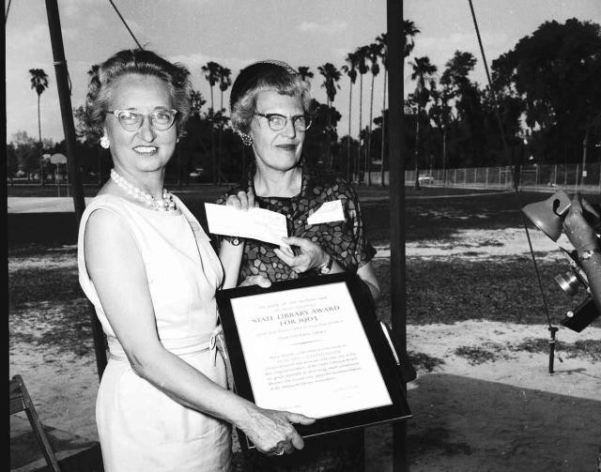
Above: Quintilla Geer Bruton (L) holds the State Library Award for 1963. Image used with permission from Plant City, Florida-Photo Archives.

Quintilla Geer Bruton was born in 1907 in Walton, Kentucky. She moved to Plant City, FL, with her parents and sister on Thanksgiving Day, 1923. She was the valedictorian at Plant City High School for the Class of 1926. She attended Tampa Business College and Brewster Vocational School, both in Tampa, FL. She married her high school classmate, James D. Bruton, Jr. in 1932. The couple made their home in Plant City where they accomplished much for the community. Quintilla's pioneering role in creating a public library for Plant City led her to be affectionately known as "The Library Lady."
Quintilla Geer Bruton's contributions to libraries, archives, and local history are still felt and appreciated in Plant City, Hillsborough County, and throughout Florida today. Bruton was instrumental in founding the community's public library.
The Plant City Woman's Club held their meetings in the Miller House in Plant City. From 1927 to 1959, the volunteers gathered books and ran a community library from their meeting space where residents could check out items for a fee. The city government contributed $25 per month beginning in 1940.
In 1959, the library space in the Plant City Woman's Club facility became infested by termites and needed to be destroyed. The Plant City Woman's Club, and Quintilla Geer Bruton in particular, were not satisfied with the space, collections, and services currently being provided to the residents in lieu of a proper, municipal library. Bruton launched a movement within the community for a government-funded, public library. In response, the city commission held an election to determine if the residents of Plant City supported a new tax to fund the creation of a municipal library. The residents voted to tax themselves in exchange for a public library, those in favor winning nearly 75% of the votes with 551 votes for and 190 votes against.
The Plant City Woman's Club meeting site was torn down after 2,000 volumes were retained for the new library space. The Plant City Public Library was built on the same site and opened in 1960. Bruton was the 1961 winner of the annual Outstanding City of Plant City Award.

The Plant City Public Library flourished. During only its third year in existence, the library won the award for Florida's Most Outstanding Public Library from the Book-of-the-Month Club and the Dorothy Canfield Fisher Award.
Quintilla Geer Bruton made a great contribution to the history of the Plant City area. She co-wrote the book "Plant City: Its Origin and History" with David E. Bailey. The book, published in 1985, details the history of Plant City through to 1976. Bruton was passionate about local history and preservation. She volunteered with the Daughters of the American Revolution, the East Hillsborough Historical Society, and the Community Archives Center, the latter of which is now named in her honor.
Quintilla Geer Bruton died on January 4, 1989. The Plant City Public Library was renamed the Quintilla Geer Bruton Library from 1990-1994. Her husband continued her work after her death and donated funds to support the library. In 1994, the library was renamed the Bruton Memorial Library to honor both Quintilla Geer Bruton and her husband, Judge James D. Bruton, Jr.

Sources:
By Angie Neely-Sardon, who is the Reference Librarian/Instructor for the Mueller Campus of Indian
River State College and former Computer Services Librarian for Bruton Memorial Library in Plant City, FL. As submitted to: “Women of Library History.” Quintilla Geer Bruton . A Project of the ALA/SRRT/Feminist Task Force.

Glamsch, Panky (January 22, 1968). "There goes the library lady -- it's Mrs. Bruton". Tampa Tribune.
Darling, Dave (February 16, 1989). "Plant City to rename library in memory of Quintilla Bruton". Tampa Tribune.

