Librarians We Have Lost-Sesquicentennial Memories -1976-2026,
Maynard J. Brichford

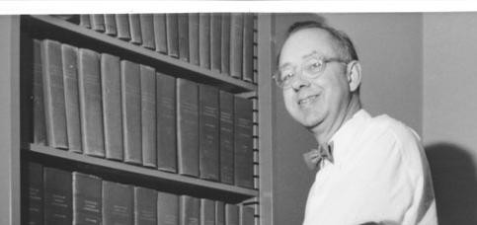

Maynard J. Brichford (1926-2019), Fellow and President of the Society of American Archivists, established the archives program at the University of Illinois at Urbana-Champaign.

He was responsible for bringing the American Library Association Archives to the University of IllinoisChampaign.

Upon graduation from Madison High School in Ohio in 1944, Maynard Brichford completed a semester at Hiram College before entering the Navy. After World War II he completed college and earned a MS in history from the University of Wisconsin-Madison.

Brichford worked at the Wisconsin State Historical Society, then went on to positions in records management with the states of Illinois (1956-59) and Wisconsin (1959-63).

He was appointed as the first full-time Archivist of the University of Illinois in 1963. Under his leadership the University of Illinois archives grew into national prominence for which he was recognized with the Chancellor's Medallion in 2017.

Brichford was a Fellow of the Society of American Archivists and served as its president in 1979-80. He retired in 1995. In addition to numerous publications on archival topics, he authored a biography of UI football coach Bob Zuppke.

Publications:

Archives & Manuscripts: Appraisal & Accessioning (Chicago: Society of American Archivists, 1977)
"Current Status of the American Library Association Archives: A Preliminary Report." The Journal of Library History (1974) 12.1 (1977): 64–69.
Bob Zuppke: The Life and Football Legacy of the Illinois Coach (Jefferson, N.C.: McFarland & Co., 2008)
"University Archives: Relationships with Faculty," American Archivist 34, no. 2 (1971): 173-181
"Academic Archives: Überlieferungsbildung," American Archivist 43, no. 4 (1980): 449-460
"Who Are the Archivists and What Do They Do?" American Archivist 51, no. 1-2 (1988): 106-110

Sources:

40 Years of ALA Archives at the U of I
Brichford, Maynard. "Current Status of the American Library Association Archives: A Preliminary Report." The Journal of Library History (1974) 12.1 (1977): 64–69.

American Library Association Press Release, October 31, 1973, Library Advisory Committee Minutes & Correspondence, 1967-1980, Record Series 18/1/1, Box 1, Folder: ALA Archives Correspondence, 1973-74, American Library Association Archives.

Brichford, Maynard J. | University of Illinois Archives

Presidents, Society of American Archivists.

Maynard Brichford Obituary

Maynard J. Brichford - Wikipedia

------------------------------
Kathleen de la Peña McCook
Distinguished University Professor
School of Information University of South Florida
------------------------------

