Dina Abramowicz (1909–2000) Vilna, Lithuania
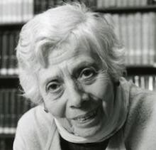

Dina Abramowicz (1909–2000) was one of the most important Yiddish librarians of the twentieth century. Born in Vilna, Lithuania, she survived the Holocaust and worked in the Vilna Ghetto library, where reading helped people hold on to hope during a very dark time. After the war, she moved to the United States and spent more than 50 years working at the YIVO Institute for Jewish Research. There, she became known for her incredible knowledge, her helpful guidance to researchers, and her dedication to preserving Jewish history and Yiddish culture.
Abramowicz was remarkable not only because she knew so much, but because she deeply believed in the importance of saving and sharing the past. She saw libraries as living places where culture survives and grows. Through her work at YIVO, she helped rebuild and protect materials that might have been lost forever, including books, documents, and stories from Eastern European Jewish communities. Many people said that talking with her felt like speaking with a living archive because she carried so much history with her.
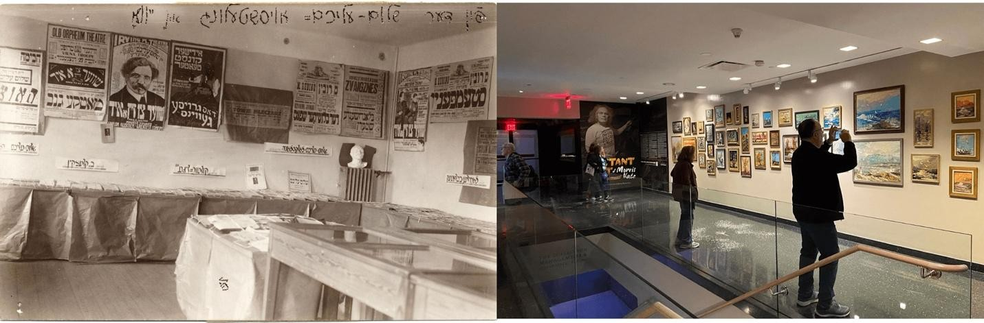
Her legacy lives on in the YIVO collections and in the many scholars, students, and community members she helped over the years. Dina Abramowicz showed how powerful librarianship can be by preserving memory, supporting learning, and keeping culture alive. She reminds us that libraries are places of care, history, and hope. Dina Abramowicz passed away at age 85. She is remembered as a survivor, a scholar, and one of the most influential Yiddish librarians of the modern era.

Miranda Macias
University of South Florida

References
Berger, J. (2000, April 9). Dina Abramowicz, 90, Librarian and Yiddish Expert, Dies. The New York Times. https://www.nytimes.com/2000/04/09/nyregion/dina-abramowicz-90librarian-and-yiddish-expert-dies.html
Dina Abramowicz | Jewish Women’s Archive. (2025). Jewish Women’s Archive.
https://jwa.org/encyclopedia/article/abramowicz-dina

