Dr. Peggy Sullivan (Librarians We Have Lost, ALA Sesquicentennial Memories 1976–2026)
November 13, 2025; (updated from original post October 27, 2024).

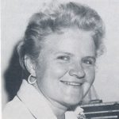

Dr. Peggy Sullivan (1929-2020) was Chair of the Centennial Celebration of the American Library Association in 1976.

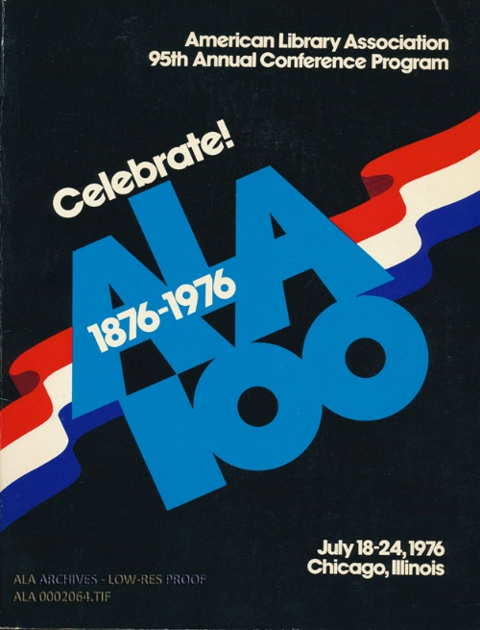

Peggy Sullivan earned the Ph.D., University of Chicago Graduate Library School. 1972; the M.S. in L.S., Catholic University of America, Washington, DC, 1953; Thesis:(1953). Work of public libraries with trade unions in the United States; and the B.A., Clarke College, Dubuque, IA, 1950.

She served as President of the American Library Association (1980-1981). Her conference theme was "Libraries and the Pursuit of Happiness."

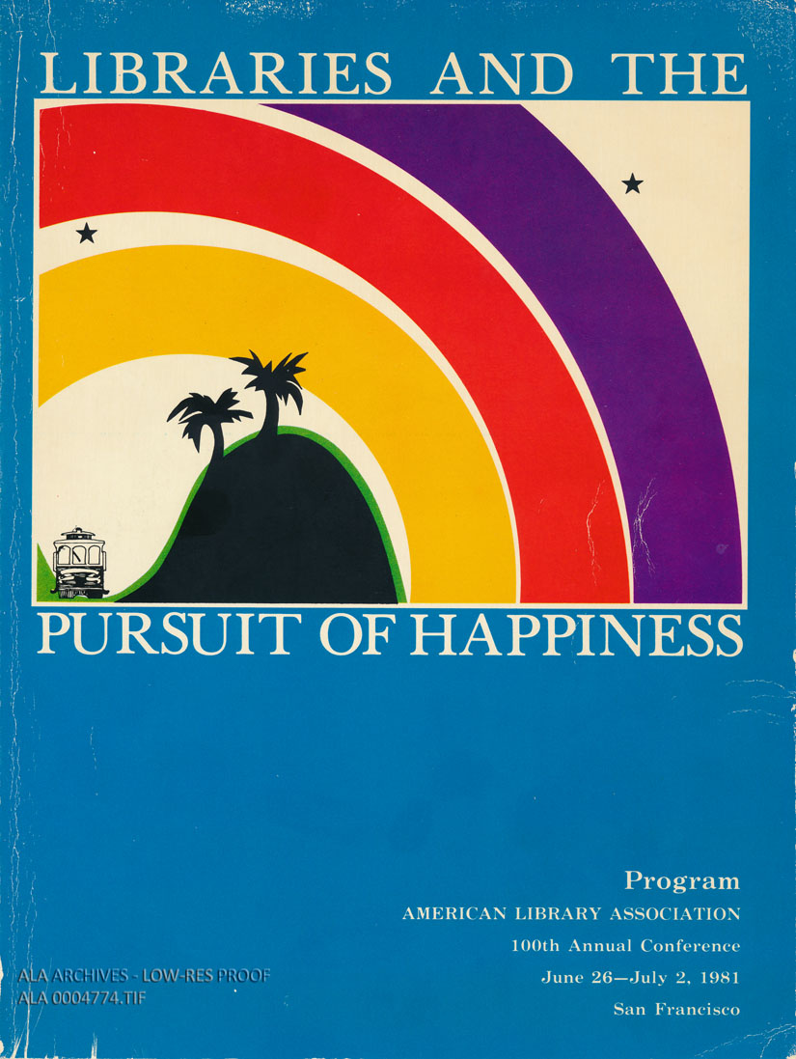

Dr. Sullivan also served as American Library Association Executive Director (1992 – 1994).

CAREER
Knapp School Libraries Project

Dr. Sullivan’s work as director of the The Knapp School Libraries Project was a five-year initiative launched on March 1, 1963, by the American Library Association—the largest such grant specifically for school library development at the time. It was administered by the American Association of School Librarians to demonstrate the educational benefits of exemplary school library programs by establishing model library media centers in selected U.S. schools.
The project's primary goal was to demonstrate the educational value of high-quality school library programs, services, and resources by creating model school library media centers in selected elementary and secondary schools across the United States.
The project had four main objectives:
- To illustrate the educational benefits of well-resourced school libraries.
- To foster improved understanding and effective use of library resources among teachers, administrators, school board members, and other stakeholders.
- To facilitate visits and observations by educators, librarians, students, and community members to disseminate the model's characteristics and impact.
- To stimulate interest in demonstration programs in education more broadly.

Realization: The Final Report of the Knapp School Libraries Project," edited by Peggy Sullivan and published by the American Library Association (ALA) in 1968.

Dr. Peggy Sullivan Career Highlights
- Dean, Graduate School of Library and Information Science, Dominican University (prev.Rosary College (1995-1997),
- Director and Professor, University Libraries, Northern Illinois University (1990-1992), Dean and Professor, College of Professional Studies, Northern Illinois University (1981-1990),
- Assistant Commissioner, Chicago Public Library (1977–1981),
- Dean of Students, University of Chicago Graduate Library School (1974-1977).

Dr. Peggy Sullivan and the American Library Association
She was devoted to the American Library Association and wrote of its history, worked for its stability and contributed to its legacy throughout her career. She wrote more than 100 articles on various aspects of librarianship, education, administration, and history.
Of special note as ALA looks to the Sesquicentennial was the American Libraries article she wrote with Leonard Kniffel and Edith McCormick: “100 of the Most Important Leaders We Had in the 20th Century. (1999).” American Libraries, 30(11), 38.

- ALA Memorial Resolution Honoring Peggy Sullivan (2020).
- Honorary Membership, American Library Association, 2008.
- Established Sullivan Award for Public Library Administrators Supporting Services to Children-An annual award consisting of a commemorative gift and a 24k gold-framed citation presented to an individual who has shown exceptional understanding and support of public library service to children while having general management/supervisory/ administrative responsibility that has included public library service to children in its scope, 2004.
- · Recipient of the Joseph W. Lippincott Award, 1991.
- · American Library Association President, 1980-1981.
- · Author of Carl H. Milam and the American Library Association (H. W. Wilson, 1976).
- President of the Association for Library Services to Children, 1976-1977.

