Librarians We Have Lost, Sesquicentennial Memories -1976-2026: Margaret E. Monroe

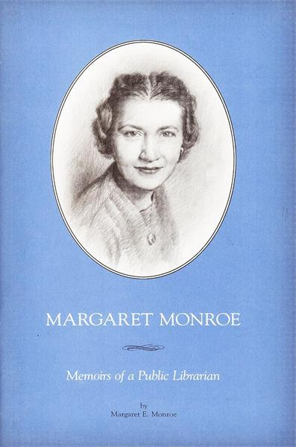 Margaret E. Monroe (1914-2004)
Margaret E. Monroe served as Professor and Director of the Library School at the University of Wisconsin – Madison from 1963 until 1970 (Now the The Information School at UW-Madison ).
Monroe was on the forefront of the movement to develop library services for persons and groups with special needs, such as the disadvantaged, institutionalized, and aged. She was a national leader in adult services in libraries and in 1985 the American Library Association (ALA) created the Margaret E. Monroe Library Adult Services Award to honor individuals who have made significant contributions to library adult services.
Monroe saw the library as an agent for change even before we had the words to describe this concept, and her view of the democratic role of the library underscored practically every position she took.
Education and Career
Monroe was born in New York City. She received a bachelor's degree in English and a bachelor's degree in librarianship from New York State College in Albany. She received a master's degree in English and a doctorate from Columbia University.
- Monroe served in various capacities at the New York Public Library for thirteen years.
- Monroe was on the faculty of the Graduate School of Library Science at Rutgers University before coming to Madison, Wisconsin.
- Monroe served as Professor and Director of the Library School at the University of Wisconsin – Madison from 1963 until 1970.
While Monroe was Director of the UW Library School, she initiated the Ph. D degree and an Advanced Studies Certificate. Major outside funding was received by the Library School for research on library services to adults. In 1970 she returned to full time teaching at the library school. Her work is noted for her focus on the library in the life of the user.
She retired as Professor Emerita in 1981.
Association contributions
- Monroe was president of the Adult Services Division of the American Library Association (ALA). She was chair of the Committee on Accreditation of ALA. She served on the Council of ALA.
- She was president of the Association of American Library Schools (Now ALISE-Association for Library and Information Science Education).
- She was active in the Wisconsin Library Association and served as chair of the Wisconsin Public Library Association and the Intellectual Freedom Committee.
Honors:
- Monroe was a national leader in adult services in libraries and in 1985 the American Library Association (ALA) created the Margaret E. Monroe Library Adult Services Award to honor individuals who have made significant contributions to library adult services.
- she received the Beta Phi Award for Distinguished Service to Education for Librarianship.
- Gail A. Schlachter. 1982. The Service Imperative for Libraries : Essays in Honor of Margaret E. Monroe. Littleton, Colo.: Libraries Unlimited.
- Reader Services in Libraries : A Day in Honor of Margaret E. Monroe : The 1981 Alumni Day of the Library School, University of Wisconsin-Madison, May 1, 1981.
- Margaret E. Monroe was inducted into the Wisconsin Library Hall of Fame at the Wisconsin Library Association Conference in Appleton on October 22, 2009. Margaret Ellen Monroe (1914-2004) – Wisconsin Library Heritage Center
Selected Publications
Monroe, Margaret Ellen. 2006. Margaret Monroe : Memoirs of a Public Librarian. 1st ed. Madison, Wis.: Parallel Press, University of Wisconsin--Madison Libraries.
Miriam Pollack, "Margaret E. Monroe: Bibliography," in The Service Imperative for Libraries: Essays in Honor of Margaret E. Monroe, ed. Gail A. Schlacter (Littleton, Colo.: Libraries Unlimited, 1982), 189.
Monroe, Margaret Ellen, K. McCook, and United States Office of Educational Research and Improvement Library Programs. 1991. Partners for Lifelong Learning : Public Libraries & Adult Education. Washington, D.C.: Office of Library Programs, U.S. Dept. of Education, Office of Educational Research and Improvement .
Monroe, Margaret Ellen, and Rhea Joyce Rubin. 1983. The Challenge of Aging : A Bibliography. Littleton, Colo.: Libraries Unlimited.
Monroe, Margaret Ellen, and K. McCook. 1979. Emerging Patterns of Community Service. [Urbana]: University of Illinois Graduate School of Library Science.
Monroe, Margaret Ellen. 1963. Library Adult Education, the Biography of an Idea. New York: Scarecrow Press.
Monroe, Margaret Ellen. 1962. The Evolving Conception of Adult Education in Three Public Libraries : 1920-1955. [Ann Arbor, Mich.: University Microfilms]. (dissertation)
Monroe, Margaret Ellen, and Patricia Mary Kenny. 1954. Planning Your Program for American Heritage Discussion. [Chicago]: American Heritage Project of the American Library Association. catalog.hathitrust.org/api/volumes/oclc/3484956.html.
Sources:
Margaret Ellen Monroe (1914-2004) – Wisconsin Library Heritage Center
Oral History Interview: Margaret E. Monroe. 1988. Permanent Link : Minds@UW. digital.library.wisc.edu/1793/66134
Schlachter, Gail A. "Margaret E. Monroe Beyond the Service Imperative." Reference & User Services Quarterly 44, no. 3 (2005): 184–209. www.jstor.org/stable/20864360.
Gail A. Schlachter. 1982. The Service Imperative for Libraries : Essays in Honor of Margaret E. Monroe. Littleton, Colo.: Libraries Unlimited. Catalog Record: The Service imperative for libraries : essays... | HathiTrust Digital Library

------------------------------
Kathleen de la Peña McCook
Distinguished University Professor
School of Information
University of South Florida
------------------------------

