Dr. Robert J. “Bob” Grover- Librarians We have Lost- Sesquicentennial Memories - 1976-2026
Submitted by Carmaine Ternes
Librarian, Author, Editor, Presenter
Kansas Association of School Librarians
"A child who reads will be an adult who thinks!" StoryCorps One Small Step

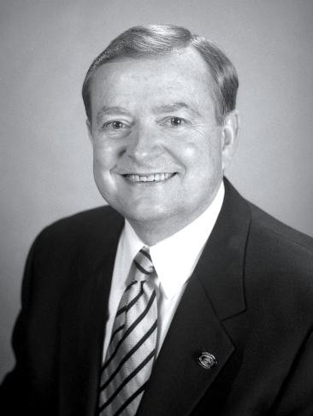

Robert J. “Bob” Grover, Emporia, Kansas, passed away at his home on Saturday, November 22, 2025 at the age of 83. He was born October 27, 1942.
Among his publications:
- Roger C. Greer : A Festschrift by Roger’s Colleagues, Friends, & Family. Edited by Robert Grover, Herbert K. Achleitner, and Kelly Visnak. Emporia, Kansas: Bluestem Press. 2020.
- *Grover, Robert. 2022. First in the West : A History of the Emporia State University School of Library and Information Management. Emporia: Bluestem Press.
- Evolving Global Information Infrastructure and Information Transfer. Santa Barbara, California: Libraries Unlimited. 2015
- Libraries Partnering with Self-Publishing : A Winning Combination. Santa Barbara, California: Libraries Unlimited. 2016.
- Assessing Information Needs : Managing Transformative Library Services. Santa Barbara, Calif.: Libraries Unlimited. 2010
- Grover, Robert, and American Association of School Librarians. 1996. Collaboration. [Chicago, IL]: American Association of School Librarians.
Robert was born in La Porte, Indiana on October 27, 1942, the son of John T. and Gladys Marie
(Hartner) Grover. Bob and Susan G. Fowler were united in marriage on August 5, 1995 at Grace United Methodist Church, Emporia, Kansas. Susan survives of the home. Bob is also survived by his son, Robert S. Grover; and a brother, Gerald V. “Jerry” Grover. He was preceded in death by his first wife, Susan (Shaw) Grover, who passed away in July of 1973; his parents; and an infant child.
Dr. Grover received his B.A. in English Education and Library Science from Ball State University in 1965, his Master in Library Science from Indiana University in 1970, and his Ph.D. in Library Science from Indiana University in 1976.
Dr. Grover served in several positions at Emporia State University, Emporia, Kansas: Dean of the
School of Library and Information Management (1981-1987, 1998-2003, 2006-2007), Professor of Library and Information Management (1990-1998, 2007-2008), Associate Vice President for Academic Affairs (2003-2007), and Dean of Graduate Studies (2003-2006).
Dr. Grover also served as Director and Professor at the University of South Florida (1987-1990).
He began his higher education career at the University of Southern California (1976-1981), serving as Assistant Professor then Assistant Dean of the School of Library and Information Management. Earlier in his career he served as a School Library Media Specialist, Newspaper Reporter and English Teacher. Most recently he was the Lay Pastor at the Bazaar (Kansas) United Methodist Church, Bazaar, Kansas.
Bob was a member of Trinity United Church of Christ, Chicago, Illinois. He was an active member of the Emporia Lions Club, having served in various offices and was President in 2007-2008. He was an Op-Ed Columnist for The Emporia Gazette and an active member of a number of organizations including the Current Club, Emporia Area and Kansas Retired School Personnel, The Silver Haired Legislature, American and Kansas Library Associations, and the League of Women Voters of Emporia.

Robert J. “Bob” Grover | Free | emporiagazette.com

