Librarians We Have Lost, Sesquicentennial Memories -1976-2026: Paul Fasana- 1933-2021

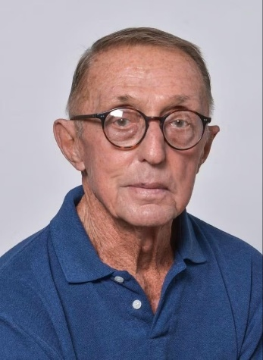
Paul Fasana served in the U.S. Army during the Korean War, then graduated from UC Berkeley; first in 1959 with a B.A. and then 1960 with a Masters of Library Science. Armed with those degrees, he began a long career in library administration; first at the New York Public Library as a cataloguer and later at the Columbia University Libraries as director of library automation. Eventually he returned to the New York Public Library as senior vice president and director of the Research Libraries until he retired in 1995.
In retirement he was chief archivist of the Stonewall National Museum & Archives in Fort Lauderdale, Florida. The Fasana/Graham Archive at the Stonewall Museum is named for him and his late husband, Dr. Robert Graham.
Spanning from the late 20th century to the present day, the Fasana/Graham Archive is a monumental repository of LGBTQIA+ political, cultural, and social history. With over 2,700 linear feet of materials-twice the height of the Empire State Building-the collection comprises more than 6 million pages of records.
Video:
https://youtu.be/uY1RgZLQLY4?t=154
Much more:
Thanks to LHRT News and Notes for posting a Harpers article about Paul Fasana.
The title of that Harpers article, "The Unknown Librarian Who Saved Queer History: You probably don't know the name Paul Fasana. But the librarian was instrumental in preserving hundreds of thousands of artifacts of queer history," resulted in messages from of the library community who most certainly DID know Paul Fasana.
*From: Michael Gorman, ALA Past President:
"The latest LHRT blog entry that I have received describes Paul Fasana as "The unknown librarian who saved queer history." Paul may be unknown to many librarians but he was an important figure in the US cataloguing community and played a role in the creation of AACR2. Photo shows Paul, second from the right in the attached--taken at the LITA cataloguing institute in 1977.
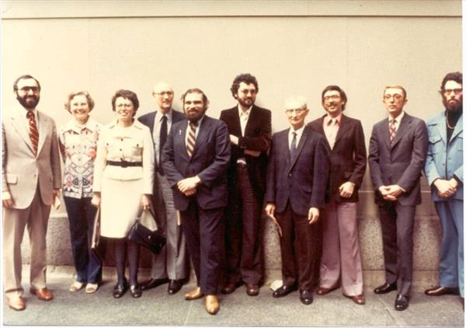
------With all the best to all, Michael
*From School of Information at UC Berkeley
Pioneering alumnus Paul Fasana (M.L.S '60), a champion of LGBTQ causes through his scholarship and philanthropy, has died at the age of 87.
Fasana had a long career in libraries, beginning with his first library position as a student at the Cal Forestry Library - now the Bioscience, Natural Resources & Public Health Library. After graduation from Berkeley, he became a cataloger at the New York Public Library, then moved on to the Itek Corporation in Massachusetts, and then to the Columbia University Libraries, where he served as director of library automation. He eventually returned to the research libraries of the New York Public Library - one of the largest public research library systems in the world. He served as Senior Vice President and Andrew W. Mellon Director of the Research Libraries until his retirement in 1995.
In retirement, he turned to philanthropy, but he remained a librarian to the core: he volunteered as the archivist for the Stonewall Museum and Archives, one of the largest LGBTQ archives and libraries in the United States, organizing critical historic documents and media that had been scattered throughout three warehouses. Due to his efforts, skills, and vision, the collection now resides in a climate-controlled building and is well-cataloged for researchers.
"More than any other single individual, he is responsible for the richness of the vast archives at Stonewall," said Hunter O'Hanian, executive director. "Thousands of pages in the archive bear his carefully hand-written notes in pencil. He cared for and nurtured the collection with remarkable accuracy right up to [the week before he died] when he was here and working. Future generations of scholars and researchers will owe him a debt of gratitude for his work and attention to detail."
The I School was also a beneficiary of his generosity: in 2018, he established the Paul Fasana LGBTQ Studies Fellowship, which supports School of Information graduate students whose research interests or studies are related to lesbian, gay, bisexual, transgender, and/or queer studies in any field or discipline. Tia Foss, the I School's Director of Philanthropy, said that Fasana, "was happy to be able to give back to the I School community because becoming a librarian enabled him to offer financial assistance to causes he believed in."
Recipients of the fellowship he established have used data science to advocate for LGBTQ rights, researched the intersection of data science and transgender identity, and challenged notions of identity in HCI and UX research.
Fasana was preceded in death by his partner of 48 years, Robert Graham, with whom he credited nudging him into philanthropy; together, they established the first endowed fund at the Our Fund Foundation in South Florida which is now the 3rd largest LGBT foundation in the country.
In celebration of Pride, and Fasana's life and legacy, we ask you to support students with a gift to the Paul Fasana LGBTQ Studies Fellowship Fund.
*From: NY Publc Library retirees association
Paul FASANA
Paul Fasana died on April 1, 2021. He was eighty-seven years of age and a resident of Fort Lauderdale, Florida, at the time of his death.
Paul served as Senior Vice President and Director of the Research Libraries at NYPL until his retirement in 1997. After his US Army service in Korea, Paul received a Bachelor of Arts degree in 1959 and a Master of Library Science degree in 1960. Both were from the University of California, Berkeley. After working as a cataloger at NYPL, Paul was appointed Director of Columbia University Libraries' Division of Library Automation. He later returned to NYPL to assume the Research Libraries position.
Upon his retirement and relocation to South Florida, Paul began twenty years of volunteer service to the Stonewall National Museum and Archives. As chief archivist, he organized and managed collections of historic documents and media. Under his leadership, this archive was brought together from several locations to its current location in Fort Lauderdale. Paul also embarked on a long career of financial philanthropy. A highlight was the establishment of the Paul Fasana LGBT Studies Fellowship at the UC Berkeley library school.
Official Obituary of Paul Fasana July 20, 1933 ~ April 1, 2021 (age 87)

