Textual Cultural Heritage Model: A Culture-Centric Approach to Library History

Ruby Spargo
Department of Library and Information Science, Indiana University Indianapolis

Author Note
Ruby Spargo  https://orcid.org/0009-0006-6471-5082
The author has no known conflict of interest to disclose. The author would like to acknowledge and thank Professor Christopher Proctor, Indiana University for their support during the writing of this paper.
Correspondence concerning this article should be addressed to Ruby Spargo, Email: spargoruby@gmail.com
Abstract
Existing library history literature points to social, political, economic, and intellectual factors as key macrocultural elements that play an important role for libraries in civilizations throughout recorded history, which is inextricably linked to a societal communication framework. Libraries are cultural institutions that represent and influence society and its culture, and attacks against libraries are often attacks aimed at the culture which they represent and cultivate. However, existing literature neglects culture as a core element in communication framework and places libraries as a mere purveyor of literature rather than an active participant as a cultural institution within a culture-centric model. Through consideration of various forms of library destruction and oppression throughout transitional points in western history, this paper argues that library history should be studied from a culture-centric perspective with a proposed textual cultural heritage model in order to advance library practice in the twenty-first century in a globalized society founded on nationalistic cultural tendencies of the twentieth century.
Keywords: library history, library destruction, culture, nationalistic, culture-centric, textual cultural heritage

Textual Cultural Heritage Model: A Culture-Centric Approach to Library History
Existing library history foundational work from Harris (1999) and the communication circuit from Darnton (1982) lay a foundation of library growth as being reliant on key macrocultural factors (social, political, economic) and an established book trade. While these foundations are indeed critical to the growth of libraries throughout civilizations over time, we run into a paradox in which we know libraries are centers of cultural institutions, yet we do not appear to study their creation and growth with the abstract notion of culture as the core driver. In an operational model, we treat libraries as an end-user or simply an organized storehouse of textual cultural materials – which we know is a falsehood. Furthermore, with the rise of strategic and deliberate destruction of libraries in an effort to destroy a culture, also known as libricide through Knuth’s (2003) work, and the targeting of libraries particularly in the twentieth century during the rise of nationalism, we can examine that when libraries are targeted it is because they are tangible extensions of culture which a perpetrator aims to control or destroy. This seems to be a shift from pre-twentieth century library destruction.
Through analysis of several examples throughout library history in the western world, this research aims to address the following questions:
- How does the existing framework of macrocultural factors from Harris (1999) and Darnton (1982) compare across different forms of library destruction and control pre and post twentieth century?
- Were western pre-twentieth century libraries targeted as acts of cultural genocide?
- When was the first act of targeted/strategic library destruction as an act of libricide?
- How did nationalism impact textual cultural heritage and library culture?
- Did nationalism instigate tensions and alienate groups leading to targeted attacks against libraries?
Through these research questions, this paper illuminates the sticking points to study library history through the lens of a culture-centric model and to operate with such consideration as a library practitioner moving forward in a globalized society founded on nationalistic cultural tendencies of the twentieth century.
Macrocultural Elements in Library History and Communication
In consideration of the foundational work of Harris (1999), stable social, economic, and political foundational macrocultural factors, alongside an established book trade, can provide favorable conditions for the development of libraries. The creation and viability of a library is presupposed by the societal requirement of literature and communication as an active cultural process. Through Darnton’s (1982) communication circuit, we understand that these macrocultural factors are at the center of textual culture in an operational model that involves a book passing from the author through the publication and distribution process that reaches readers (consumers); the circuit is influenced by each component in an outer supply chain loop that is influenced by core social, political, and economic macrocultural factors. In Darnton’s (1982) model, the library is placed as a purveyor in the outer supply chain loop under readers. Both the library history framework laid by Harris (1999) and the communication circuit developed by Darnton (1982) touch on the foundational macrocultural factors relevant to library growth and both primarily focus on the supply chain model of textual materials.
Culture
What is it?
Depending on which field of study is consulted, different answers may yield to the question: what is culture? Rather than debating endlessly between different schools of thought, it may be more practical to address this question from a different angle. Through examining what cultural assailants aim to extinguish, we can define what culture is, at least practically, from a library history perspective. As we understand from Harris (1999) and Darnton (1982), culture has key social, political, and economic factors that influence and are influenced by culture with tangible products (e.g., textual materials) that are sustained through a viable supply chain circuit. This allows for the identification of key target points for cultural attack (social, political, or economic); however, this does not address what culture is as a whole. Through examples of the libricidal events of the twentieth century, common cultural themes arise that are points of attack or defense: identity, language, claim to land, and political legitimacy. These core elements are the makeup for defining culture in the context of library history.
Libraries are key cultural institutions in society because they do not merely sell books on the shelves, they are organized in an useful or purposeful manner with a significant cultural connection to their communities – particularly with the rise of nationalism and transnational collective movements of the twentieth century (Donovan, 2024).
Nationalism
Nationalism was born out of the French Revolution where nation-states moved towards democratization and away from autocracy, imperialism, and colonialism (Owen, 2025). George Orwell (2018) places a definition on this term broader than borders, which may serve better to analyze nationalism in a modern multicultural and globalized community. Through this, we can understand nationalism as a way of identifying oneself with a single nation or community not necessarily specific to race or geography, and with a great sense of duty to advance the interests of that entity to which one identifies with. This understanding of nationalism allows us to understand complex pluralisms in nationalism that may not have borders on maps: communism, Nazism, Zionism, politicized Catholicism, etc. (Orwell, 2018). Through Orwell’s (2018) description of nationalism, we can then more deeply understand Owen’s (2025) description of how Fascists used nationalism to garner support and flip to imperialism, and even genocide in the case of Nazi Germany.
Libraries support nationalism through textual cultural materials that reinforce and advance nationalistic agendas through a shared will to be together as one and national consciousness through concrete elements such as a shared language, culture, and history (Knuth, 2003).
Globalism, Internationalism, and Culture
After World War II, nationalism was maintained as a precondition to international ongoings (Owen, 2025). However, internationalism was supported under the notion of certain nation-states supporting each other against other nation-states (e.g., The United States fight against the Soviet Union and Communism) (Owen, 2025). Globalism was a leading economic phenomenon which bolstered economic nation-state prosperity through productive international relations, yet created unequal distribution of wealth for individuals in these nation-states (Owen, 2025). Through globalism, the middle and working classes of developed nations like the United States actually suffered and did not gain a boost in economic prosperity – which caused recoil back towards nationalism (Owen, 2025). Under globalism, economic and political systems of independent nation-states may be interconnected to regional or global supranational groups, yet their cultural makeup may be at risk of cultural homogenization resulting in the potential for a rise in cultural assertiveness (Petrus, 2016). In this way, globalism can be perceived as modern colonialism which exploits, manipulates, and permeates cultures that may be subordinate to the dominant (typically western) culture (Petrus, 2016). As a dominant culture infiltrates a subordinate culture through forced cultural assimilation, the subordinate culture’s existence is jeopardized; history tells that forced cultural assimilation leads to ethnocide (Petrus, 2016).
Pre-Twentieth Century Library Destruction and Oppression
Prior to the twentieth century, oftentimes, the destruction of libraries was not a strategic endeavor, but rather a side effect of conquest, war, or abandonment. Valencia (2002) asserts that library destruction in the centuries prior to the twentieth century were merely acts of looting. In the case of the Library of Alexandria, repeated strife caused its iterative destruction in the first century BCE (Harris, 1999). Through conquest sustained by strong political, military, and presumed economic strength, the Romans inherited the cultural materials from Ancient Greece as trophies of war (Harris, 1999). Throughout the Middle Ages in Western Europe, religious strife and conquests throughout the region caused the destruction of literary materials and books, often through looting and the neglect in monasteries (Harris, 1999). Through Napoleon’s reign in the nineteenth century, there is evidence to support he not only looted textual cultural materials but also studied them to have an advantage in conquest (Owens, 2012).
Twentieth Century Library Destruction and Oppression
Jewish Erasure: World War II
Post World War I left a vacuum of social and economic disruption in Germany which was filled with nationalistic ideologies to create a strong, homogenous Germanized cultural existence that used Jewish people as a scapegoat to their troubles which grew into a hatred that fueled the massive genocide of Jewish people (Knuth, 2003). The Nazis used propaganda, destroyed books, and peddled their rhetoric to portray Jewish people as the reason for social, economic, and political woes of the country and region (Knuth, 2003). The Nazis expanded their reach beyond their borders, wreaking havoc across western Europe and forcing nations to align their literary materials to what the Germans approved (Knuth, 2003).
Poland was sought after by the Nazis for expansion and occupation (Knuth, 2003). In Cracow specifically, which has a history of Jewish people in the region since the Middle Ages, Jews made up 25% of the prewar population in the city (Sroka, 2003). The Jews were considered racial enemies of the Nazis (Sroka, 2003), and the Nazis had a pursuit to wipe Polish lands of any ethnic identification that was not that of their own (Knuth, 2003).
Occupation of Palestine: Libraries
Palestine has been troubled with foreign occupation during the twentieth century, first with British occupation and subsequently Israeli occupation of the West Bank (Hamad, 2021). During British occupation, Jewish education was pushed to be the responsibility of the Jewish community and Arab education was maintained under British authority – which, alongside the authority of some local municipalities, banned Arab Palestinians from public libraries (Hamad, 2021). A key driver for keeping Arab Palestinians from information and education was so that the British could keep this group ignorant so it was easier to occupy and erase their cultural identity (Hamad, 2021).
Once Israel was declared a state in 1948, Palestinians were forced out of their land and Israelis sought to destroy any cultural evidence that would refute the Zionist myth that the region was an open, empty land for settlement (Hamad, 2021). Literary collections of Arab Palestinians were strategically targeted by Israelis for confiscation; some books were kept but without acknowledgement of where the books came from as to not validate their cultural history (Hamad, 2021). There was strict control placed on production, distribution, and circulation of Arabic literary materials and also destruction of libraries by Israeli military (Hamad, 2021).
Libricide: Bosnia and Louvain
In Eastern Europe, after World War II, Communist leaders forced together nations to form Yugoslavia; the nations were: Slovenia, Croatia, Bosnia-Hercegovina, Serbia, Montenegro, and Macedonia (Knuth, 2003). This forced unification under the new identity of Yugoslavia was done to weaken and break down sociopolitical feuding; however, these groups historically have had ethnocentric conflict, most specifically between the Croats, Serbs, and Muslims within Croation and Bosnia (Knuth, 2003). Communism pushed an international identity instead of ethnic nationalism, which these three primary groups were aggressively accustomed to (Knuth, 2003). In the 1990s, catastrophic war ensued in which the Serbs in particular sought to outright exterminate the cultural evidence of the Muslims in the region which would validate their very existence, claim to the land, political legitimacy and identity as a group (Petrus, 2016). In Bosnia specifically, the citizens were more open to a multiethnic society as the Muslim population understood that a pluralist society meant more viability for them to survive there, and there was a number of supporters willing to fight for a multiethnic community; however, the example of coexistence completely disprove the myth perpetrated by the Serbs that Serbs, Croats, and Muslims couldn’t coexist in the region (Knuth, 2003). As one of the most grave incidents of libricide in modern history, the Serbs shelled the National Library of Bosnia-Herzegovina in Sarajevo, leading it to erupt in a fire that burned for three days and destroyed over ninety percent of the collection (Knuth, 2003; Kuntz, 2012).
The first act of libricide is said to be the destruction of the Louvain library by the Germans in 1914 (Donovan, 2024). Although the burning of the U.S. Library of Congress by the British in 1813 could possibly be the first act of libricide, it is not clear if the target was the library or the legislative buildings in which the library was housed (Donovan, 2024). The loss of the Louvain library collection in 1914 was particularly devastating due to the organic development of the collection fueled by the community (Donovan, 2024).
Nationalism and Libraries
Libraries can be a cultural reinforcement of a national identity and legitimacy. Through state-sponsored approaches in schools, books, and libraries, governments politicize national identity for active cultural heritage maintenance – even if manufactured – in order to have evidence of continuous historical identity for political legitimacy or to make indigenous claims to land (Knuth, 2003).
Ukraine has been under attack from Russia since 2022 with strategic targeting of Ukrainian cultural institutions; Ukrainians fight for their national and cultural identity past, present, and future (Anghelescu, 2022; Kandiuk, 2023). As an independent state since the fall of the Soviet Union in 1991, Ukraine has used libraries to push Ukrainian language and collections (Anghelescu, 2022; Haigh, 2009). Ukrainian was the minority language of Ukraine when it obtained independence and has used this along with libraries to reinforce and grow their national identity (Haigh, 2009).
In Australia after the Federation unified the self-governing colonies in the region; the mainland Australian libraries quickly adopted a nationalist agenda to reinforce and develop their new national identity which was supplanted in the indigenous communities (Gaunt, 2008). In Britain, the use of the English language and libraries were used to reinforce not only the national identity of Britain, but also to have a cultural stronghold over colonized regions – making the colonized regions subordinate (Peatling, 2004).
Burning South African Township Libraries: Is it Self-Destruction?
In post-apartheid South Africa, township libraries were set ablaze as the communities which they were intended to serve rejected their existence (Lor, 2013). Librarians and the library community had a difficult time initially comprehending why the community would target libraries in this way – using condemning descriptors for those that targeted the libraries and asking if it would not be helpful “[…] to highlight the importance of libraries for these communities as a way of developing and educating them so they can rise above their poverty, etc.” (Lor, 2013). The librarian community initially placed more value on their roles in the impoverished and recently freed communities of the townships in South Africa which blinded them from initially reflecting in a professional manner on the core issues and dynamics that led to the burnings of libraries (Lor, 2013). Ultimately, this is an example of a colonized and post-apartheid community which likely saw the library as a symbol of oppression (Lor, 2013).
Discussion
Twentieth Century and Prior: Library Destruction
With library destruction prior to the twentieth century, the framework from Harris (1999) and Darnton (1982) provide a nice foundation to review library growth and destruction. However, more research could be conducted to more deeply analyze gaps in culture as a driving force for destruction; determining if there was value placed on culture to identify or legitimize a civilization – or destroy it – prior to the twentieth century would need to be founded. However, it does not appear that pre-twentieth century libraries were targeted as acts of cultural genocide as the research included herein does not prove that value was placed on culture to identify or legitimize a civilization nor to destroy it. As this cannot be determined herein, this research leads to the understanding that library destruction prior to the twentieth century may have been caused by being in the wake of strife.
Leading into the twentieth century, nationalism used textual materials and libraries as tools to support their ideologies and build national consciousness (Knuth, 2003). Ukraine has used nationalism via language, textual materials, and libraries to reinforce their national identity (Anghelescu, 2022; Kandiuk, 2023). Australia has used nationalism via library practice to advance their new identity after the union of their independent colonies (Gaunt, 2008). Britian used nationalism via language and textual materials to reinforce and expand their national identity and influence (Peatling, 2004). Nationalism certainly causes friction with other groups, particularly in cases where a nation at some point claimed independence from another nation. The Communists forced many Balkan nations together despite their ethnocentric conflict because the Communists wanted these groups to identify under the single nationalist ideologies of Communism – which caused catastrophe in the libricide in the region during wartime (Knuth, 2003).
Redefining Culture and the Textual Cultural Heritage Model
With the clear shift in the twentieth century towards cultural destruction, inclusive of libricide, there is a need to reconsider how we study library history in future. While culture has different definitions in other fields, it may very well be valuable to define culture in the library history field as the very things that are either cultural targets or culture as defense as has been discussed in examples herein: identity (e.g., religion, ethnicity, national, etc.), language, claim to land, political legitimacy. Additionally, it is valuable to consider the cultural connection libraries have to influence the macrocultural elements and culture directly – and how each influence each other. Figure 1 showcases a proposed textual cultural heritage model as a starting point as a shift in library history.
Figure 1
Textual Cultural Heritage Model
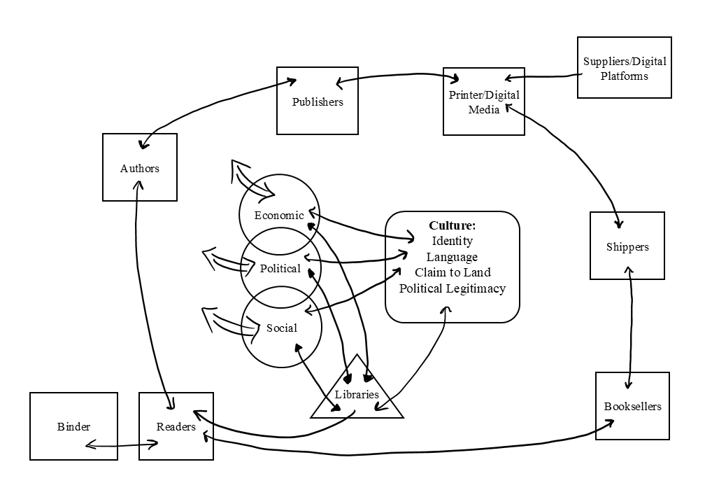
Conclusion: Libraries and Globalism
The twenty-first century saw a key dynamic shift – globalism. Globalism unevenly shifts wealth globally and caused some recoil towards nationalism due to an economic setback for particularly middle class communities in developed nations (Owen, 2025). Through globalism, we see interconnectedness of economic and political infrastructures of nations; however, the cultural makeup of nation states may be at risk of forced cultural homogenization (Petrus, 2016). As we see dominant entities unevenly benefit from globalism through strategic supranational partnerships, it could be perceived that globalism is a new form of colonialism (Petrus, 2016). The twentieth century surely has taught us that nationalism can cause grave acts of cultural genocide and libricide as international frictions arise. The case of library burning in post-apartheid South Africa has taught us that forced cultural institutions can cause violence and rejection (Lor, 2013). Globalism poses a cultural risk to certain nation states that recently claimed independence, have had long histories of cultural clashes, and those that are indigenous communities that still are feeling impacts of historical colonialism. Through the Textual Cultural Heritage Model in Figure 1, perhaps we can start to look at library history and textual culture heritage from a culture-centric model that defines the very cultural things that so many fight to destroy and protect.

References
Anghelescu, H. G. B. (2022). Ukraine’s libraries under Russian Fire: The first fifty days of aggression. Libraries: Culture, History, and Society, 6(2), 237. https://doi.org/10.5325/libraries.6.2.0213
Darnton, R. (1982). What is the history of books? Daedalus, 111(3), 65–83.
Donovan, J. (2024). More than censorship: The harm of libricide. Libraries: Culture, History, and Society, 8(1), 1–21. https://doi.org/10.5325/libraries.8.1.0001
Gaunt, H. (2008). A native instinct of patriotism: Nationalism in the Australian Public Library, from Federation to the 1930s. A case study of the Public Library of Tasmania. Library History, 24(2), 152–166. https://doi.org/10.1179/174581608X329835
Haigh, M. (2009). Making Ukrainians in the library: Language, libraries, and national identity. The Canadian Journal of Information and Library Science, 33(3/4), 141–158.
Hamad, A. (2021). History of Palestinian libraries and archives under Israeli occupation (1948-1993). Progressive Librarian, 48, 7–30. https://search.ebscohost.com/login.aspx?direct=true&db=lls&AN=150951161&site=ehost-live
Harris, M. H. (1999). History of libraries in the western world (4th ed.). The Scarecrow Press, Inc.
Kandiuk, M. (2023). The war on the cultural heritage of Ukraine. Art Documentation: Journal of the Art Libraries Society of North America, 42(1), 1–23. https://doi.org/10.1086/728257
Knuth, R. (2003). Libricide. Praeger.
Kuntz, B. (2012). The politics of cultural genocide. Progressive Librarian, 40, 91–108.
Lor, P. (2013). Burning libraries for the people: Questions and challenges for the library profession in South Africa. Libri, 63(4), 359–372. https://doi.org/10.1515/libri-2013-0028
Orwell, G. (2018). Notes on nationalism. Penguin Random House UK.
Owen IV, J. M. (2025). Whose nationalism? Hedgehog Review, 27(1), 78–89.
Owens, B. M. (2012). The archival manuscript and the book: Tools of knowledge and artifacts of destruction during the Napoleonic wars and the War of 1812. Library & Archival Security, 25(1), 5–19. https://doi.org/10.1080/01960075.2012.660615
Peatling, G. K. (2004). Public libraries and national identity in Britain, 1850-1919. Library History, 20, 33–47. https://doi.org/10.1179/lib.2004.20.1.33
Petrus, T. (2016). Globalism vs culture(s): A critique of transculturalism and the one world, one culture globalist narrative in Africa. International Social Science Journal, 66(219–220), 39–48. https://doi.org/10.1111/issj.12114
Sroka, M. (2003). The destruction of Jewish libraries and archives in Cracow during World War II. Libraries & Culture, 38(2), 147–165. https://search.ebscohost.com/login.aspx?direct=true&db=lls&AN=502902700&site=ehost-live
Valencia, M. (2002). Libraries, nationalism, and armed conflict in the twentieth century. Libri, 52(1), 1–15. https://doi.org/10.1515/libr.2002.1

