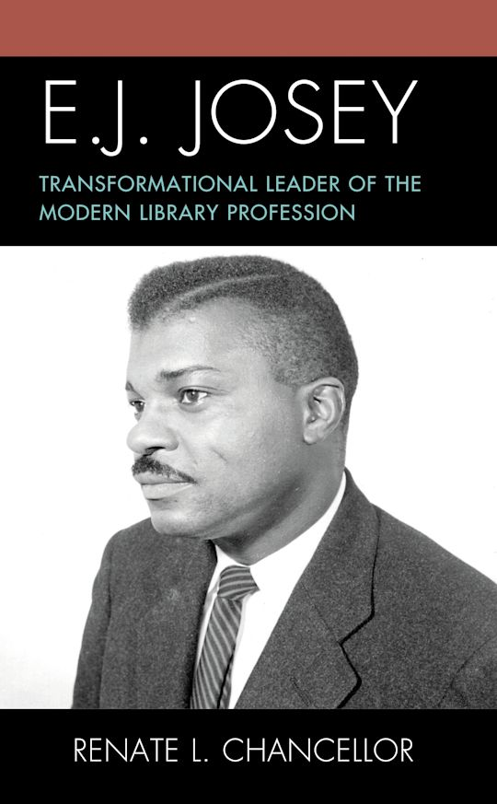
Elonnie Junius "E.J." Josey (1924- 2009) was American Library Association President 1984 to 1985. He was named Honorary Member of the American Library Association in 2002. Renate Chancellor has written his biography: E. J. Josey: Transformational leader of the modern library profession, Rowman & Littlefield, 2020.
E.J. Josey was born in Norfolk, Virginia, to Willie Josey, a World War I veteran and laborer at the Norfolk Naval Shipyard, and Frances Bailey Josey, a former teacher who encouraged his love of reading and creativity.
Josey served in the U.S. Army during World War II from 1943 - 1946.
He earned a Bachelor of Arts (AB) from Howard University in 1949, a Master of Arts (MA) in history from Columbia University in 1950 and a Master of Library Science from the State University of New York at Albany in 1953.
Career
E.J. Josey joined the Free Library of Philadelphia in 1953. Despite his advanced degrees, he faced racism, including assignment to clerical tasks. He advocated for a transfer to the social sciences section but left after one year due to ongoing bias.
From 1955 to 1959, Josey served as Director of the Library at Delaware State College (now Delaware State University). He then moved to Savannah State College in Georgia, as Chief Librarian and Associate Professor from 1959 to 1966.
E.J. Josey participated in the Civil Rights struggle in Savannah. He supported students' founding of a local chapter of the NAACP and also served on the executive board of the Savannah Branch of the NAACP.
In 1964 he carried the Civil Rights struggle into the American Library Association. Josey offered the resolution at the 1964 Conference which prevented ALA officers and staff members from attending segregated state chapter meetings.
In 1966, Josey joined the New York State Education Department's Division of Library Development. He was promoted to Chief in 1968, a position he held until 1976, then became Chief of the Bureau of Specialist Library Services until 1986. In these roles, he focused on academic and research libraries, information systems, and outreach programs. He was president of the Albany branch of the NAACP 1982 - 1986.
From 1986 to 1995, Josey was a professor at the University of Pittsburgh's School of Library and Information Sciences . Upon retirement, he was named Professor Emeritus, and the E.J. Josey Endowment Scholarship for Minorities was established in his honor.
E.J. Josey and the American Library Association
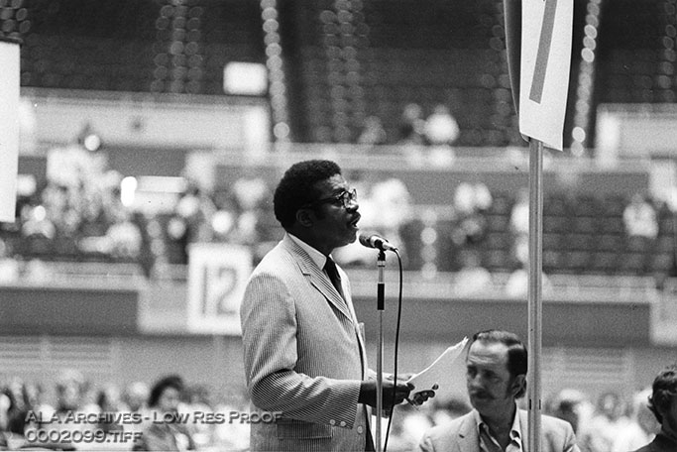
Image from ALA Archives, https://archon.library.illinois.edu/ala/index.php?p=digitallibrary/digitalcontent&id=703
Josey transformed the library profession by confronting systemic racism. At the 1964 ALA Annual Conference-the same week President Lyndon B. Johnson signed the Civil Rights Act-Josey authored a resolution barring ALA officers and staff from participating in segregated state library associations. This led to the desegregation of associations in several Southern states, including Georgia, where he became the first Black member in 1965. He was outraged by ALA honoring the Mississippi Library Association amid the unsolved murders of civil rights workers Andrew Goodman, James Chaney, and Michael Schwerner.
In 1970, Josey founded the Black Caucus of the American Library Association (BCALA), serving as its first chair. BCALA advocated for the recruitment, education, and hiring of Black librarians, addressing underrepresentation in the field.
E.J. Josey was elected to the ALA Council in 1970, serving 29 years until 2000, and to the Executive Board from 1979 to 1983. He chaired chaired key ALA committees, including the Committee on Pay Equity, Legislation, and International Relations (multiple times).
E.J. Josey served as ALA President from 1984 to 1985, only the second Black American to do so (after Clara Stanton Jones in 1976).
Josey pushed for removing outdated racial terms from Library of Congress Subject Headings and protested ALA's controversial film The Speaker.
In his inaugural address, E.J. Josey emphasized libraries' role in the public good and social progress.
International Activities
Josey advised emerging African nations on library science and led efforts in the 1980s to maintain sanctions against apartheid South Africa. He was a life member of the NAACP, serving as president of its Albany branch from 1982 to 1986. He lectured in Ethiopia, Zimbabwe, and Zambia under the U.S. Information Agency in 1987. In 1998, Forest Press and OCLC honored him with the John Ames Humphrey Award, "in recognition of significant contributions to international librarianship."
Selected Awards and Honors
Joseph W. Lippincott Award. 1980- American Library Association.
In 1985 a Capital Tribute was presented in Washington, D.C., by Congressman Major Owens and the Congressional Black Caucus Brain Trust.
1991- American Library Association Equality Award.
1998, Forest Press and OCLC honored E.Josey with the John Ames Humphrey Award, "in recognition of significant contributions to international librarianship."
2002- American Library Association Honorary Membership.
Selected Publications.
E.J. Josey wrote over 400 articles and wrote and edited 13 books, including The Black Librarian in America (1970, revised 1994), which collected autobiographical essays from pioneers like Virginia Lacy Jones and Augusta Baker, exposing racism in the profession.
Josey, E. J. (1969) "Edward Christopher Williams: A Librarian's Librarian." The Journal of Library History, Vol. 4, No. 2 (Apr., 1969), pp. 106-122.
The Black Librarian in America, Scarecrow Press, 1970.
What Black Librarians are Saying, Scarecrow Press, 1972.
Handbook of Black Librarianship, co-editor with Ann Allen Shockley, Fisk University Library, Libraries Unlimited, 1977.
Libraries in the Political Process, Oryx Press, 1980.
Josey, E. J.; DeLoach, Marva (1983). "Discrimination and Affirmative Action: Concerns for Black Librarians and Library Workers". In Harvey, John R.; Dickinson, Elizabeth M. (eds.). Librarians Affirmative Action Handbook. Metuchen, NJ: Scarecrow Press.
Libraries, Coalitions and the Public Good, Neal-Schuman Press, 1987.
Josey, E. J. . "The Civil Rights Movement and American Librarianship: The Opening Round." In Activism in American Librarianship, 1962–1973, edited by Mary L. Bundy and Frederick J. Stielow, 1987.
Handbook of Black Librarianship. 2nd ed. E. J. Josey and Marva L. DeLoach, eds. Lanham, Md., Scarecrow Press, 2000.
Selected Sources:
American Library Association Equality Award
American Library Association Honorary Membership
American Library Association. Joseph W. Lippincott Award.
Black Caucus of the American Library Association. BCALA in partnership with North Carolina Central University will preserve the history of African American Librarianship and make accessible the EJ Josey papers.
Abdullahi, Ismael. 1992. E.J. Josey: An Activist Librarian. Metuchen N.J: Scarecrow Press, 1992.
Chancellor, Renate E. J. Josey: Transformational leader of the modern library profession, Rowman & Littlefield, 2020.
Chancellor, Renate .The Activist Life of E. J. Josey: Josey scholar discusses the trailblazer's impact on the library world. American Libraries. November 2, 2020
Rayman, Denise. Action, Not Reaction: Integrating the Library Profession. American Library Association Archives. University of Illinois. (February 12, 2015.)
------------------------------
Kathleen de la Peña McCook
Distinguished University Professor
School of Information
University of South Florida
------------------------------

