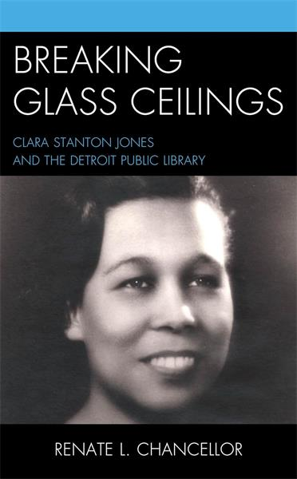

Librarians We Have Lost, Sesquicentennial Memories -1976-2026: Clara Stanton Jones
Clara Stanton Jones (1913 – 2012) was the American Library Association President during the ALA Centennial in 1976.
She received her Bachelor of Arts in 1934 from Spelman College and the degree in Library Science in 1938 from the University of Michigan, Ann Arbor. She worked at at Dillard University in New Orleans and in 1940, became a librarian at Southern University in Baton Rouge, Louisiana.
She joined the staff at the Detroit Public Library's main branch on Woodward Avenue in Detroit in 1944. In 1970 her appointment as Director of the Detroit Public Library came after a contentious vote.. During her 34-year career at the the Detroit Public Library, she persuaded ALA to pass the "Resolution on Racism and Sexism Awareness" in 1977.
Clara Stanton Jones was the first Black president of the American Library Association.
As impressive as her rise above racial barriers was, Jones also had extraordinary vision. Her innovative leadership changed libraries from simple book depositories into the information, resource and educational meccas they are today.
She first began these changes in 1973, when she told the ALA in a speech that most people didn't use libraries, and that "public libraries can no longer depend on reading guidance as the only major adult activity." Life was more complicated and people needed more than card catalogues, "namely, information and referral."
Clara Stanton Jones instituted a new service, The Information Place – "TIP" for short – in Detroit. This service answered the need, as Jones described it, for "guidance through the maze of social, legal, governmental and other agencies, regardless of socio-economic class."
Her work to desegregate libraries, library services and overall library culture led to recognition as the first recipient of the Distinguished Service to Librarianship Award by the ALA's Black Caucus in 1970 and the Trailblazer Award from the same group in 1990.
She was appointed by President Jimmy Carter to the National Commission on Libraries and Information Science and served from 1978 to 1982.
She was awarded American Library Association Honorary Membership in 1983.
The American Library Association "Memorial Resolution Honoring Mrs. Clara Stanton Jones" (2013 ALA Midwinter Meeting) noted:
Mrs. Clara Stanton Jones worked tirelessly to promote justice, human rights, and intellectual freedom; and provided leadership in combating racism and sexism
in the library profession, thereby putting ALA at the forefront in the struggle against oppressive practices.
Sources:
American Library Association. Memorial Resolution Honoring Mrs. Clara Stanton Jones. 2013 ALA Midwinter Meeting.
Black Women Stirring the Waters collection, MS 152, African American Museum & Library at Oakland, Oakland Public Library. Oakland, California.
Clara Stanton Jones interviewed by Marva DeLoach," in Women of Color in Librarianship, pp. 29- 57.Chicago: American Library Association Editions, 1998.
Chancellor, Renate. "Clara Stanton Jones: Stirring the Waters in the Detroit Public Library." Libraries: Culture, History, and Society (2022) 6 (1): 81–101.
Chancellor, Renate. Breaking Glass Ceilings : Clara Stanton Jones and the Detroit Public Library. Rowman & Littlefield, 2024.
Trailblazing librarian, U-M alumna Clara Stanton Jones elected to Michigan Women's Hall of Fame.
Wheeler, Maurice . "Remembering Clara Stanton Jones." Library Journal. (28 December 2012)
------------------------------
Kathleen de la Peña McCook
Distinguished University Professor
School of Information
University of South Florida

