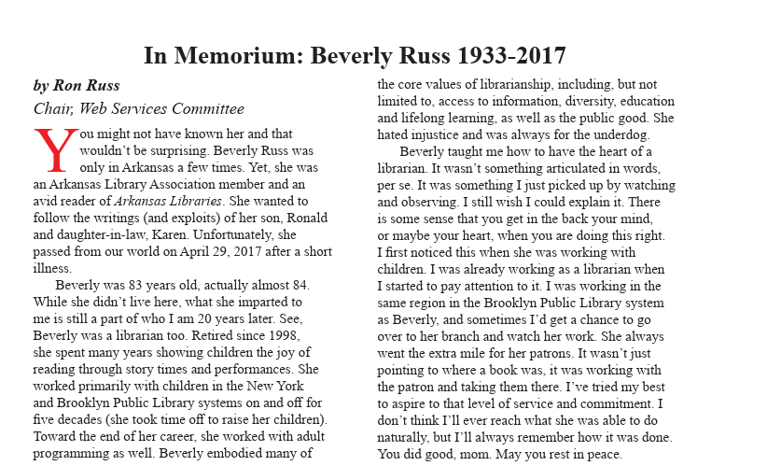

Published in Arkansas Libraries, 2017, Vol 74, No. 2, page 18.
Submitted by Ron Russ.

Screen Reader Transcript: In Memoriam: Beverly Russ 1933-2017 by Ron Russ Chair, Web Services Committee You might not have known her and that wouldn’t be surprising. Beverly Russ was only in Arkansas a few times. Yet, she was an Arkansas Library Association member and an avid reader of Arkansas Libraries. She wanted to follow the writings (and exploits) of her son, Ronald and daughter-in-law, Karen. Unfortunately, she passed from our world on April 29, 2017 after a short illness. Beverly was 83 years old, actually almost 84. While she didn’t live here, what she imparted to me is still a part of who I am 20 years later. See, Beverly was a librarian too. Retired since 1998, she spent many years showing children the joy of reading through story times and performances. She worked primarily with children in the New York and Brooklyn Public Library systems on and off for f ive decades (she took time off to raise her children). Toward the end of her career, she worked with adult programming as well. Beverly embodied many of the core values of librarianship, including, but not limited to, access to information, diversity, education and lifelong learning, as well as the public good. She hated injustice and was always for the underdog. Beverly taught me how to have the heart of a librarian. It wasn’t something articulated in words, per se. It was something I just picked up by watching and observing. I still wish I could explain it. There is some sense that you get in the back your mind, or maybe your heart, when you are doing this right. I first noticed this when she was working with children. I was already working as a librarian when I started to pay attention to it. I was working in the same region in the Brooklyn Public Library system as Beverly, and sometimes I’d get a chance to go over to her branch and watch her work. She always went the extra mile for her patrons. It wasn’t just pointing to where a book was, it was working with the patron and taking them there. I’ve tried my best to aspire to that level of service and commitment. I don’t think I’ll ever reach what she was able to do naturally, but I’ll always remember how it was done. You did good, mom. May you rest in peace.

