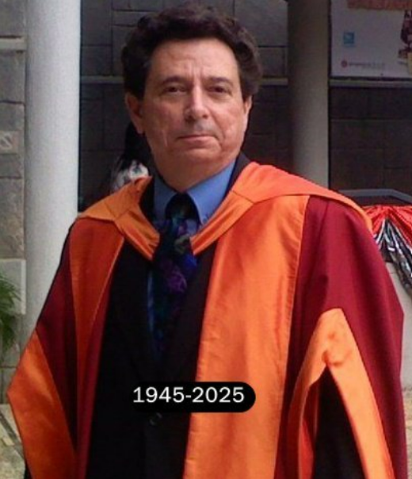

Dr Frederick Nesta, Honorary Senior Research Fellow in the Department of Information Studies at University College London, died peacefully at his home in Athens, Greece, on 7 June 2025 of pancreatic cancer. He was seventy-nine years old. Dr Nesta had previously been Associate Professor at UCL’s campus in Doha, Qatar, starting UCL’s MA Programme in Library and Information Studies there and was the author of three books and numerous articles.

Dr Nesta had a long career in librarianship, serving as University Librarian of Lingnan University, Hong Kong, An Irish national, he also lived and worked in London for several years, serving as College Librarian for Lambeth College in London. In the United States he was Library Director at Saint Peter’s College in Jersey City, NJ and at Marymount Manhattan College in New York. Dr Nesta also worked for the Research Libraries of the New York Public Libraries, Columbia University, PaineWebber, and the Sex Information and Education Council of the United States (SIECUS). Before becoming a librarian, Dr Nesta was a bookseller, owning a shop in New York’s Greenwich Village and later, one in Hong Kong. Dr Nesta was born in San Francisco in 1945, the son of Tresa K. Nesta, an Army nurse. He received his BA from Washington and Jefferson College, his MSLS from Columbia, and his PhD from the University of Wales, Aberystwyth. He is survived by his wife, Dr Maureen Buja, a musicologist.

Books:
George Gissing, Grub Street, and The Transformation of British Publishing. Brighton: Edward Everett Root Publishers, 2020.

Published This Day: Marketing Books in Victorian England. Brighton: Edward Everett Root Publishers, 2022.

Where the Victorians Got Their Reading: Cultural Change In Marketing, Distribution, and Individual Access for ‘The Million’ In Britain, North America, And Australia. Brighton: Edward Everett Root Publishers, 2024.
Maureen Buja, Ph.D.
MaureenBuja@gmail.com

