Dr. Herbert S. White (Librarians We Have Lost, ALA Sesquicentennial Memories 1976–2026)

Dr. Herbert S. White (July 5, 1927 – September 9, 2024)
Dr. Herbert S. White was Dean and Professor at the Indiana University School of Library and Information Science from 1975-1991.
He was President of both the Special Libraries Association and the American Society of Information Science.
He was recipient of the American Library Association Medal of Excellence Award (formerly Melvil Dewey Award), the American Society for Information Science Award of Merit, and the Watson Davis Award.
He was Director of the NASA Scientific and Technical Information Facility, librarian at the Library of Congress and Atomic Energy Commission, program manager of the IBM Corporate Technical Information Center, executive director of the NASA Scientific Technical Information Facility in Bethesda, Maryland, and Vice President for Operations of the Institute of Scientific Information.
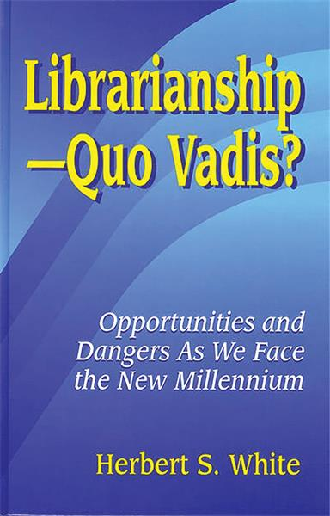
He was author of more than 200 books and articles on topics of library administration, supervision and library automation including Librarianship--quo Vadis?: Opportunities and Dangers as We Face the New Millennium. Libraries Unlimited.
More:
International Essen Symposium. 1993. Opportunity 2000--Understanding and Serving Users in an Electronic Library : 15th International Essen Symposium 12 October-15 October 1992 to Commemorate the 20th Anniversary of the Essen University Library: Festschrift in Honour of Herbert S. White. Essen: Universitätsbibliothek Essen.
Herbert S. White - Wikipedia
------------------------------
Kathleen de la Peña McCook
Distinguished University Professor
School of Information
University of South Florida
------------------------------

