Dr. Henrietta M. Smith (Librarians We Have Lost, ALA Sesquicentennial Memories 1976–2026)
October 25, 2024

Dr. Henrietta M. Smith (1922-2021), Professor Emerita, School of Information at the University of South Florida was a scholar, librarian, and storyteller.
Among Dr. Smith's many publications were four volumes documenting the Coretta Scott King Awards given annually to outstanding African American authors and illustrators of books for children and young adults that demonstrate an appreciation of African American culture and universal human values.
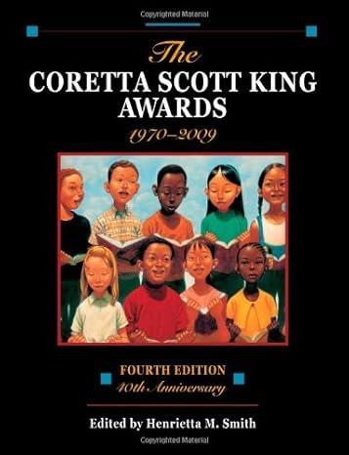
Dr. Smith was instrumental in establishing the Ashley Bryan Art series at the African American Research Library and Cultural Center of the Broward County Library.
She was a nationally known storyteller who participated in storytelling events in New Mexico and on a medical trip on the Amazon River.
She received many professional awards and recognitions.
- Association for Library Service to Children (ALSC) Distinguished Service Award for significant contributions to library service to children (2008).
- Coretta Scott King-Virginia Hamilton Award for Lifetime Achievement for her body of work as a significant and lasting literary contributions. (2011)
- Carle Honors Award from Eric Carle Museum of Picture Book Art for her life's work as a champion of diversity in children's literature. (2014).
More here: Henrietta M. Smith - Wikipedia
------------------------------
Kathleen de la Peña McCook
Distinguished University Professor
School of Information
University of South Florida
------------------------------

